Java?

James Gosling

Object oriented, Platform independent, WORA

Why Platform independent?

It is because the compiler convert code into bytecode(.class) which is platform independent.

Compiler VS Interpretor

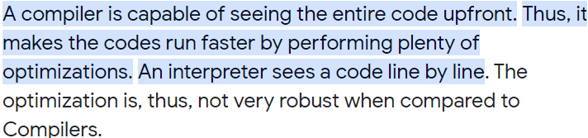

.war and .jar  
.war -> zipping of .class files and files of frontend like .html, .css, .js, ....

.jar -> zipping of .class files

how to run java code?

javac filename.java ....compiler

java filename .. execute

# Difference between JDK, JRE, and JVM

JDK: (Java Development Kit) is a Kit that provides the environment to **develop and execute(run)** the Java program.

JRE: (Java Runtime Environment) is an installation package that provides an environment to **only run(not develop)** the java program(or application)onto your machine. JRE is only used by those who only want to run Java programs that are end-users of your system.

JVM: [(**Java Virtual Machine)**](https://www.geeksforgeeks.org/jvm-works-jvm-architecture/)is a very important part of both JDK and JRE because it is contained or inbuilt in both. Whatever Java program you run using JRE or JDK goes into JVM and JVM is responsible for executing the java program line by line, hence it is also known as an [**i*nterpreter***](https://www.geeksforgeeks.org/compiler-vs-interpreter-2/)**.**

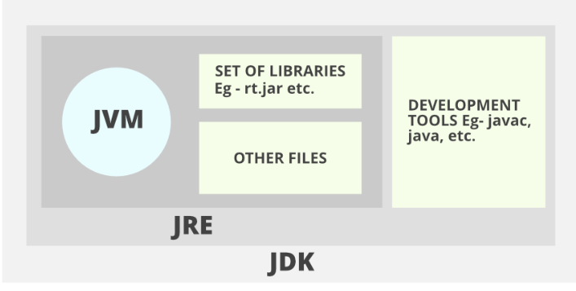

How JVM works?

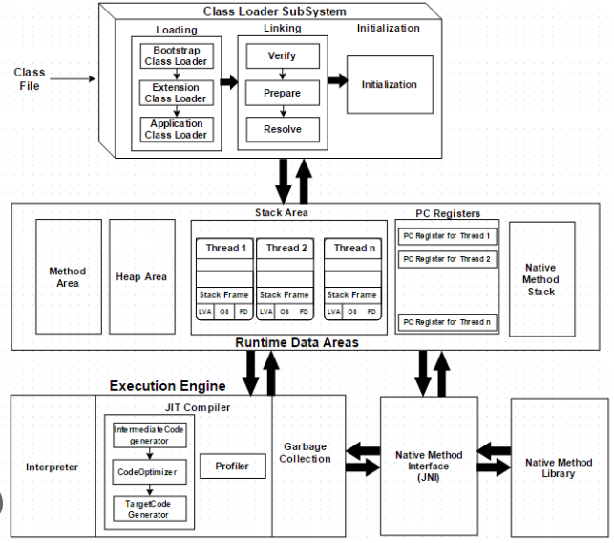

Execution:

1. Class load  
2. static variable declare

3. static block

4. static method(main method)

5. instance variable (when object creates in static method)

6. instance block

7. constructor

Process:

Loading: It loads the .class file . It contains three loaders.  
 Bootstrap - Load builtin class like scanner,..  
 Extension, application - It loads user defined classes

Linking; It verify code and provide heap memory to static variables of a class.

Initialization : It execute static block if present.

Method area : It stores complete byte code  
Heap area : It stores instance variable(static too)

Stack area : It stores method(stack frame) and local variable.

PC Register : It stores the instruction to execute

Native : It stores native method in other language for execution

JIT(Just In Time)

OOPs

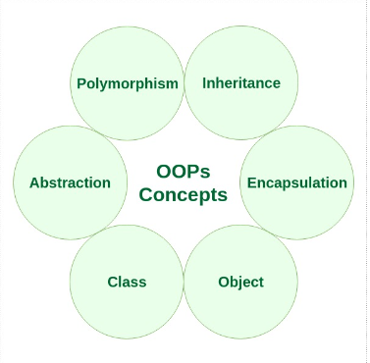

Class: A [class](https://www.geeksforgeeks.org/classes-objects-java/)is a user-defined blueprint or prototype from which objects are created. It represents the set of properties or methods that are common to all objects of one type.

Object: An object is a basic unit of Object-Oriented Programming that represents real-life entities. An object can be defined as a data field that has unique attributes and behaviour.

Abstraction: Data Abstraction is the property by virtue of which only the essential details are displayed to the user. The trivial or non-essential units are not displayed to the user. Ex: A car is viewed as a car rather than its individual components.

Interface: The interface in Java is *a*mechanism to achieve [abstraction](https://www.geeksforgeeks.org/abstraction-in-java-2/).

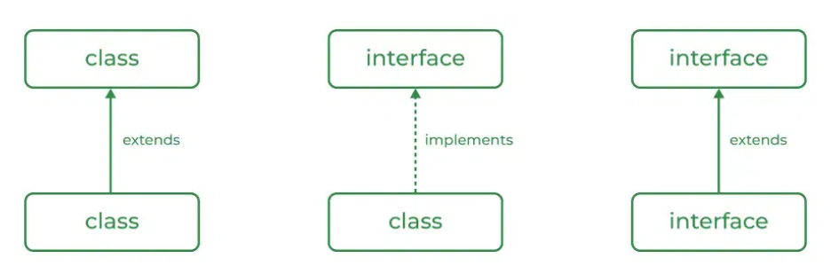

Why abstract class has constructor and interface dont?

Abstract Class:-

It is used to perform initialization of object.

Used to provide value to the object.

Contain instance variable which are required for child object to perform initialization for those instance variable.

Interface Class:-

An Interface in Java doesn't have a constructor because all data members in interfaces are public static final by default, they are constants (assign the values at the time of declaration).

There are no data members in an interface to initialize them through the constructor.

In order to call a method, we need an object, since the methods in the interface don’t have a body there is no need for calling the methods in an interface.

Since we cannot call the methods in the interface, there is no need of creating an object for an interface and there is no need of having a constructor in it.

Encapsulation: It is defined as the wrapping up of data under a single unit. It is the mechanism that binds together the code and the data it manipulates. Another way to think about encapsulation is that it is a protective shield that prevents the data from being accessed by the code outside this shield.

Polymorphism: The word polymorphism means having many forms. In simple words, we can define Java Polymorphism as the ability of a message to be displayed in more than one form.

* Compile-time Polymorphism (method overloading)
* Runtime Polymorphism (method overridding)

new Instance():

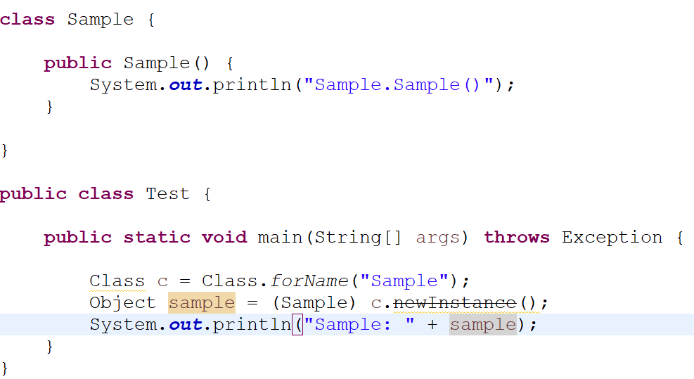 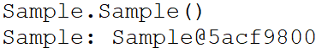

Spring VS Springboot

Spring: Spring is a widely-adopted open-source framework for building enterprise(large scale) applications.

SpringBoot: Spring Boot is a Java framework that enables developers to build robust applications with ease. It allows users to create standalone, production-grade Spring-based Applications that “just run.

Benefits of spring over springboot

> Dependency resolution  
> Minimum configuration

> Embedded Server

> Bean auto scan  
> Health metric

> Dependency resolution : In spring suppose you want to work with hibernate then you need to find features of spring(core, mvc, orm...) to use in project and need to add it pom.xml file with version.

But in springboot you need to add only starter dependency and jpa, it will automatically take it and version too.

> Minimum configuration: In spring you need to configure class which we need to use in hibernate like datasourse, session factory in xml file.

In springboot you need to add only few properties in .properties file.

> Embedded Server: In spring u need to add tomcat server to start your web application

In springboot by default tomcat server is present which can run service fast.

> Bean auto scan: In spring you need to add component scan properties in xml to scan bean.

In springboot you need to follow structure then it will automatically search bean in packages.

> Health metric: In springboot we have actuator to get the health of our app.

Stream Api:

Java 8 java.util.stream package consists of classes, interfaces and an enum to allow functional-style operations on the elements. It performs lazy computation.

So, it executes only when it requires.

These are the major changes in java8 and other changes also which is not required

Q> Find numbers start with 1 using stream



Multithreading in Java:

It is the process of executing two or more thread simultaneously. A thread in Java is a ***lightweight process***.

## Life Cycle of a Thread:

## There are five states a thread has to go through in its life cycle. This life cycle is controlled by JVM (Java Virtual Machine). These states are:

New

Runnable

Running

Non-Runnable (Blocked)(Waiting/Sleep)

Terminated(Dead)

**New**

In this state, a new thread begins its life cycle. This is also called a ***born thread***. The thread is in the new state if you create an instance of Thread class but before the invocation of the ***start()*** method.

**Runnable**

A thread becomes runnable after a newly born thread is started. In this state, a thread would be executing its task.

**Running**

When the thread scheduler selects the thread then, that thread would be in a running state.

**Non-Runnable (Blocked)**

The thread is still alive in this state, but currently, it is not eligible to run.

**Terminated**

A thread is terminated due to the following reasons:

* Either its ***run()*** method exists normally, i.e., the thread’s code has executed the program.
* Or due to some unusual errors like segmentation fault or an unhandled exception.

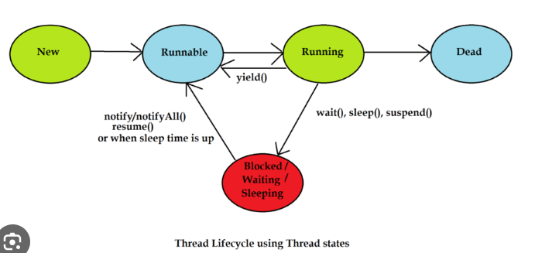

yield():

A yield() method is a static method of Thread class and it can stop the currently executing thread and will give a chance to other waiting threads of the same priority. If in case there are no waiting threads or if all the waiting threads have low priority then the same thread will continue its execution.

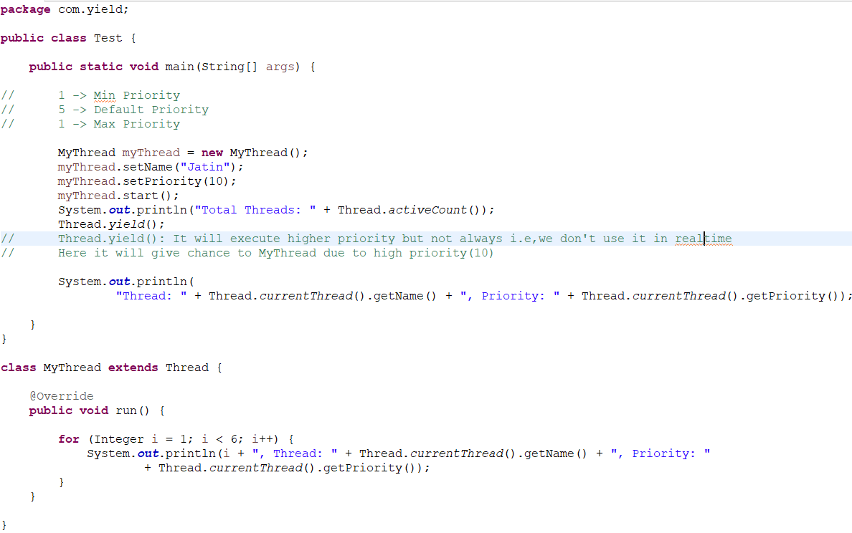

join():

Join method in Java allows one currentThread to wait until other thread completes its execution. In simpler words, it means it waits for the other thread to die. It has a ***void***type and throws ***InterruptedException***. Joining threads in Java has three functions namely,

* join()
* join(long millis)
* join(long millis, int nanos)

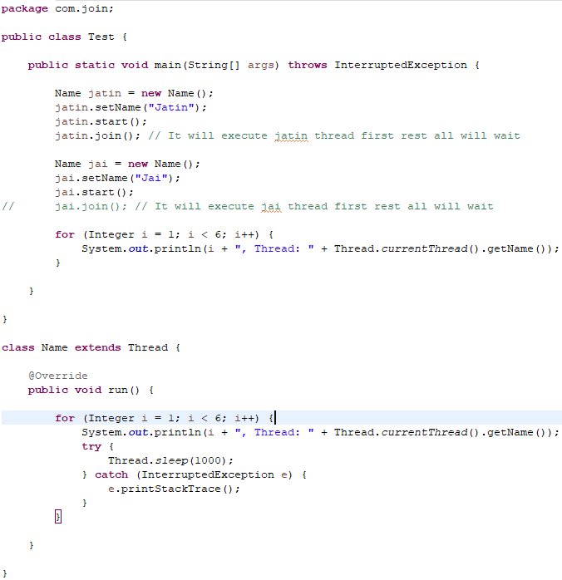

Output:

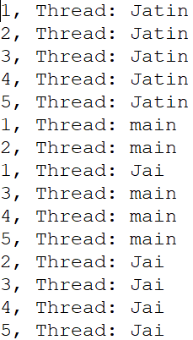

Current thread will wait until jatin thread completes execution and rest all other thread works normally. Only current thread will wait due to join().

wait(), notify(), notifyAll()

### [wait](https://www.digitalocean.com/community/tutorials/java-thread-wait-notify-and-notifyall-example#wait)

Object wait methods has three variance, one which waits indefinitely for any other thread to call notify or notifyAll method on the object to wake up the current thread. Other two variances puts the current thread in wait for specific amount of time before they wake up.

### [notify](https://www.digitalocean.com/community/tutorials/java-thread-wait-notify-and-notifyall-example#notify)

notify method wakes up only one thread waiting on the object and that thread starts execution. So if there are multiple threads waiting for an object, this method will wake up only one of them. The choice of the thread to wake depends on the OS implementation of thread management.

### [notifyAll](https://www.digitalocean.com/community/tutorials/java-thread-wait-notify-and-notifyall-example#notifyall)

notifyAll method wakes up all the threads waiting on the object, although which one will process first depends on the OS implementation. These methods can be used to implement [producer consumer problem](https://www.digitalocean.com/community/tutorials/java-blockingqueue-example) where consumer threads are waiting for the objects in Queue and producer threads put object in queue and notify the waiting threads. Let’s see an example where multiple threads work on the same object and we use wait, notify and notifyAll methods.

Consumer:

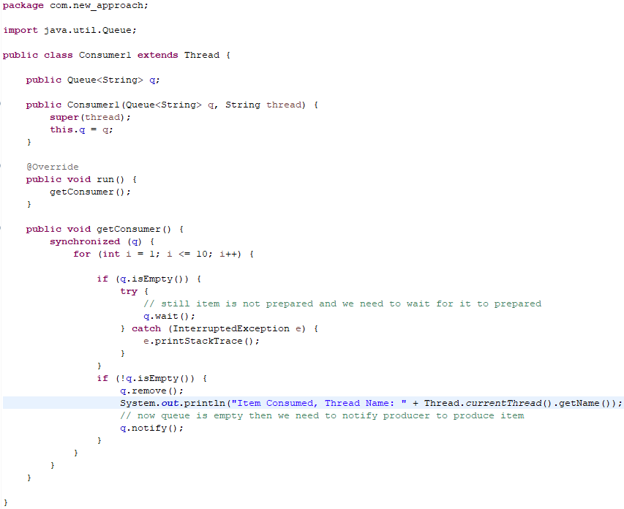

producer:

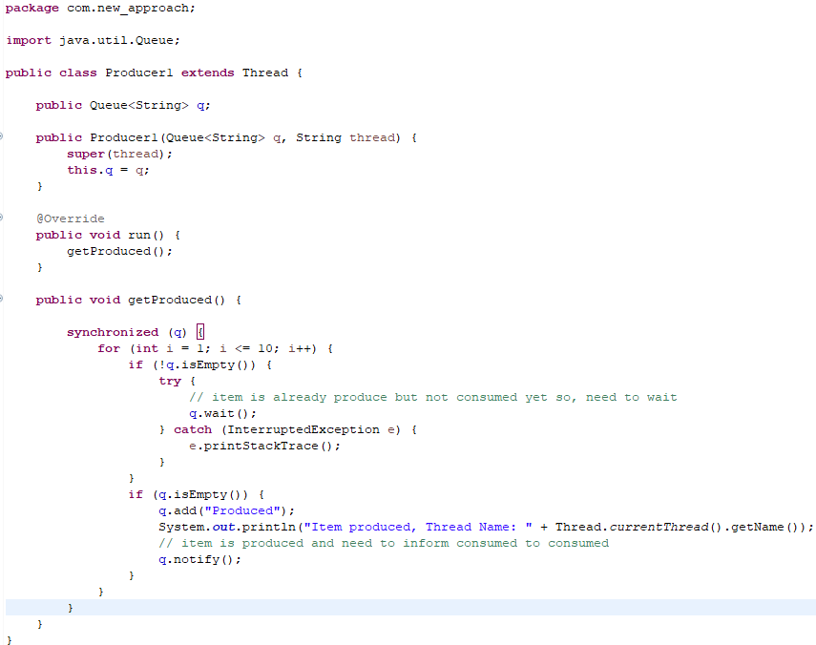

Company:

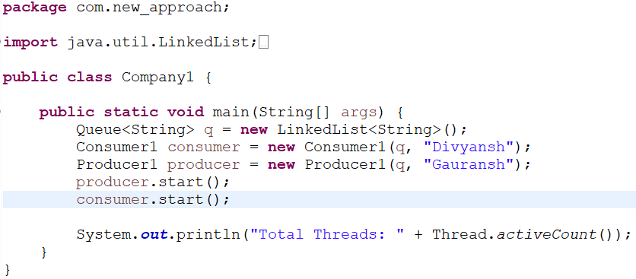

Output:

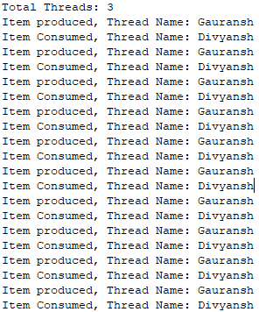

static synchronization:

The Synchronized method may lose its behavior of getting an ordered output. When there are more objects of a class, It acquires only the lock of the particular instance. To maintain the Synchronized behavior, we need a class-level lock rather than an instance-level lock which can be achieved by Static Synchronization.

Static Synchronized method is also a method of synchronizing a method in java such that no two threads can act simultaneously static upon the synchronized method. The only difference is by using Static Synchronized. We are attaining a class-level lock such that only one thread will operate on the method. The Thread will acquire a class level lock of a java class, such that only one thread can act on the static synchronized method.

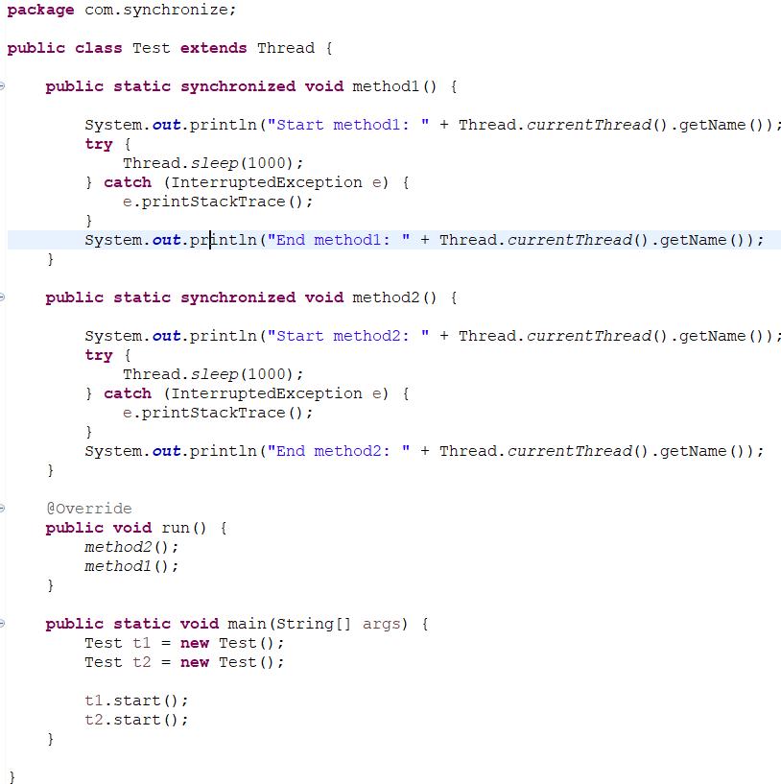

output:

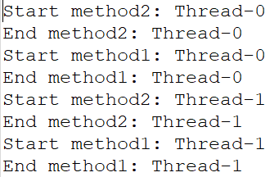

Deadlock:

Deadlock in java is a programming situation where two or more threads are blocked forever.

Eg:

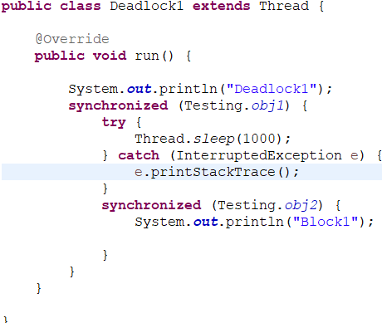

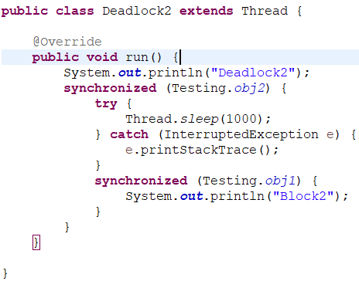

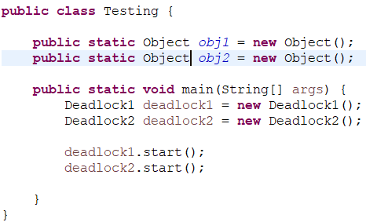

Volatile: “volatile” tells the compiler that the value of a variable must never be cached as its value may change outside of the scope of the program itself. Means don’t store value in cache.

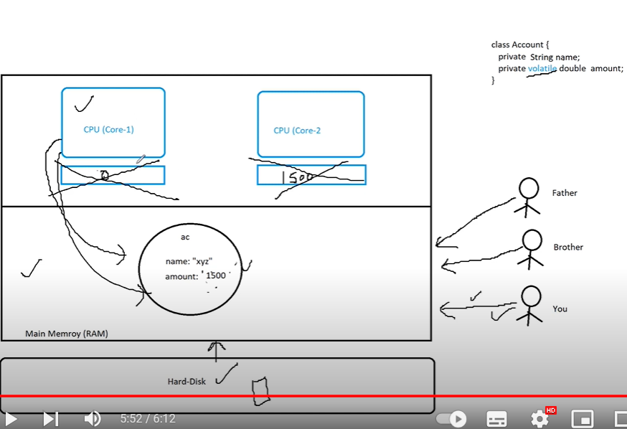

Daemon:

In Java, daemon threads are low-priority threads that run in the background to perform tasks such as **garbage collection** or provide services to user threads. The life of a daemon thread depends on the mercy of user threads, meaning that when all user threads finish their execution, the Java Virtual Machine (JVM) automatically terminates the daemon thread.

Collections:

The **Collection in Java** is a framework that provides an architecture to store and manipulate the group of objects.

Java Collections can achieve all the operations that you perform on a data such as searching, sorting, insertion, manipulation, and deletion.

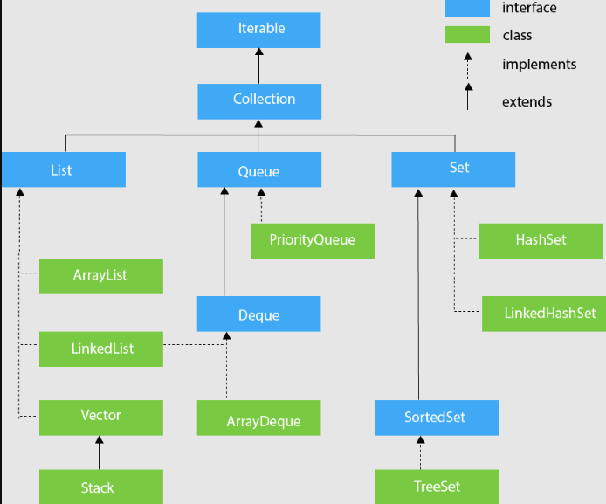 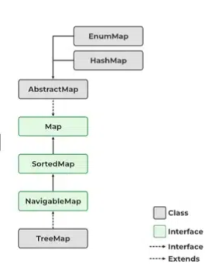

# ArrayList vs LinkedList in Java:

Arraylist: [ArrayList](https://www.geeksforgeeks.org/arraylist-in-java/) is a part of the [**collection framework**](https://www.geeksforgeeks.org/collections-in-java-2/). It is present in the [**java.util**](https://www.geeksforgeeks.org/java-util-package-java/) package and provides us [dynamic arrays in Java](https://www.geeksforgeeks.org/creating-a-dynamic-array-in-java/). Though, it may be slower than standard arrays but can be helpful in programs where lots of manipulation in the array is needed. We can dynamically add and remove items. It automatically resizes itself.

LinkedList: [LinkedList](https://www.geeksforgeeks.org/linked-list-in-java/) is a linear data structure where the elements are not stored in contiguous locations and every element is a separate [object](https://www.geeksforgeeks.org/classes-objects-java/) with a data part and address part. The elements are linked using pointers and addresses. Each element is known as a node. Due to the dynamicity and ease of insertions and deletions, they are preferred over the [arrays](https://www.geeksforgeeks.org/introduction-to-arrays/).

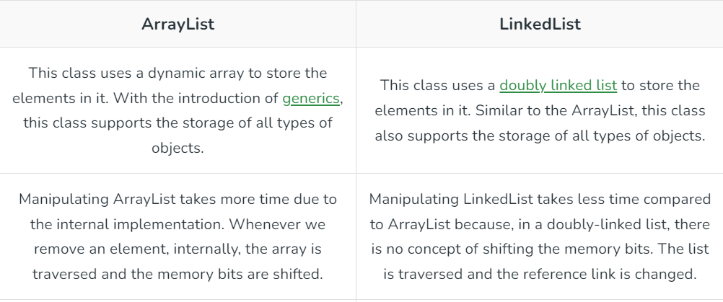

ArrayList: follow array DS  
LinkedList: follow double linkedlist DS  
Stack: follow stack(LIFO) DS  
queue: follow queue(FIFO) DS  
Deques: value can be add or remove from both ends. It can either be LIFO or FIFO.

Priority Queue: Min heap DS  
Tree: follow tree DS

@SpringBootApplication annotation:

This annotation is a powerhouse that combines the functionality of three different annotations: @EnableAutoConfiguration, @ComponentScan, and @SpringBootConfiguration.

**@EnableAutoConfiguration**

The @EnableAutoConfiguration annotation is all about automating the configuration of your Spring Boot application. It works by automatically configuring beans that are present in the classpath, making it much easier for developers to set up and run their applications without needing to manually configure every single bean.

For example, if you have the tomcat-embedded.jar in your classpath, Spring Boot will automatically create a TomcatEmbeddedServletContainerFactory bean to configure the Tomcat server for you. This eliminates the need for developers to write extensive configuration code, reducing boilerplate and simplifying the development process.

**@ComponentScan**

The @ComponentScan annotation is a built-in functionality in Spring Boot applications. It plays a crucial role in identifying Spring beans available within your application. Essentially, it scans the base package and all its sub-packages to find these beans.

For instance, if you have a base package like com.javaproject, @ComponentScan will scan not only the classes in that package but also all the sub-packages like com.javaproject.models, com.javaproject.services, com.javaproject.repos, and so on. This allows Spring Boot to discover and manage your beans without manual intervention.

**@SpringBootConfiguration**

The @SpringBootConfiguration annotation represents your class as a configuration class, essentially making it a configuration source for your Spring Boot application. It is internally using the @Configuration annotation to achieve this. Configuration classes are instrumental when you want to customize the creation of beans within your application.

By combining the @Bean method with the @Configuration annotation, you can create custom beans and configurations for various purposes. This is commonly used to configure components like restTemplate, jdbcTemplate, hibernateTemplate, as well as Spring Boot-specific configurations such as Kafka and Spring Batch.

**Hashtable:-**

->Hashtable is a legacy class available since jdk 1.1 which uses synchronized methods to achieve thread safety. At a time only one thread can read or write into Hashtable. In other word, thread acquires lock on entire Hashtable instance. Hence its performance is quite slow and we can not utilize the advantages of multithreaded architecture.

->Another point to note about Hashtable is that it does not allow null keys or values whereas HashMap allows one null key and any number of null values.

**Collections.SynchronizedMap:-**

->SynchronizedMap is a static inner class of utility class java.util.Collections. It is quite similar to Hashtable and it also acquires lock on entire Map instance. It is not a legacy class like Hashtable and it was introduced in jdk 1.5.

->It provides functionality to convert any thread-unsafe Map implementation to thread-safe implementation using Collections.synchronizedMap(Map map) static method

**ConcurrentHashMap:-**

->Hashtable and SynchronizedMap both acquires lock on entire Map object which provides thread-safety, but not good performance as at a time only one thread can access that Map instance.

->To overcome this issue, ConcurrentHashMap was introduced in Java 5 along with other concurrent classes like CopyOnWriteArrayList,.. within java.util.Concurrent package.

->ConcurrentHashMap divides the Map instance into different segments. And each thread acquires lock on each segment. By default it allows 16 threads to access it simultaneously without any external synchronization i.e. by default concurrency level is 16. We can also increase or decrease the default concurrency level while creating ConcurrentHashMap by using below constructor :

ConcurrentHashMap(int initialCapacity, float loadFactor, int concurrencyLevel)

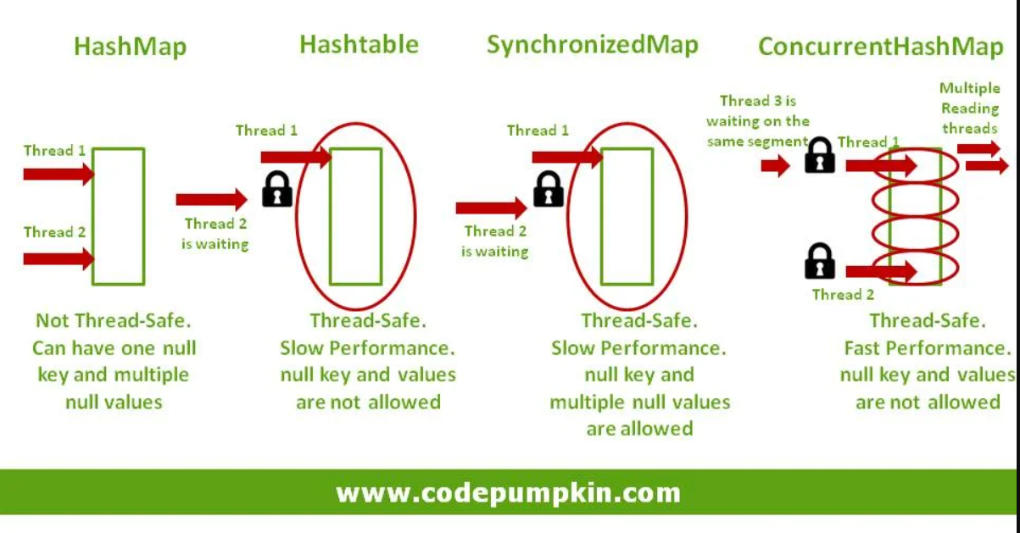

**Key Difference Between HashMap and HashTable:-**

The main difference between HashMap and HashTable is their approach to synchronization and thread safety. While HashTable is inherently synchronized, ensuring that only one thread can access it at a time, HashMap is non-synchronized, allowing simultaneous access by multiple threads. This makes HashMap generally faster in single-threaded scenarios, due to the absence of synchronization overhead.

**Fail Fast and Non Fail Fast(Fail Safe) Iterators:-**

Concurrent Modification in programming means to modify an object concurrently when another task is already running over it. For example, in Java to modify a collection when another thread is iterating over it. Some Iterator implementations (including those of all the general purpose collection implementations provided by the JRE) may choose to throw **ConcurrentModificationException** if this behavior is detected.

**Fail Fast:-**

Iterators in java are used to iterate over the Collection objects.Fail-Fast iterators immediately throw **ConcurrentModificationException** if there is structural modification of the collection. Structural modification means adding, removing any element from collection while a thread is iterating over that collection. Iterator on ArrayList, HashMap classes are some examples of fail-fast Iterator.

Important points :

->These iterators throw ConcurrentModificationException if a collection is modified while iterating over it.

->They use original collection to traverse over the elements of the collection.

->These iterators don’t require extra memory.

Ex : Iterators returned by ArrayList, Vector, HashMap.

**Non Fail Fast(Fail Safe):-**

Fail-Safe iterators don’t throw any exceptions if a collection is structurally modified while iterating over it. This is because, they operate on the clone of the collection, not on the original collection and that’s why they are called fail-safe iterators. Iterator on CopyOnWriteArrayList, ConcurrentHashMap classes are examples of fail-safe Iterator.

First of all, there is no term as fail-safe given in many places as Java SE specifications does not use this term. I am using this term to demonstrate the difference between Fail Fast and Non-Fail Fast Iterator. These iterators make a copy of the internal collection (object array) and iterates over the copied collection. Any structural modification done to the iterator affects the copied collection, not original collection. So, original collection remains structurally unchanged.

Important points :

->Fail-safe iterators allow modifications of a collection while iterating over it.

->These iterators don’t throw any Exception if a collection is modified while iterating over it.

->They use copy of original collection to traverse over the elements of the collection.

->These iterators require extra memory for cloning of collection.

Ex : ConcurrentHashMap, CopyOnWriteArrayList.

The major difference is fail-safe iterator doesn’t throw any Exception, contrary to fail-fast Iterator. This is because they work on a clone of Collection instead of the original collection and that’s why they are called as the fail-safe iterator.

Collisions in the HashMap:-

->A collision, or more specifically, a hash code collision in a HashMap, is a situation where two or more key objects produce the same final hash value and hence point to the same bucket location or array index.

->It can also happen because of the finite size of the underlying array, that is, before resizing. The smaller this array, the higher the chances of collision.

->Keep in mind that it’s the hash value of the key that determines the bucket the object will be stored in. And so, if the hash codes of any two keys collide, their entries will still be stored in the same bucket.

->And by default, the implementation uses a linked list as the bucket implementation.

->The initially constant time O(1) put and get operations will occur in linear time O(n) in the case of a collision. This is because after finding the bucket location with the final hash value, each of the keys at this location will be compared with the provided key object using the equals API.

Steps to reduce hashing collision:-

->One way to avoid collisions is to choose a large enough hash table size.(Less size more collisions)

->Chaining: Although the hash function should minimize the collision, if it still happens then we can use an array of LinkedList as a hash table to store data, the fundamental idea is for each hash table slot to point to a linked list of records with the same hash value. This technique is called chaining type of hashing in java.

->Double Hashing in java: As the name suggest, it uses two hash functions to resolve collision.

**Serialization**

=> The process of saving (or) writing state of an object to a file(byte stream) is called serialization but strictly speaking it is the process of converting an object from java supported form to either network supported form (or) file supported form.

=> By using FileOutputStream and ObjectOutputStream classes we can achieve serialization process.

|=> writeObject(Object obj)

**De-Serialization**

=> The process of reading state of an object from a file is called DeSerializationbut strictly speaking it is the process of Sconverting an object from file supported form (or) network supported form tojava supported form.

=> By using FileInputStream and ObjectInputStream classes we can achieve DeSerialization.

|=> readObject()

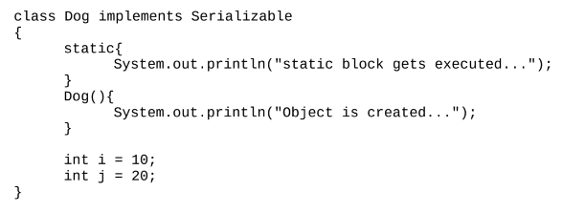

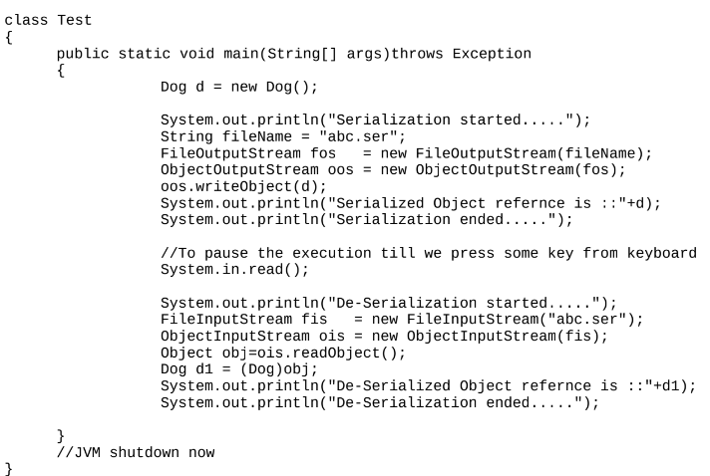

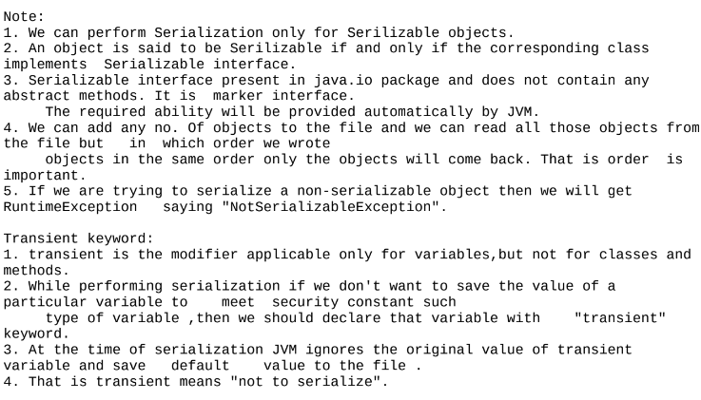

**Externalization:**

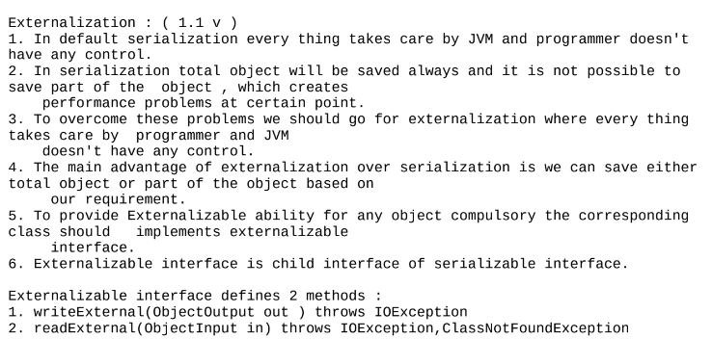

**serialVersionUID:**

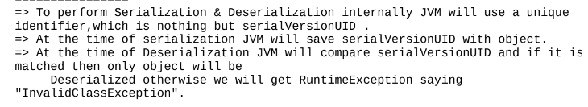



**JDBC:**

For a Java Application(Normal java class or Servlet) if we want to communicate with database, then we need to go for JDBC.

Steps given by SUNMS to communicate with Database:

1. Load and register the Driver.

2. Establish the connection with Database.

3. Create Statement Object and execute the Query.

4. Process the ResultSet.

5. Handle the SQLException if it gets generated.

6. Close the Connection.

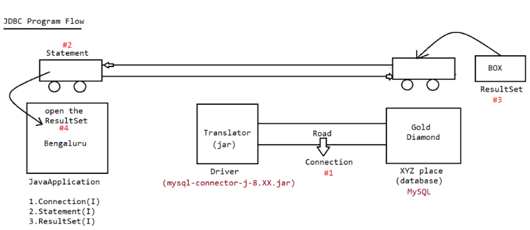

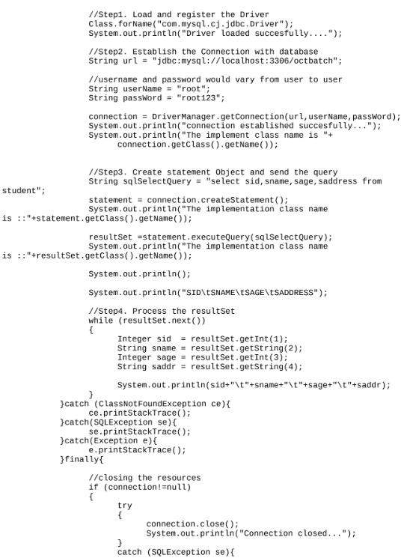

After JDBC4.X we don’t need to load driver class, it will automatically load based on url.

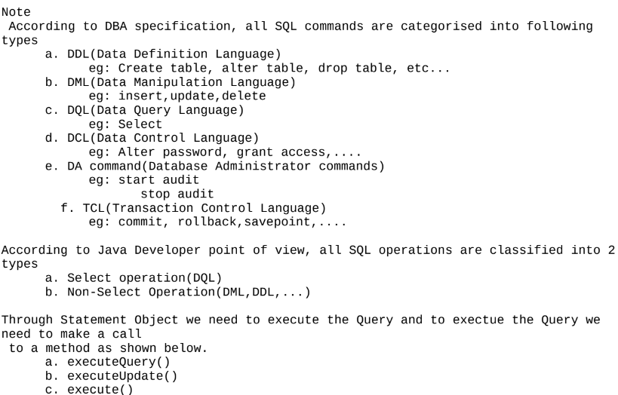

**a. executeQuery():**

This method is used only if we perform select operation. Because of this method execution, we will get a group of records which are represented as "ResutlSet" object.

public ResultSet executeQuery(String sqlSelectQuery) throws SQLException;

eg: ResultSet resultSet =statement.executeQuery("select sid,sname,sage,saddress from student");

**b. executeUpdate():**

This method is used for "Non-Select Operations" like(Insert|Update|Delete)Because of this method execution, we

won't get group of records, we will get a numeric value which represents the number of rows affected. So return type of the method is "int".

public int executeUpdate(String sqlNonSelectQuery) throws SQLException;

eg: int rowAffected = statement.executeUpdate("delete from student where sid = 10");

System.out.println("No of rows affected is :: "+rowAffected);

**c. execute():**

we can use this method for both select and nonselect operation if we don't know the type of query at the begining and if is available dynamically at the runtime then we need to use this method for execution.

public boolean execute(String sql) throws SQLException;

eg: boolean value = statement.execute(dynamicQuery);

if(value == true){

//select Query

ResultSet resultSet = statement.getResultSet();

//process the resultSet

}

else{

//nonSelect Query

int rowCount = statement.getUpdateCount();

System.out.println("Number of rows affected is :: "+rowCount);

}

**PrepardStatement(I):**

public abstract PreparedStatement prepareStatement(String query) throws SQLException;

While using PreparedStatement the query would be as shown below:-

String sqlInsertQuery ="insert into student(`sname`,`sage`,`saddress`,`sgender`)values(?,?,?,?)";

PreparedStatement pstmt = con.prepareStatement(sqlInsertQuery);

//query compiled ready for execution

pstmt.setString(1,"apeksha");

pstmt.setInt(2,26);

pstmt.setString(3,"MI");

pstmt.setString(4,"F");

int rowCount = pstmt.executeUpdate();

**Advantages of PreparedStatement:**

1. Performance is very high performance compared to Statement approach becoz query will be compiled only once.

2. Since we don't send the query multiple times b/w java application and database traffic will be reduced.

3. inputs to the query need not be supplied at the begining dynamically we can supply the inputs.

4. inputs to the query can be supplied just like java style, no need to perform formatting as per the DB specification.

5. Best suitable for inserting Date values.

6. Best sutiable for insertion of BLOB's and CLOB's (image and pdf files).

7. It prevents SQLInjection Attack.

**SQLInjection Attack:**

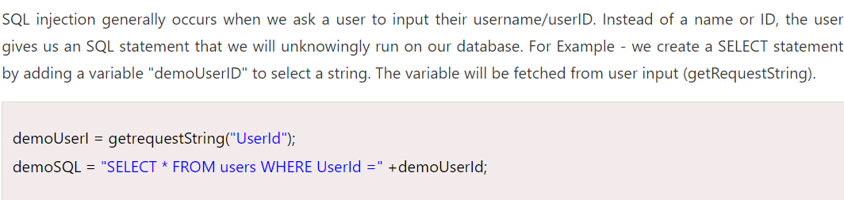

**Static query vs Dynamic query:**

The sql query without positional parameter(?) is called static query.

eg: delete from employee where ename = 'sachin';

The sql query with positional parameter(?) is called dynamic query

eg: delete from employee where ename = ?

select eid,ename,esal from employee where esal > ?

Note:

Simple Statement object can be used for static queries, where as Prepared statement object can be used for static queries and dynamic queries also.

**CallableStatement:**

Statement(I) => Executing the query(Query should be written by java developer)

PreparedStatement(I) => Executing the query(Query should be written by java developer)

CallableStatement(I) => Executing the query(Query will be coded by DBA and present inside database)

If we want to execute only StoredProcedure can we use Statement/PreparedStatement?

Answer: No, we need to use "CallableStatement"

In programming if any code is repeatedly required,we can define the code inside the method and we can call that method multiple times based on our requirement. Hence forth methods are best reusable component in programming.

Similarly in Database programming, if any group of sql statements is repeatedly required then we define those sql statements in a single group and we call that group repeatedly based on our requirement. This group of sql statements that peform a particular task is nothing but "Stored Procedure".

StoredProcedure is the best reusable component at database level.

**StoredProcedure:**

It refers to group of sql statements that peform particular task. These stored procedures are stored permanently in database for future usage and hence the name "Stored procedure".

Usually StoredProcedures are created by DatabaseAdmin(DBA)

Every database has its own language to create StoredProcedures

a. Oracle -> PL/SQL

b. MySQL -> Stored Procedure Language

c. MicrosoftSQLServer -> Transact SQL(TSQL)

**TransactionManagement:**

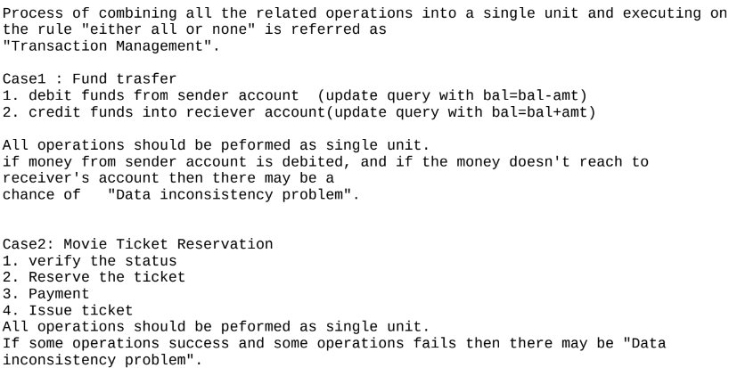

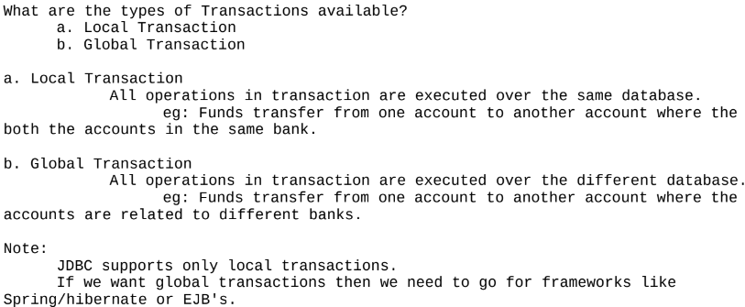



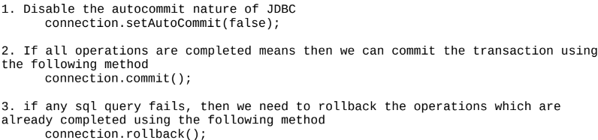

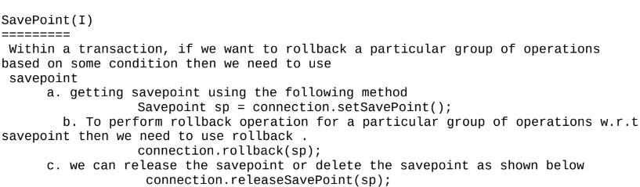

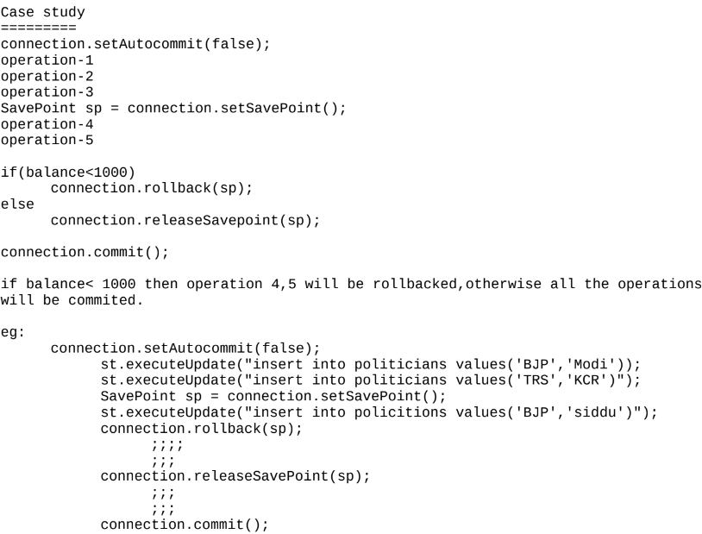

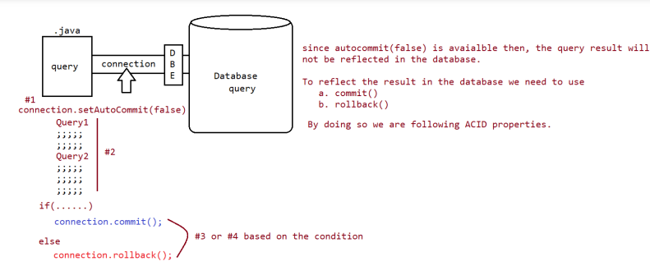

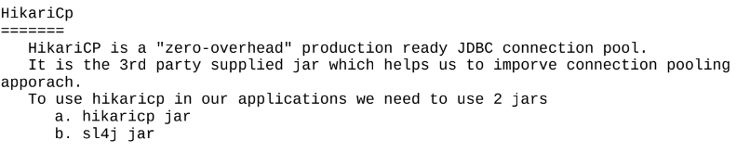

**Transaction Properties:**

Every Transaction should follow the following four ACID properties:|  
 A -> Atomicity  
 C -> Consistency  
 I -> Isolation

D -> Durability

**a. A -> Atomicity**

Either all operations should be done or none.

**b. C -> Consistency**

It should ensure bringing the database from one state to another state. Means total sum of money before transaction and total sum of   
money after transaction should be same.

Before

A- 1000Rs B- 2000Rs Total- (1000 + 2000) => 3000Rs

500 Rs debited from account A and credited to account B.

A- (1000-500)Rs B- (2000+ 500)Rs Total- (500 + 2500) => 3000Rs

The amount is same, it means it is consistent.

**c. I -> Isolation**

It ensures the transactions are isolated from other transactions.

**d. D -> Durability**

It means once the transaction is commited,the results are permanent even in the case of system restart, errors,etc..

## @Transactional Annotation:

In Spring Boot, @Transactional annotation is used to manage transactions in a Spring boot application and used to define a scope of transaction. This annotation can be applied to the class level or method level. It provides data reliability and consistency. When a method is indicated with @Transactional annotation, it indicates that the particular method should be executed within the context of that transaction. If the transaction becomes successful then the changes made to the database are committed, if any transaction fails, all the changes made to that particular transaction can be rollback and it will ensure that the database remains in a consistent state.

***Note:****To use****@Transactional****annotation, you need to configure transaction management by using* ***@EnableTransactionManagement****to your main class of Spring Boot application.*

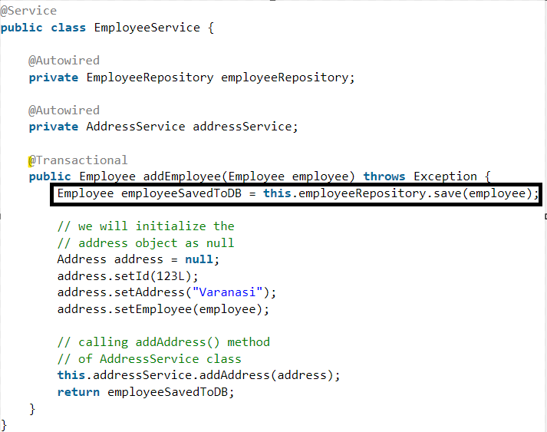

If anything fail inside addEmployee(exception happen) then it will not commit the data, will rollback it.

**Servlet:**

A **standalone application,** also known as a desktop(local system) application is a software program designed in such a way that to run this software program, users **don’t need an internet connection or any server access.** Web-based applications need an internet connection, servers, and any additional resources to run but standalone applications do not require any additional resources such as an internet connection, server, etc.

Eg: Game application which is present in your system and work without internet. Desktop software, Mobile apps, Gaming Applications, Industrial control systems Medical Devices, etc

In conclusion, standalone applications are a type of software program that is designed to **run on a single computer or local machine of the user**, without the need for a server or internet connection. This application provides a number of benefits, such as offline capabilities and greater customization.

**Webapplication:**

webapplication is a server side application, it will be designed without distrubuting application logic over multiple jvm.

To build webapplication we need to use technologies like CGI,Servlet,JSP and so on...

The main purpose of webapplication is to generate dynamic response from server machine.

webapplication provides services to webclients only(using the browser we need to send the request)

eg: BMS(webapp) -------> to send the request to this application u need browser + internet mobile based apps(internet)

Webapplication => client to server model

In case of webapplications to execute the program we need "webservers".

**Distrubuted application:**

Distrubutedapplication is a server side application, it will be designed by distrubuting application logic over multiple jvm.

To build distrubuted application we need to use technolgies like RMI(remote method invocation), EJB's, WebServices,.....

The main purpose of distrubuted application is to establish the communication b/w local machine and remote machine to access the remote services.

Distrubuted applications will provide service to any type of clients.

Distrubutedapplication => buisness to buisness model.

In case of distrubutedapplications to execute the program we need "application servers".

**Webapplication:**

The application which is developed only using web based technologies like html,css,javascript,servlet,jsp etc is called "webapplication"

application ===> collection of many programs

**Webserver:**

if we want webapplications to execute, we need one special software that special software only we call it as "webserver".

webserve provides environment to run webapplications

eg: tomcat,resin,jetty,glassfish,jboss,oracleweblogic server,.....

**Deployment and UnDeployment:**

The process of placing the webapplication inside webserver is called "Deployment".

The process of removing webapplication from the webserver is called"UnDeployment".

**Webclient:**

To send the request from the user we need to have special software installed in the client machine.

The special software is only called as "browser".

eg: mozilla,chrome,safari,........

**Servlet:**

1. **To build web applications using Servlet,** we need to have knowledge of Java properly.

2. Servlet is mainly meant for Processing logic(pick the request and process the request).

3. Any modification done in the Servlet, then we need to perform compilation and reloading on the server explicitly.

4. If we build webapps using MVC design pattern, then Servlet will placed inside Controller logic.

5. In case of Servlet, we are unable to seperate both presentation logic and buisness logic.

**Architecture of Webserver(tomcat):**

Tomcat(https://tomcat.apache.org/download-90.cgi)

1. It is webserver provided by apache foundation.

2. Every webserver will have webcontainer

a. webcontainer is responsible to manage and execute servlet and jsps.

3. Internally webcontainer consists of 2 components

a. catalina container(servlet container)

b. jasper container(jsp container)

4. ServletContainer

It is also known as ServletEngine.

It is responsible for managing and executing servlet components.

Tomcat servlet container name is "CATALINA".

5. JSP container

It is also known as JSP Engine

It is responsible for managing and exeucting

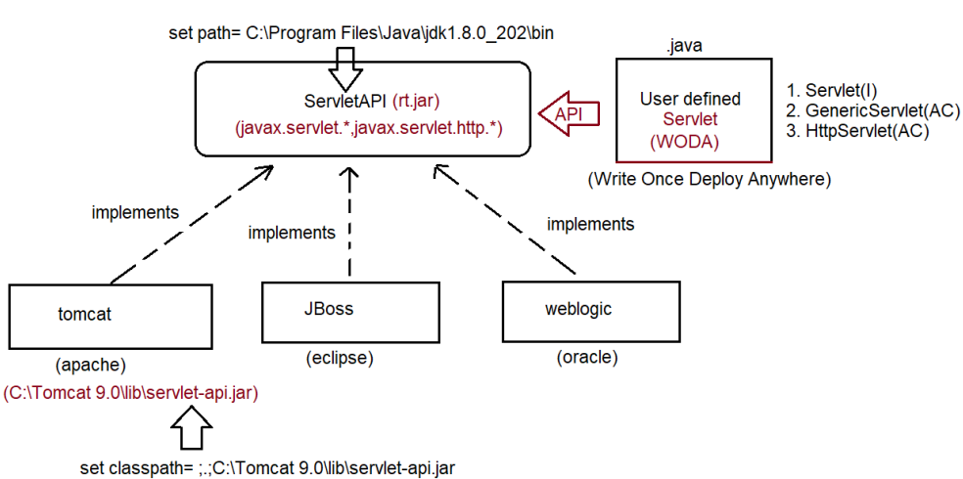

**How to create Servlet in Java?**

To create Servlet in java there are 3 approaches

a. Servlet(I) Interface

b. GenericServlet(AC) Abstract Class

c. HttpServlet(AC) Abstract Class

**Servlet(I):**

public interface Servlet {

public abstract void init(ServletConfig config) throws ServletException;

public abstract ServletConfig getServletConfig();

public abstract void service(ServletRequest request,ServletResponse response) throws ServletException, IOException;

public abstract String getServletInfo();

public abstract void destroy();

}

Whenever we write Servlet,Automatically for the written servlet container will perform the following actions:

Depending on the url pattern supplied by the user for a dynamic resource(When we hit servlet then only it will load initially(once)).

a. Servlet Loading will happen ===========> static block will be executed.

b. Servlet Instantiation will happen ========> constructor will be called and object will be created.

c. Servlet Initialization will happen ========> void init(ServletConfig config) throws ServletException

d. Serlvet Request Processing will happen ===> void service(ServletRequest request,ServletResponse response) throws ServletException,IOException

e. Servlet De-Instantiation will happen =====> void destroy();

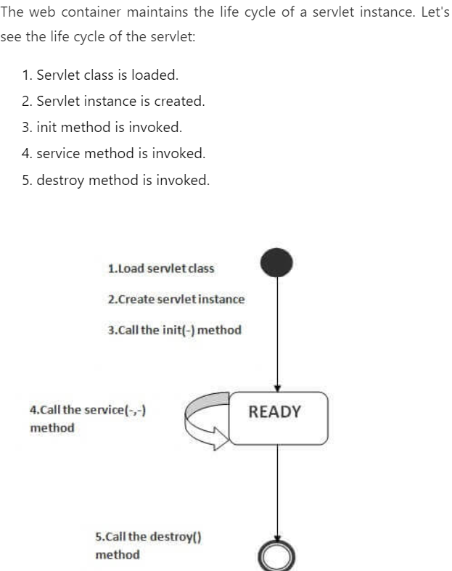

**Standard folder structure of webapps to deploy in tomcat server:**

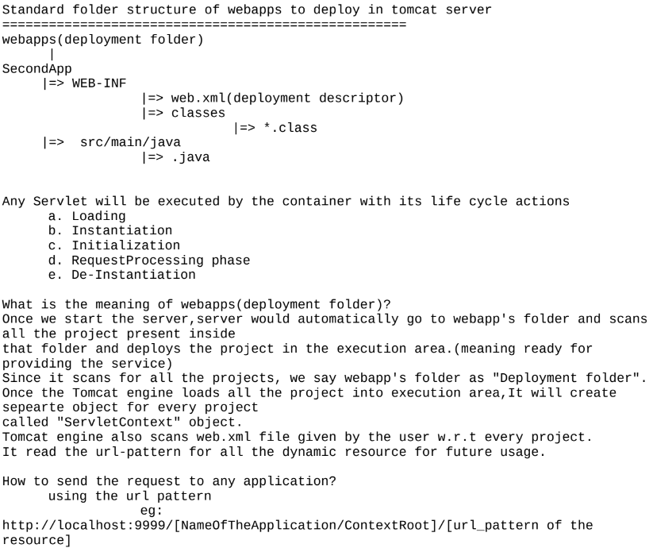

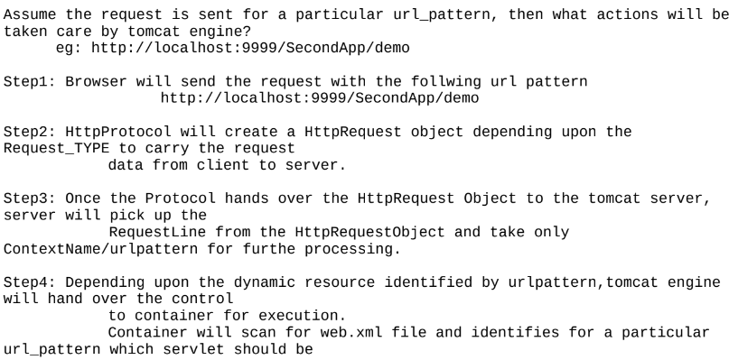

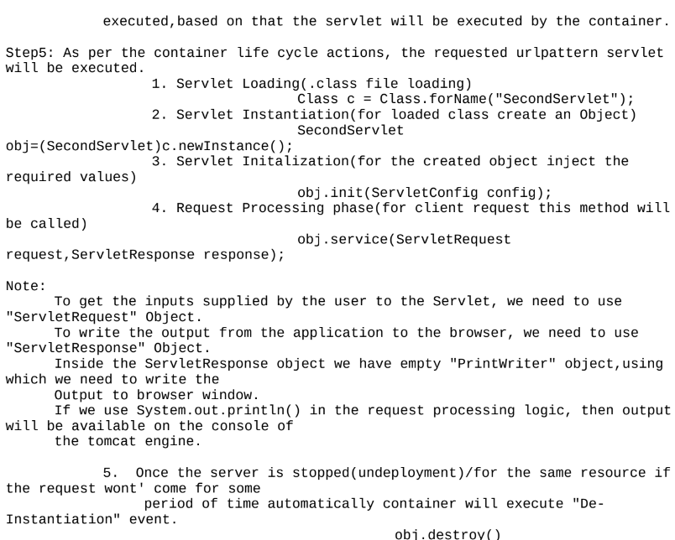

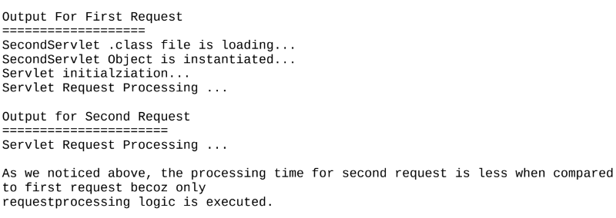

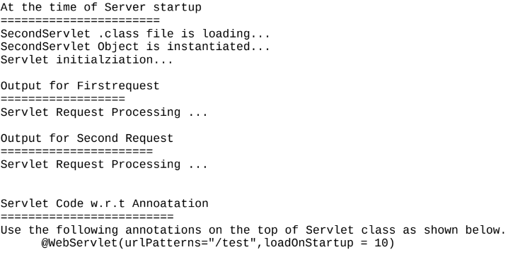

**Limitation of implementing Servlet interface:**

If we create a servlet using Servlet(I), then it is mandatory for us to give the implementation for all the methods of the interface whether it is required or not. Becoz of this length of the code would increase and it decreases the readability. To Overcome this problem we need to use "**GenericServlet**".

GenericServlet has already implemented Servlet Interface and it gives body for all the methods of Servlet interface

except service().

if we use GenericServlet to create a Servlet, then we need to give body only for service() as a result of which the

lines of code would be less, which increase the readablity of the application.

Compiled from "GenericServlet.java"

public abstract class GenericServlet implements Servlet,ServletConfig,Serializable{

public GenericServlet();

public void init(ServletConfig config) throws ServletException;

public void destroy();

public ServletConfig getServletConfig();

public ServletContext getServletContext();

public String getServletInfo();

public void init() throws javax.servlet.ServletException;

**public abstract void service(ServletRequest req, ServletResponse resp) throws** ServletException,IOException;

public java.lang.String getServletName();

}

Note:

GenericSevlet is an best example for "Adapter class design pattern". init() is overloaded in GenericServlet.

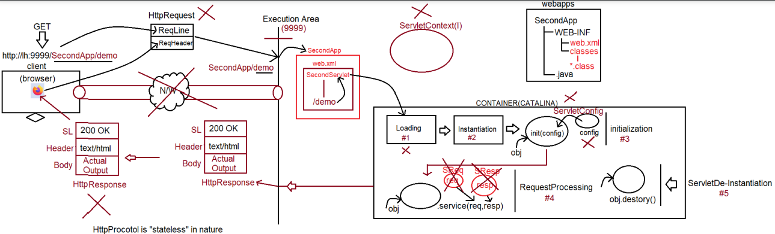

We can build Servlet in a easier way with the help of GenericServlet, then y need **HttpServlet**(AC)?

Ans. In case of GenericServlet(AC), to process the request we have only one method(pvs(req,resp)) which is generic for any type of request like GET,POST,....

Becoz there is only one method available which is generic for any type of request,Debugging the application becomes difficult. henceforth to deal with only Httpprotocol, we have a special approach to create a servlet called "**HttpServlet**".

Note:

C:\Users\nitin>javap javax.servlet.http.HttpServlet

Compiled from "HttpServlet.java"

public abstract class HttpServlet extends GenericServlet {

protected void doGet(HttpServletRequest request, HttpServletResponse response) throws ServletException,IOException;

protected void doPost(HttpServletRequest request,HttpServletResponse response) throws ServletException,IOException;

protected void service(HttpServletRequest request, HttpServletResponse response) throws ServletException,IOException;

public void service(ServletRequest request, ServletResponse response) throws ServletException,IOException;

}

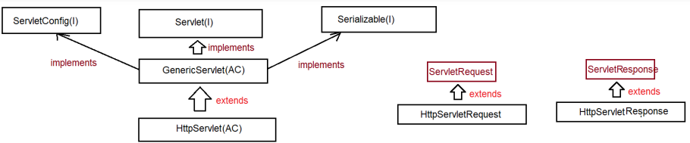

**ServletConfig(I):**

1. Loading ======> static block

2. Instantiation ===> Object obj = Class.forName(String urlPattern).newInstance();

Object will be created for the loaded class using Zero parameterized constructor.

3. Initialization ====> For the created Servlet object, we can initialize the value using init(ServletConfig config)

**ServletConfig:**

This object will be used to initialize the values for the loaded servlet.

How to initialize the value of ServletConfig object?

To initalize the value of ServletConfig object, we need to configure the container.

Container can be configured in 2 ways

a. XML

web.xml:

<servlet>

<servlet-name>InitializationParamterApp</servlet-name>

<servlet-class>in.ineuron.controller.InitializationParamterApp</servlet-class>

<init-param>

<param-name>name</param-name>

<param-value>sachin</param-value>

</init-param>

<init-param>

<param-name>age</param-name>

<param-value>49</param-value>

</init-param>

<init-param>

<param-name>address</param-name>

<param-value>MI</param-value>

</init-param>

</servlet>

b. Annotations:

@WebServlet(urlPatterns = {}, loadOnStartup= 10, initParams = {

@WebInitParam(name = "url", value ="jdbc:mysql:///octbatch"),

@WebInitParam(name = "user", value = "root"),

@WebInitParam(name = "password", value ="root123")

}

**Why there is no main method in Servlets??**

JVM has be designed to make a call to main method with the following prototype to start the execution

public static void main(String[] args)

If the application is standalone application then jvm will come into picture so we need main method to start the execution. If the application is webapplication, then container will execute our java code based on its life cycle actions like

a. Loading

b. Instantiation

c. Initalization

d. RequestProcessing

e. De-Instantiation

Since jvm does not play vital role to start the execution we don't need "main method" in Servlets.

**SessionTracking mechanism:**

**HttpSessionTracking:**

When browser hit request for first time then:

HttpSession objects are created manually, and for these objects container will maintain unique ID in the form of HexaDecimal value called SessionID.

Container will prepare Session id value in the form of key called "JSessionID". Container will create a cookie and attach the session id to send it as a response to the browser every time when the interaction happens b/w client and server. When we use request.getSession(), container will get the sessionid and checks whether that user specific object is available or not, if avaiable it will identify that object to process the data.

**Note**: we can destroy the HttpSession object manually using the method called **public void invalidate()**.  
  
SessionId and its value will be store at server side in form of key-value pair. We fetch value based on sessionId we get from request. For first time, we validate the request and create sessionId and pass it in response.  
  
Drawback:

1. Session id will stored in the form of cookie and in client side if browser disables the cookie HttpSessionTracking mechanism won't work.

2. Maintainence of Session object is at the server side which would be burden to the server.

eg: jSESSIONID = .........DBEFH

3.Creating HttpSession object w.r.t client at the server side is too costly which would decrease the performance of the application(managing the session object at the server side).

**CookieSessionTracking:**In case of Cookie Session Tracking mechanism, we need to create a cookie for every request data w.r.t every user.

After creating a cookie, we need to send this cookie along with response object. These cookies will be exchanged b/w client and server in the form "request-

response" object.

To Create a cookie we use: public Cookie(String key,String value)

To retreive the cookies we use request object: public Cookies[] getCookies()

To add the cookies to response object we use public void addCookie(Cookie c)

Drawback:

1. Cookies will be stored in the client side and if browser disables the cookies then we can't keep track of client data.

2. Since cookies are used to store the client data,it might result in "Security Breach".

**URLRe-Writing Mechanism:**

1. This mechanism is same as "HttpSessionTracking" mechanism, but sessionid won't be stored inside cookie rather the sessionId will be appended to the url everytime when the request-response happens b/w client and server.

eg: <form method ="get" action='"+response.encodeURL('./second')+"'>

</form>

|

./second?JSESSIONID = .......

Here also data store in key-value pair in server side but in response, we are not sending as a cookie, we send in response and same sessionId we append in every request for tracking.

**Filters/Interceptors:**

It can be used for PreProcessing and PostProcessing of the request before they reach the target resource in the web application.

**Areas of Application:**

Logging, Security,Altering Request information, Compressing response,encryption of response,authenication etc...

Filters Concpets introduced in Servlet 2.3V

FilterApi contains 3 interfaces

1. Filter(I)

2. FilterConfig(I)

3. FilterChain(I)

To create a filter we need to implement Filter(I):

public interface Filter {

public void init(FilterConfig config) throws ServletException;

public abstract void doFilter(ServletRequest request, ServletResponse response, FilterChain chain) throws IOException, ServletException;

public void destroy();

}

**Hibernate:**

When we already have JDBC Techology, What is the need to go for framework/tool called ORM?

**Limitations of JDBC:**

**1.** If we use JDBC to develop persistence logic, we need to write sql queries by following the syntax of "Database". DBQueries are specific to Database, this makes JDBC not portable across mulitple databases.

**2.** JDBC technology if we use and write a code, there would be a boiler plate code in our application.

Boiler plate code => A code which would repeat in multiple parts of the project with no change/small change is called boiler plate code.

CRUD:

1. Load and register the driver(automatic from JDBC4.X)

2. Establish the connection

3. Create PrepareStatement

4. Execute the Query

5. Process the ResultSet

6. Handle the Exception

7. Closing the Resource

Step1,2,3,6,7 boiler plat code becoz it is a common logic.

**3.** JDBC technology throws only one Exception called "SQLException', but it is a CheckedException which means u should have handling logic otherwise code would not compile.

a. try{...}catch(SQLException e){...}

b. public static void main(String... args) throws SQLException{}

**4.** JDBC technology has only Exception class called "SQLException",so we don't have detailed hierarchy of Exceptions related to different problems.

**5.** JDBC ResultSet object is not serializable, so we can't send it over the network, we need to use Bean/POJO to send the data over the network by writing our own logic.

**6.** While closing the jdbc connection object, we need to analyze the code allot otherwise it would result in "NullPointerException".

eg:

Connection con = DriverManager.getConnection(url,user,password)

if(con!=null){.....}

closing the connection object should take place in "finally" block only.

To make the usage of AutoCloseable, we need to know the syntax of "try with Resource".

**7.** Java ====> OOP's based language

Assume we need to send Student object to database, can we write a logic of Database query at Object level if we use JDBC?

No, Not possible becoz DBqueries always expectes the value,but not the object directly.

**8.** JDBC doen't have good support of Transaction Management

a. local

b. global(no support in JDBC)

**9.** JDBC supports only positional parameters,it is difficult for the user to inject the values,It doesnot support namedparamaters.

String sqlInsertQuery = "insert into student(`name`,`email`,`city`,`country`) values(?,?,?,?)";

String sqlInsertQuery = "insert into student(`name`,`email`,`city`,`country`) values(:name,:email,:city,:country)";

**10.** To use JDBC, Strong knowledge of SQL is required.

**11.** JDBC does not supports versioning, timestamp as inbuilt features

versioning:: keeping track of how many times record got modified.

timestamp:: keep track of when record was inserted and when lastly it was modified.

**12.** While developing persitence logic using JDBC, we can't enjoy oops features like

a. inheritance

b. polymorphism

c. composition

because jdbc does not allow objects as input values in sqlqueries. Solution to all these problems is use "**ORM**".

**ORM:- (ORM stands for ): Object Relational Mapping.**

It is a theory concept used at database programming to perform operations like insert. Update, delete and select in object format only ie. JDBC converts object to primitive data and SQL Query should be written by programmer using primitives, which is not following OOPs.

ORM says “Do not convert object data, do operations in OOPs. Format only”.

For this concept programmer should follow mapping rule. Given as

1. className- Must be mapped with – tableName

2. VariableName- Must be mapped with – columnName

** should be done by programmer using XML/Annotations concept.

** Then ORM convert Object ROW ⬄

** Here , ORM only generates SQL Query

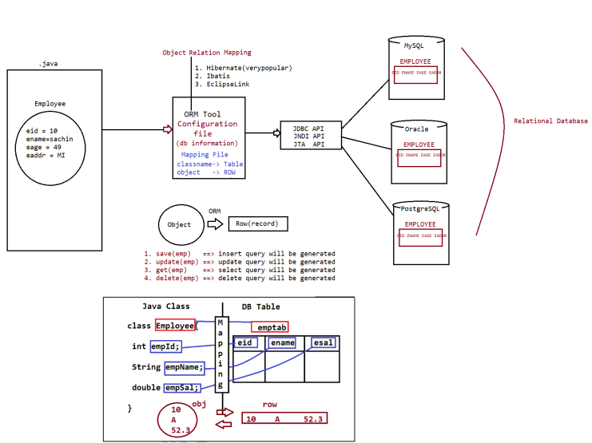

**HibernateArchitecture:**

Hibernate Configuration File will provide all the configuration details like driver class name, driver URL, Database User name , Database password,.... which we required to establish connection with database and to setup JDBC environment.

Hibernate Mapping file will provide all the mapping details like Bean Class name and Database table name, ID property and Primary key column , Normal Properties and Normal Columns,....

**When Client Application perform persistence operation, Hibernate Software will perform the following actions.**

**1) Hibernate Software will take persistence method call and identify persistence Object.**

**2) Hibernate Software will take all mapping details from hibernate mapping file like database table name and all column names on the basis of Persistence object.**

**3) Hibernate Software will prepare database dependent sql query on the basis of table names and column names and with the persistence object provided data.**

**4) Hibernate Software will execute the generated database dependent sql query and perform the required persistence operation.**

In Hibernate applications, the standard name of hibernate configuration file is "hibernate.cfg.xml", it is not fixed, we can provide any name but that name must be given to Hibernate software. In Hibernate applications, we are able to provide more than one configuration file but, for each and every database, that is,

in hibernate applications if we use multiple databases then we are able to prepare multiple configuration files.

**Prepare Hibernate Client Application:**

The main intention of Hibernate Client application is to activate Hibernate Software, creating persistence objects and performing Persistence operations.

To prepare Client Application in hibernate applications we have to use thefollowing steps.

1. Create Configuration class object

2. Create Session Factory object

3. Create Session Object

4. Create Transaction object if it is required.

5. Perform Persistence operations

6. Close Session Factory and Session objects.

**1. Create Configuration class object:**

In Hibernate, the main intention of Configuration object is to store all the configuration details which we provided in hibernate configuration file. To represent Configuration object Hibernate has provided a predefined class in the form of "org.hiberante.cfg.Configuration". To create Configuration class object we have to use the following constructor from Configuration class.

EX: Configuration cfg = new Configuration();

If we use the above instruction in Hibernate applications then we are able to get an empty Configuration object in heap memory, it will not include any Configuration details. If we want to store Configuration details from Configuration file we have to use either of the following methods.

1. public Configuration configure()

This method will get configuration details from the configuration file with the name hibernate.cfg.xml.

2. public Configuration configure(String config_file_Name)

This method can be used to get configuration details from hibernate configuration file with an name, it will be used when we change configuration file name from hibernate.cfg.xml file to some other name .

3. public Configuration configure(File file)

This method can be used to get configuration details from a file which is represented in the form of java.io.File class object.

4. public Configuration configure(URL url)

This method can be used to get Configuration details from a file which is available in network represented in the form of java.net.URL .

EX: Configuration cfg = new Configuration();

cfg.configure();

When we use configure() method then Hibernate Software will search for hibernate.cfg.xml file, if it is available then Hibernate software will load the content of hibernate.cfg.xml file, parse it and read content from configuration file to Configuration object.

**2. Create Session Factory object:**

In Hibernate, **the main intention of Session Factory object is to manage Connections, Statements, Cache levels,** **.... and it able to provide no of Hibernate Session objects**. To represent Session Factory object Hibernate has provided a predefined interface in the form of "org.hibernate.Session Factory". To get Session Factory object we have to use the following method from Configuration class.

public Session Factory buildSessionFactory()

EX: SessionFactory sf = cfg.buildSessionFactory();

In Hibernate applications, if we use multiple Databases then we have to prepare multiple Configuration files, multiple Configuration Object, w.r.t this, we have to prepare multiple Session Factory objects. Session Factory object is heavy weight and it is thread safe upto a particular Database, because, it not able to allow more than one thread at a time.

**3. Create Session Object:**

In Hibernate, **for each and every database interaction a separate Session will be created.** In Hibernate, Session is able to provide no of persistence methods in order to perform persistence operations. To represent Session object, Hibernate has provided a predefined interface in the form of "org.hibernate.Session". To get Session object, we have to use the following method from Session Factory.

public Session openSession()

EX: Session s =sf.openSession();

In Hibernate, Session object is light weight and it is not thread safe, because, for each and every thread a separate Session object will be created.

**Difference b/w Session Object vs SessionFactory object?**

SessionFactory

It is a heavy weight object containing multiple other objects like DataSource, Dialect, TxFactory, generators etc.

**It is a immutable Object.**

ThreadSafe Object is by default.

Created by using buildSessionFactory() method which is designed based on "builder" design pattern.

Long Lived Object of the application.

It maintains Level-L2 cache.

Session

It is a Light Weigth Object(con++)

**It is a mutable Object.**

Not ThreadSafe by default.

Created by using openSession() which is designed based on 'factory' design pattern.

S1 cache.

hort lived Object of the application.

It maintains Level-L

**4. Create Transaction Object:**

Transaction is a unit of work performed by Front End applications on Back end systems. To represent Transactions, Hibernate has provided a predefined interface in the form of "org.hibernate.Transaction". To get Transaction object we will use either of the following methods.

1. public Transaction getTransaction()

It will return Transaction object with out begin, where to begin Transaction we have to use the following method.

public void begin()

2. public Transaction beginTransaction()

It will return Transaction and begin Transaction. In Hibernate applications, after performing persistence operations we must perform either commit or rollback operations inorder to complete Transactions, for this, we have to use the following methods from Transaction.

**5. Perform Persistence Operations:**

In Hibernate applications, to perform persistence operations Session has provided the following methods. Through hibernate we can perform

a. SRO(Single Row Operation)

a. save()/persist() ========> Insert Operation

b. get()/load() ========> Select Operation

c. update()/saveOrUpdate() => Update Operation

d. delete() =========> Delete Operation

b. Bulk operation(working with mulitple records)

a. HQL/JPQL

b. NativeQuery

c. Criterian API

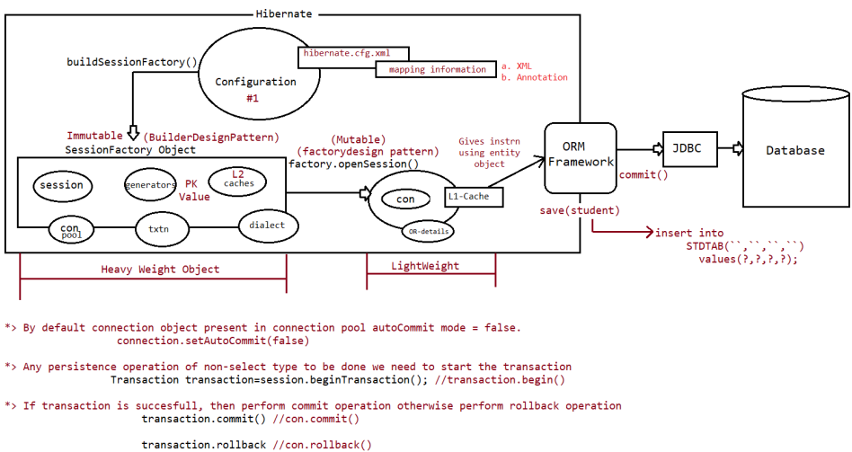

By creating object of transaction it will reflects the changes in database for non-select query by doing commit and rollback

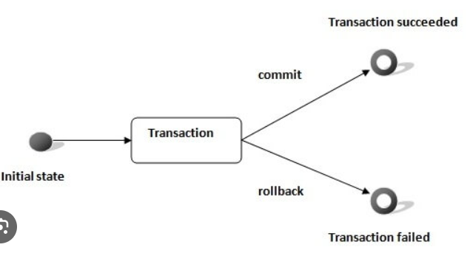

SRO(Single Row Operation)

a. save()/persist()

b. get()/load()

c. update(),saveOrUpdate()

d. delete()

**a. save()/persist()**

These methods are used to perform insert operation.

What is the difference between save() method and persist() method?

Ans: In Hibernate applications, **save()** method can be used to insert a record into the Database table and it will **return Primary Key** value of the inserted record.

This method is from hibernate api.

public Serializable save(Object obj) throws HibernateException

In Hibernate applications, **persist()** method can be used to insert a record into database table and it will **not return any value**. This method is from JPA specification.

public void persist(Object obj)throws HibernateException

**Note:**

**@DynamicInsert(value=true) and @DynamicUpdate(value=true)**

=> It is used to generate the dynamic query, based on the fields used in the Entity Object

=> If we want our table name and column name to be same as entity name and field name then no need to use @Table(name='') and @Column(name='',length='')

=> During the creation of SessionFactory object, by refereing to mapping information hibernate will create pregenerated sql queries for insert, update, delete, select by using all the fields of the entity class.

=> If we want to avoid that and if we want query to be generated based on the field injection we do on the entity class

then we need to use @DynamicInsert(value='true') or @DynamicUpdate(value='true')

**b. get()/load()**

What are the differences between **get(-)** method and **load(-)** method?

Ans: 1. **get()** method can be used to retrive a record from database table if the record is existed. **If the required record is not existed then get() method will return null value.**

public Object get(String class_Name, Serializable pk_Val)

public Object get(Class class_Type, Serializable pk_Val)

2. **get()** method is able to perform eager or early loading, that is, it will interact with database directly and it will retrive data and return to Hibernate application in the form of Object on the method call.

1. **load()** method can be used to retreive a record from database table if the record is existed. **If the required record is not existed then load() method will rise an Exception like HibernateException.**

public Object load(String class_Name, Serializable pk_Val)

public Object load(Class class_Type, Serializable pk_val)

2.**load()** method will perform Lazy or late Loading , that is, when we access load() method then a duplicate object will be created with the primary key value without interacting with database(proxy object). When we use other properties of the Object then only it will fetch data from database table and return that data to Java application.

**c. update(),saveOrUpdate()**

**updating** a record can be done in 3 ways:

a. update total object(not prefered) remember the object exists with the id and update the entire object. if the id doesn't exists it would return 'OptimisticLockException'.

b. load the record and update(very useful for partial updation)

c. load and modify the record without using update()[Synrhonization would exist b/w row and object]

**saveOrUpdate()**

This method call would first perform

a. select operation if record found then it performs update operation, otherwise it performs insert operation

What is the difference between update() method and saveOrUpdate() method?

Ans: Where update(-) method will perform updation on a record in database table if the specified record is existed otherwise it will rise an Exception.

public void update(Object obj) throws HibernateException

Where saveOrUpdate(-) method will insert the specified record in database table if the specified record is not existed. If the specified record is existed in database table then it will update the record.

public void saveOrUpdate(Object obj) throws HibernateException

**d. delete()**

It can be done in 2 ways

a. perform deletion by supplied id value directly It generates sql select query, if the record exists it would generate delete query, otherwise it won't generate delete query and it won't throw any Exception.

b. load and delete the record[prefered].

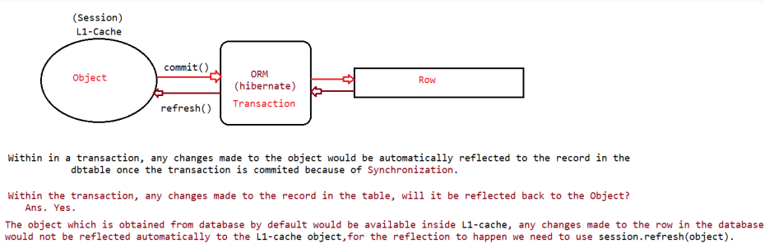

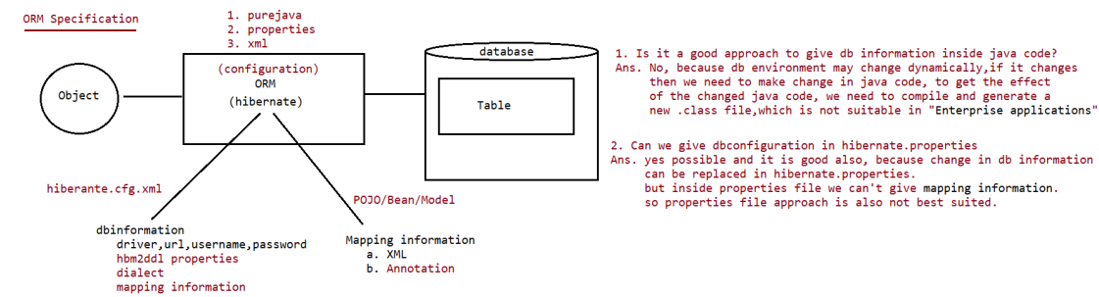

Note:

If we are using MySQL,best suited is "GenerationType.IDENITY".

If we are using Oracle,best suited is "GenerationType.SEQUENCE".

If we are not aware of what databse algorithm supports to generate primary key then go for "GenerationType.AUTO".

**Versioning:**

=> To keep track of how many times object/record is loaded and modified using hibernate.

=> It generates the special column of type numeric based special number property of Entity class to keep track of modification

=> This special property will be initialized to zero and it will incremented for every updation.

=> To configure this property we need to use @Version annotation.

eg:

**@Version**

**private Integer versionCount;**

**Caching in hibernate:**

=> It is most important feature/benefit of hibernate.

=> It reduces the no of trips b/w application and database, it improves the performance of the application.

=> Hibernate maintains cache at 2 levels, so it improves the peformance.

=> When an application wants the data from the database, then hibernate looks for the object at the L1-cache, if not then it looks for the object at L2-cache and if not then it would go for "database".

Methods associated with cache are

a. session evict(object) => To remove particular object from cache.

b. session.clear() => To clean the cache or to remove all objects from cache.

c. session.contains(object) => To check particular object exists in the cache. L1Cache(inbuilt cache). This cache is associated with session object, we can't disable it as it is inbuilt present in Session object.

L2Cache(configurable cache)

It is associated with SessionFactory object,so it is called as "GlobalCache". It is configurable cache which we can enable/disable. We have multiple providers supporting L2Cache:

a. EH_cache(It support inmemory and diskcaching)

b. swarmcache

c. oscache

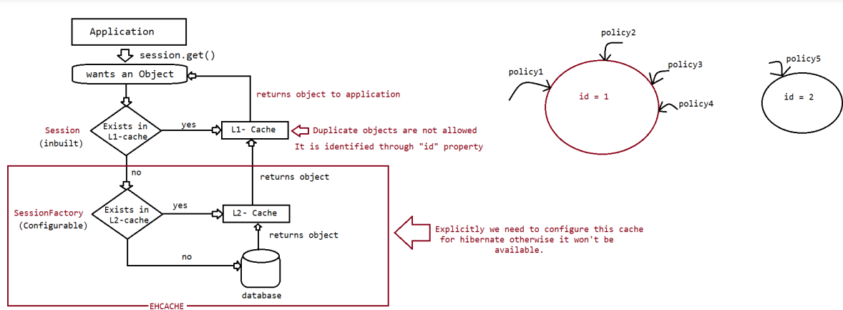

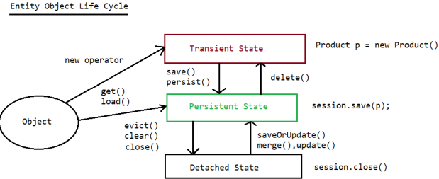 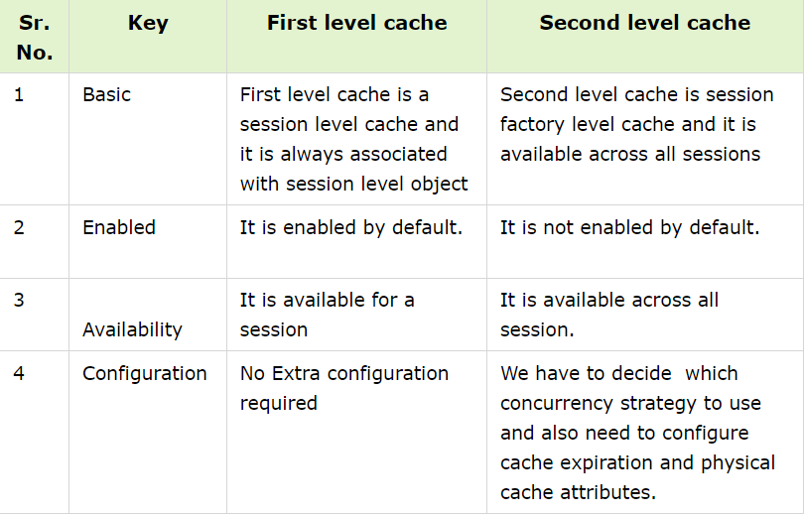

**Transient state:**

Here the object of the Entity not bound or linked with Session object. Here the object don't have id value and it doesn't hold /represent any Db table data.

eg: Product p = null;

Product p = new Product();

**Persistent State:**

Here the object is linked with Session.its placed in L1 cache of Session Object. Contains id value and it represents the record in the db table having

synchornization. All persistence operations takes place by bringing Object into this state.

eg: save(),saveOrUpdate(),load(),get(),persist()

**Detached State:**

Previously persistent ,but not now. Contains id value, but does not represents the record in the db table and it does not maintain synchornization also.

session.close(),session.clear(),session.evict()

eg: Product p =new Product();//p-> Transient state

session.save(p);//p -> persistent state transaction.commit()

session.close()//Detached state

**Locking:**

If multiple threads/app's simultaneously accessing and manipulating the records then there is a possibility of getting concurrency problem. To avoid this problem, we need to lock the record in hibernate.

Locking can be done in 2 ways

**a. optimistic locking**

=> Allows second thread/apps simultaneously to access and modify the record, first app notices the modification and throws Exception

=> To use this feature we need to enable @Version annotation in entity class.

**b. pesimistic locking**

=> First thread/app locks the record,so if the second thread tries to access and modify the record then it would result in "Exception".

=> To use this feature we need to use session.get(,,LockMode.UPGRADE_NOWAIT) as the third argument value.

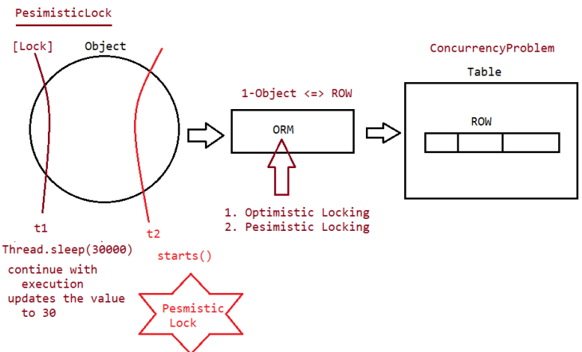

**SOLID Principles:**

## Single Responsibility:

This principle states that “**A class should have only one reason to change**” which means every class should have a single responsibility or single job or single purpose. In other words, a class should have only one job or purpose within the software system.

Eg:   
1. Imagine a baker who is responsible for baking bread. The baker’s role is to focus on the task of baking bread, ensuring that the bread is of high quality, properly baked, and meets the bakery’s standards.

However, if the baker is also responsible for managing the inventory, ordering supplies, serving customers, and cleaning the bakery, this would violate the SRP

2. Service class should have only logic not a dao layer code.

## Open/Closed Principle:

This principle states that “Software entities (classes, modules, functions, etc.) should be open for extension, but closed for modification” which means you should be able to extend a class behavior, without modifying it.

Imagine you have a class called PaymentProcessor that processes payments for an online store. Initially, the PaymentProcessor class only supports processing payments using credit cards. However, you want to extend its functionality to also support processing payments using PayPal.

Instead of modifying the existing PaymentProcessor class to add PayPal support, you can create a new class called PayPalPaymentProcessor that extends the PaymentProcessor class. This way, the PaymentProcessor class remains closed for modification but open for extension, adhering to the Open-Closed Principle

## Liskov’s Substitution Principle:

If class *A* is a subtype of class *B*, we should be able to replace *B*with *A*without disrupting the behavior of our program. **The principle defines that objects(no object reference) of a superclass shall be replaceable with objects of its subclasses without breaking the application.**

In simple words,

* Objects of a superclass should be able to be replaced with objects of a subclass without affecting the program.
* Object of subclass should be able to access the all the methods and properties of the superclass.

Let’s explore two examples.

## Example 1:

Here, Green is a base super class of Blue. When a new object of Blue will be assigned in object of Super class, **getColor()**of Green will be replaced by **getColor()**of Blue according to inheritance rules of OOP. In this situation, we are expecting “Green” color from **Green**class but we are getting “Blue” color from **Green**color. So the design of class is violating the LSP.

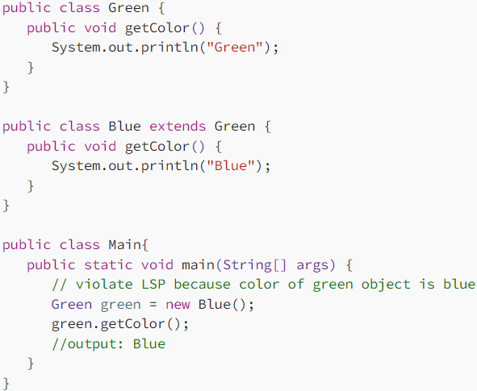

In the main method, green object is asking for color but it’s getting “Blue” color. How to solve the issue. See the solution.

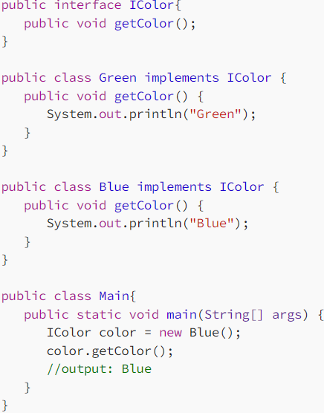

## Example 2:

Here, “Fly()” and “walk()” are the actions of Bird class. Penguin inherits the Bird class but Penguin can not fly. As a child class Penguin can not use the fly. So design of class can not satisfy the LSP rules.

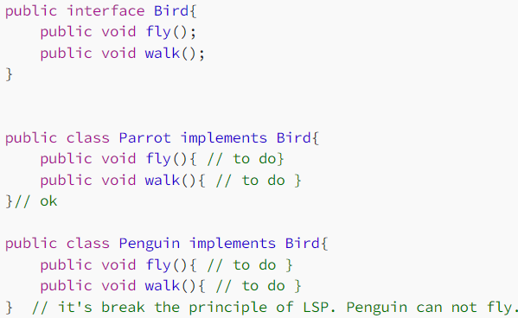

In the above example, object of Penguin can not access the fly method. . So we can solve the problem below way.

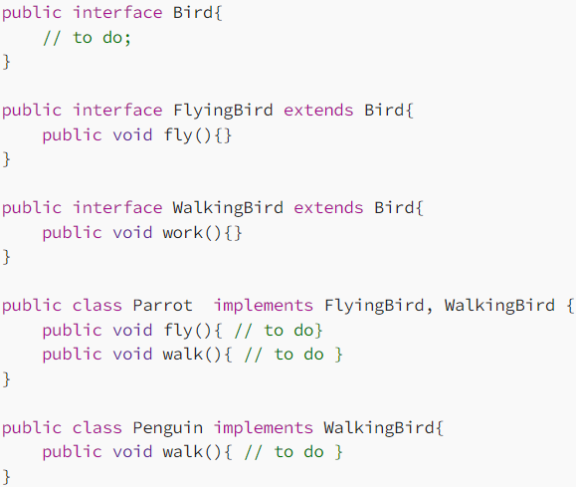

Summary: Agar mein parent child ka object create krta hoo aur method call krta hoo toh uska kuch result aayega but agar mein child class ka object create krta hoo aur phir method call krta hoo toh uksa result different(differnt matlb ki woh koi eror de rha hai ua woh method child ke liye nhi hai just like penquin example) aayega parent wale result se, means woh liskov ko follow nhi kr rha.

Green g1 = new Green();

g1.getColor(); // Green

Green g2 = new Blue();

g2.getColor(); // Blue voits Liskov rule.

## Interface Segregation Principle:

This principle is the first principle that applies to Interfaces instead of classes in SOLID and it is similar to the single responsibility principle. It states that “**do not force any client to implement an interface which is irrelevant to them**“. Here your main goal is to focus on avoiding fat interface and give preference to many small client-specific interfaces. **You should prefer many client interfaces rather than one general interface** and each interface should have a specific responsibility.

**Eg:**

Suppose if you enter a restaurant and you are pure vegetarian. The waiter in that restaurant gave you the menu card which includes vegetarian items, non-vegetarian items, drinks, and sweets.

In this case, as a customer, you should have a menu card which includes only vegetarian items, not everything which you don’t eat in your food. Here the menu should be different for different types of customers.

## Dependency Inversion Principle:

The Dependency Inversion Principle (DIP) is a principle in object-oriented design that states that “**High-level modules should not depend on low-level modules. Both should depend on abstractions**“. Additionally, abstractions should not depend on details. Details should depend on abstractions.

* In simpler terms, the DIP suggests that classes should rely on abstractions (e.g., interfaces or abstract classes) rather than concrete implementations.
* This allows for more flexible and decoupled code, making it easier to change implementations without affecting other parts of the codebase.

Eg:

In our shopping cart example, we have applied this principle by creating an interface  PaymentProcessor that defines the methods a payment processor should have. This allows the ShoppingCartService class, a high-level module, to depend on the PaymentProcessor interface rather than on a specific implementation of a payment processor.

class ShoppingCartService{ // HLmodule

private PaymentProcessor paymentProcessor; // LLmodule

}

**Design Pattern(Theory):**

A design pattern is **a general repeatable solution to a commonly occurring problem in software design**.

In core java, there are mainly three types of design patterns, which are further divided into their sub-parts:

**1.Creational Design Pattern**

Factory Pattern

Singleton Pattern

Prototype Pattern

**2. Structural Design Pattern**

Adapter Pattern

Bridge Pattern

Composite Pattern

**3. Behavioral Design Pattern**

Iterator Pattern

Template Pattern

StrategyPattern

**Singleton Pattern:**Singleton Pattern says that just**"define a class that has only one instance and provides a global point of access to it".**

In other words, a class must ensure that only single instance should be created and single object can be used by all other classes.

**EagerSingleton: LazySingleton: MultiThreadSingleton:**

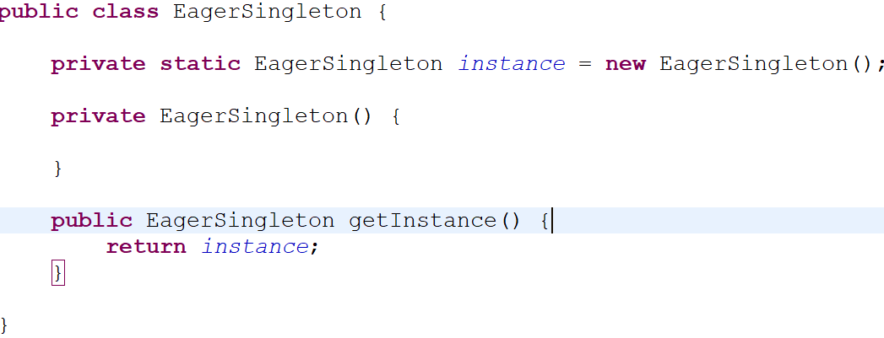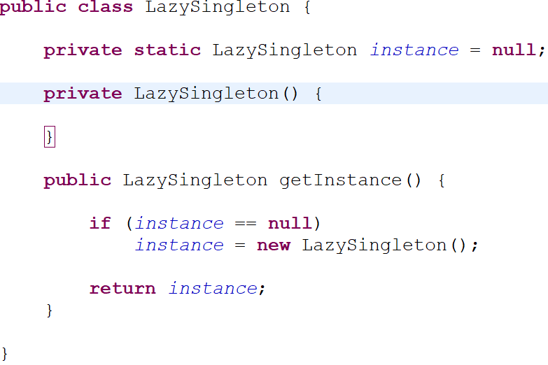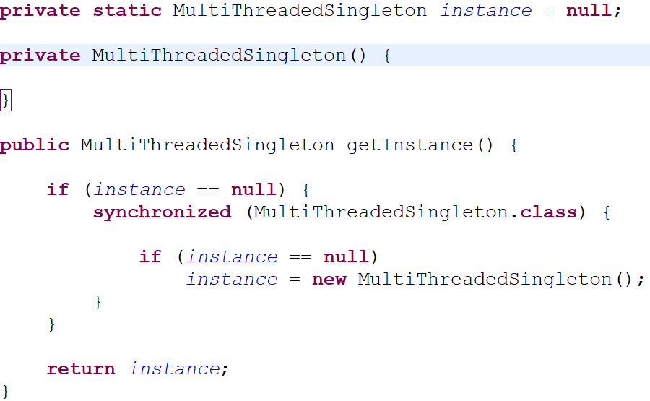

Object created when class load.  Object created when required**.** When two or more thread call this method sametime then multiple object creates i.e., use synchronize block to allow one thread can work at a time.

Note:

getInstance() method should be static.

**How to break singleton design patterm?**

1. Multithreading: when two or more thread call getInstance() method same time then multiple objects create which break singleton pattern to prevent this we use synchronize block.

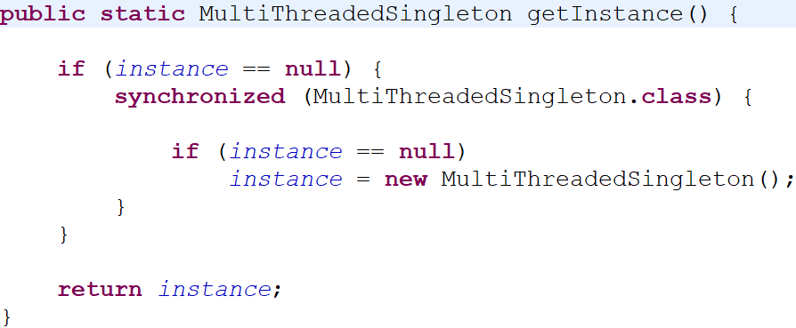

2. Serialization: If we serialize the object and again deserialize it will create new object which break pattern. To prevent this we have to make readResolver() method which call internally at the time of deserialization.

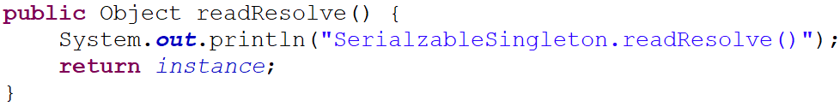

3. Clone: By the help of clone method we can create a new object of singleton class. To prevent this we can throw error in clone method().

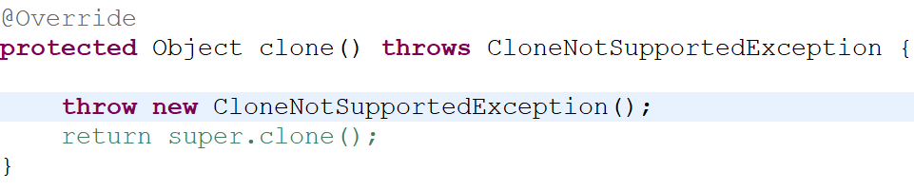

4. ReflectionApi: We can convert private constructor to public by using reflectionApi to prevent this we can use enum or throw exception in constructor method if object already created.

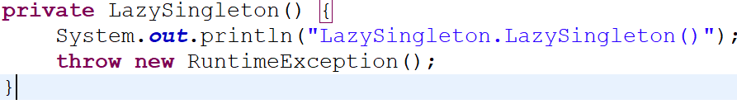

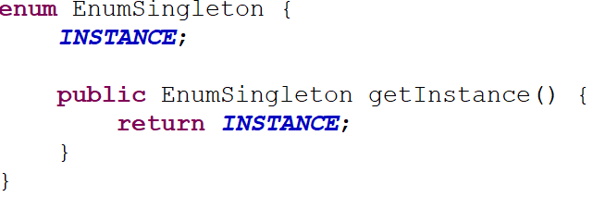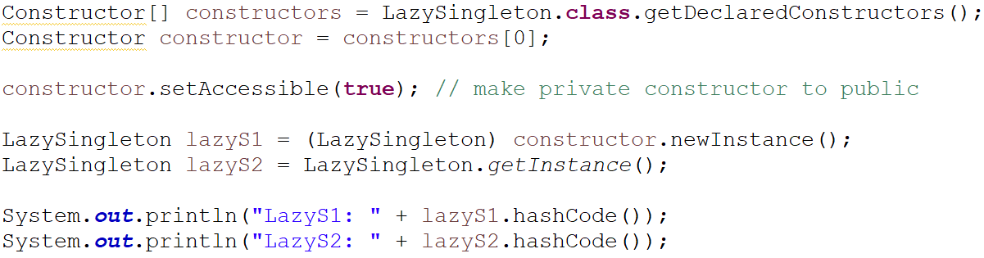

## Properties of Enum in Java

There are certain properties followed by Enum as mentioned below:

* Every enum is internally implemented by using Class.
* Every enum constant represents an **object** of type enum.
* Enum type can be passed as an argument to **switch** statements.
* Every enum constant is always implicitly **public static final**. Since it is **static**, we can access it by using the enum Name. Since it is **final**, we can’t create child enums.
* We can declare the **main() method** inside the enum. Hence we can invoke the enum directly from the Command Prompt.

Why we can’t inherit enum

* **It turns the enum into a subclass of the abstract class *java.lang.Enum***
* **It compiles the enum as a *final* class**

**Factory Pattern:**

A Factory Pattern or Factory Method Pattern says that just **define an interface or abstract class for creating an object but let the subclasses decide which class to instantiate.** In other words, subclasses are responsible to create the instance of the class.**The factory design pattern is used when we have a superclass with multiple sub-classes and based on input, we need to return one of the sub-class.**

The Factory Method Pattern is also known as **Virtual Constructor.**

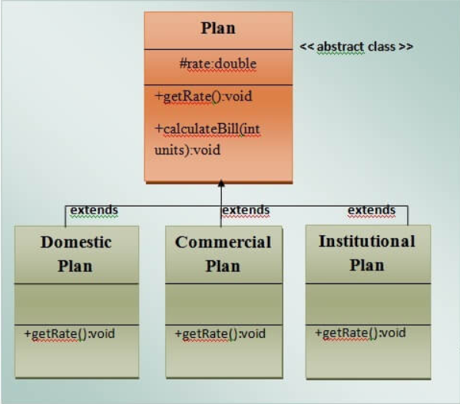 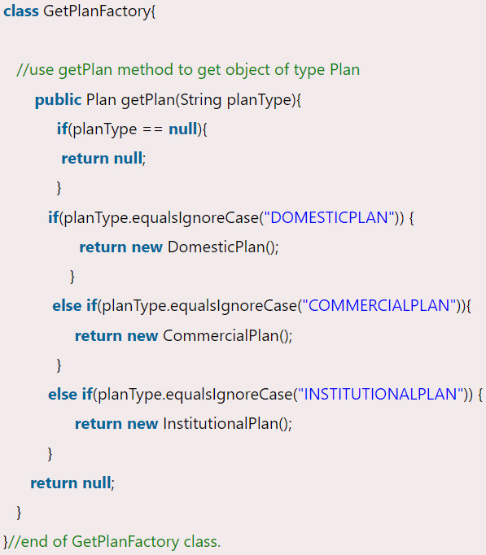

**Adapter Pattern:**

**The Adapter design pattern is a**[**structural pattern**](https://www.geeksforgeeks.org/structural-design-patterns/)**that allows the interface of an existing class to be used as another interface.** It acts as a bridge between two incompatible interfaces, making them work together.

**Eg:**

Let’s say you have two friends, one who speaks only English and another who speaks only French. You want them to communicate, but there’s a language barrier.You act as an adapter, translating messages between them. Your role allows the English speaker to convey messages to you, and you convert those messages into French for the other person.

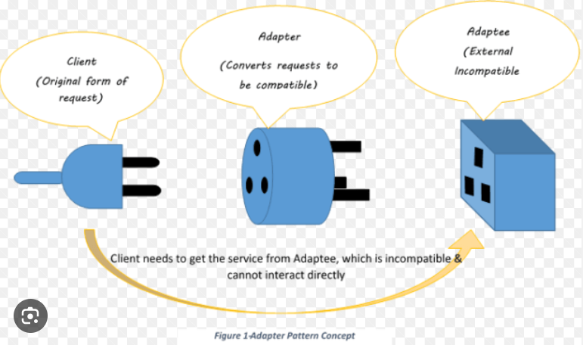

## Strategy Design Pattern:

**A strategy pattern is a**[**behavioral design pattern**](https://www.geeksforgeeks.org/behavioral-design-patterns/)**that allows the behavior of an object to be selected at runtime.** It is one of the [Gang of Four (GoF)](https://www.geeksforgeeks.org/gang-of-four-gof-design-patterns/) design patterns, which are widely used in object-oriented programming.

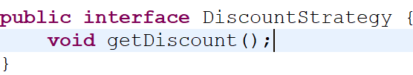 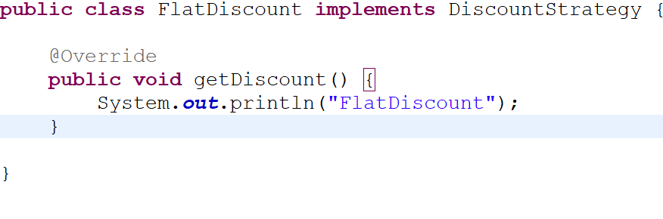

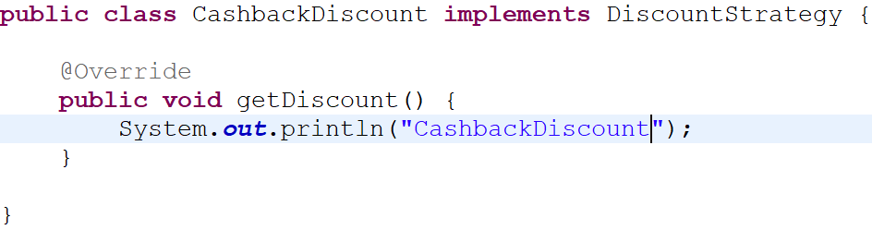 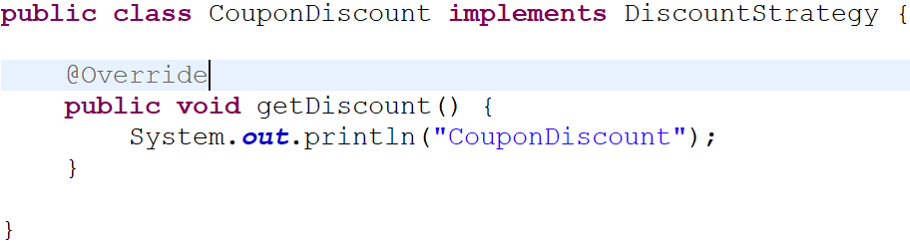

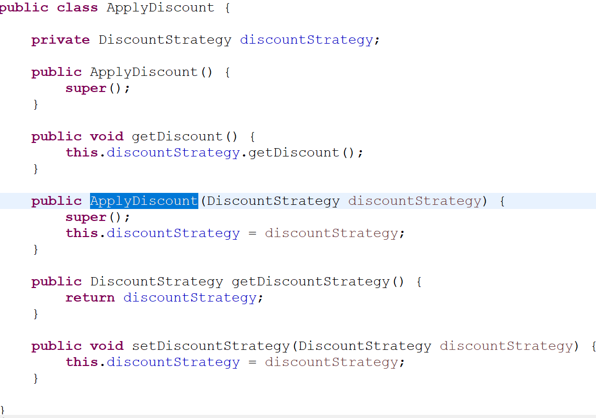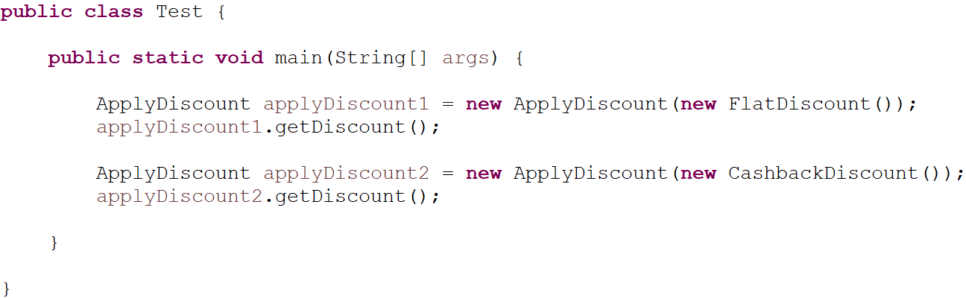

# Iterator Pattern:

Iterator Pattern is used **"to access the elements of an aggregate object sequentially without exposing its underlying implementation".**

The Iterator pattern is also known as **Cursor.**

In collection framework, we are now using Iterator that is preferred over Enumeration.

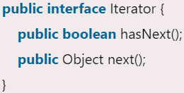

**Bridge Pattern:**

It is same as strategy design pattern but the intent of strategy is change the behaviour of object at runtime. and in Bridge we decouple abstraction from implementation so that they can vary(work) independently.

Although both are same but intent is different.

JPA Mapping

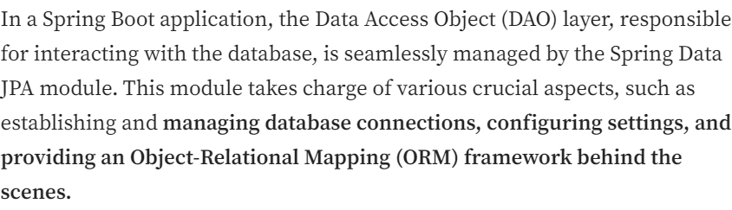

**@JoinColumn and mappedBy:**

JPA Relationships can be either unidirectional or bidirectional. For a bidirectional relationship, we usually define

* the owning side
* inverse or the referencing side

The [*@JoinColumn*](https://www.baeldung.com/jpa-join-column) annotation helps us specify the column name we’ll use for joining an entity association or element collection. On the other hand, the *mappedBy* attribute is used to define the referencing side (non-owning side) of the relationship.

In a One-to-Many/Many-to-One relationship, **the owning side is usually defined on the *many* side of the relationship.** **It’s usually the side that owns the foreign key.**

Once we have defined the owning side of the relationship, Hibernate already has all the information it needs to map that relationship in our database.To make this association bidirectional, all we’ll have to do is to define the referencing side. The inverse or the referencing side simply maps to the owning side.We can easily use the *mappedBy* attribute of *@OneToMany* annotation to do so.

## What Is Cascading?

Entity relationships often depend on the existence of another entity, for example the *Person*–*Address* relationship. Without the *Person*, the *Address* entity doesn’t have any meaning of its own. When we delete the *Person* entity, our *Address* entity should also get deleted. Cascading is the way to achieve this. **When we perform some action on the target entity, the same action will be applied to the associated entity.**

All JPA-specific cascade operations are represented by the *javax.persistence.CascadeType*enum containing entries:

* *ALL (below all properties)*
* *PERSIST(save)*
* *MERGE(update)*
* *REMOVE(delete)*
* *REFRESH*
* *DETACH*

You can use cascade any where means at parent side, child side or both. If you are using it only on parent Side and you need to save the data in db from parent(parentRepo.save(obj)), this is because the child data will automatically save in db due to cascade present on parent. But if you are saving from child side then it might be throw error because parent data is not saved in the database and u are using parent foriegn key in child table and cascade is also not present.

Parent -> We consider entity as parent when its key is using in other table as foriegn key means other table is dependent on parent entity.

**One-to-One:**

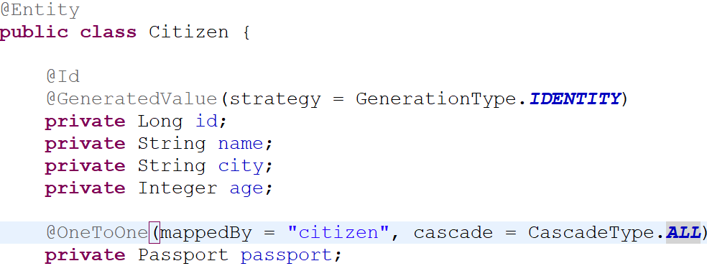 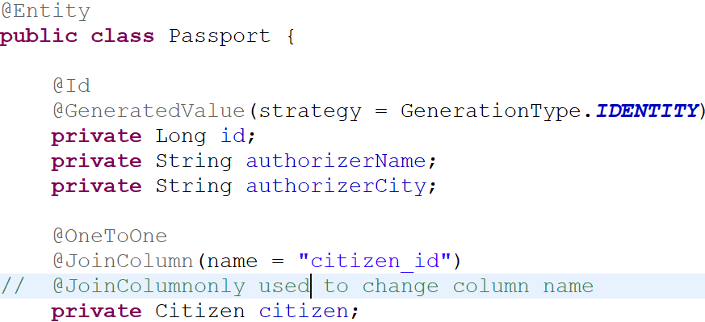

Citizen : Parent( Here we are saving data in db through citizen because cascade is present as citizen means it will automatically save passport data in db when we save citizen.)   
Passport: Child(Uses citizen foreign key)

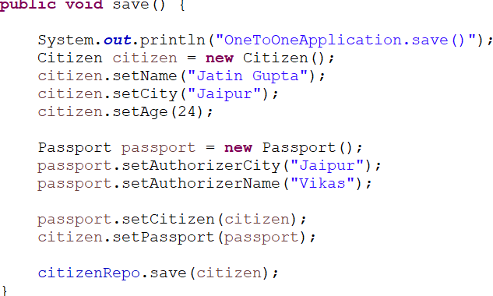 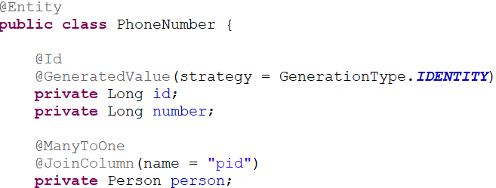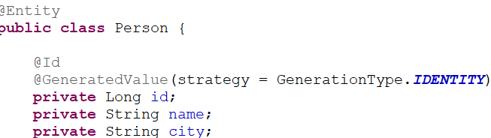

Above PhoneNumber and Person is a unidirectional means you can go from PhoneNumber to person but reverse can’t.

**One-to-Many/Many-to-One:**

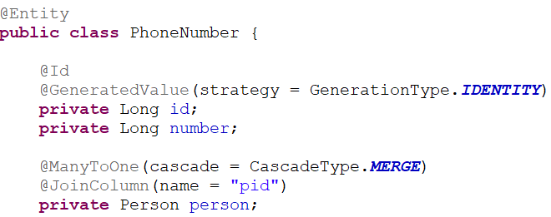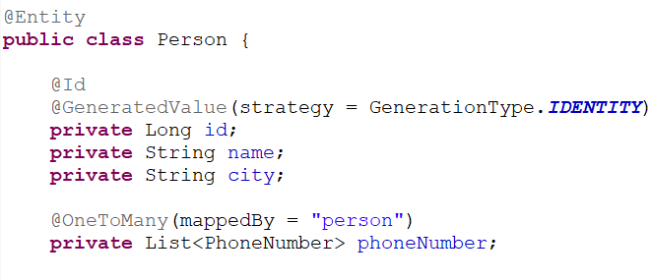

Bidirectional  
Parent: Person(save, update, delete from parent side and will reflect changes in child if present)  
Child: PhoneNumber

Unidirectional:

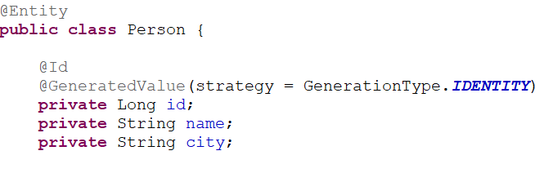 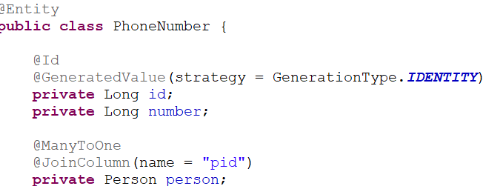

Use below link to learn

<https://www.baeldung.com/spring-jpa-unidirectional-one-to-many-and-cascading-delete>

**Many-to-Many:**

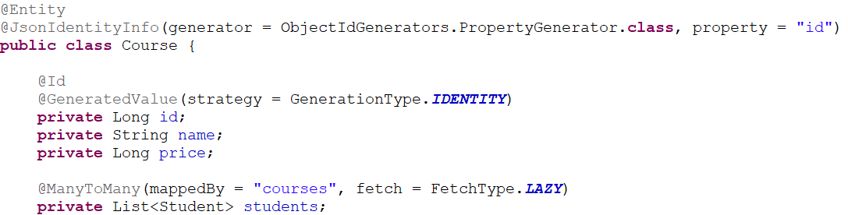

d

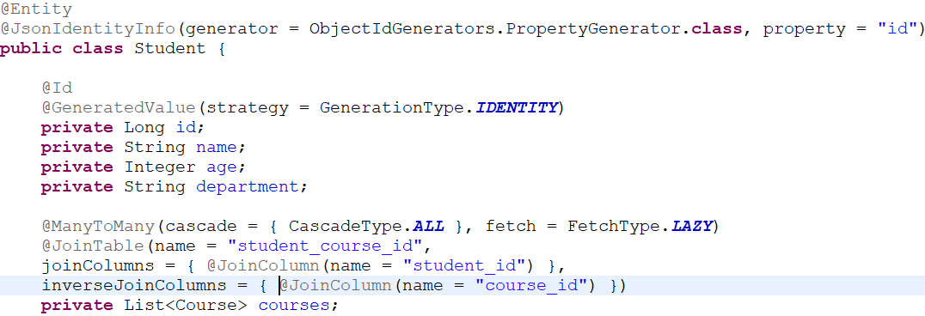

**@JsonIdentityInfo:** used to handle circular reference of an object by serializing the back-reference's identifier rather than serializing the complete reference. @JsonIdentityInfo allows to serialize a POJO by id when it is encountered second time during serialization.

Parent: courses  
Chils: Student

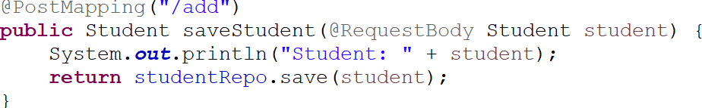

Saving data through student because cascade is present in student entity.

Note: You can decide which entity you want to make parent or child, it will not affect the functionality but where you are using cascade from there only we need to (save, update, deleted,....) do all db operation data. If cascade present in both parent and child then you can to db operation from anywhere.

**Spring Security:**

To use spring security in your project you need to enableWebSecurity by using **@EnableWebSecurity**.

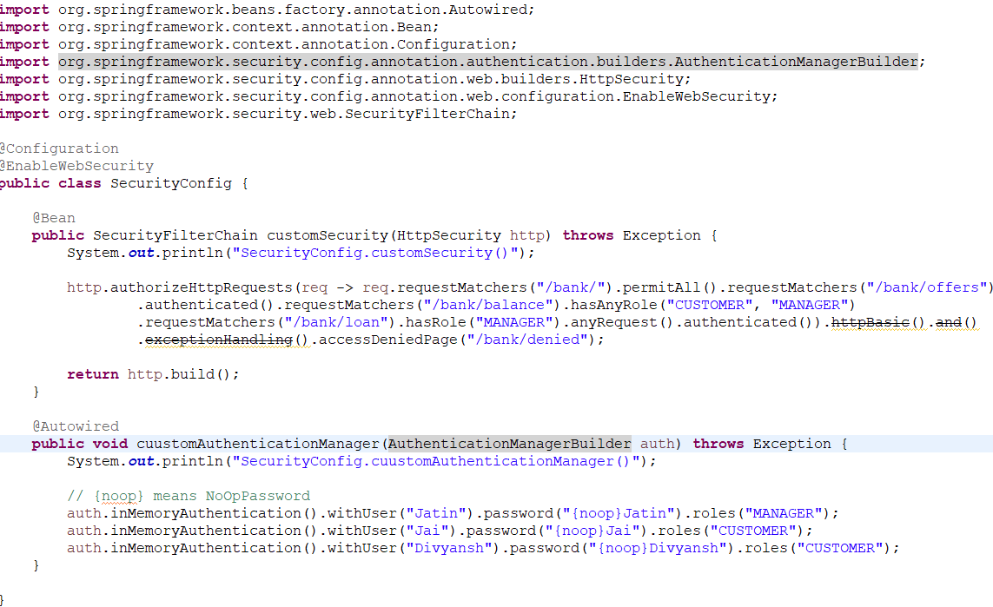

In the above image you need to create bean of **SecurityFilterChain** which will use to set which url is required to authectication and which are not.

**AuthenticationManagerBuilder** helper class that eases the set up of UserDetailService, AuthenticationProvider, and other dependencies to build an AuthenticationManager

HS256 - Secret Key

RS256 - Public/Private Key

**Oauth:**

OAuth 1.0 has a consumer, service provider, and user, and it doesn't explicitly separate the roles of the resource server and authorization server. On the other hand, OAuth 2.0 has a client, authorization server, resource server, and resource owner. That's why these versions don't have backward compatibility.

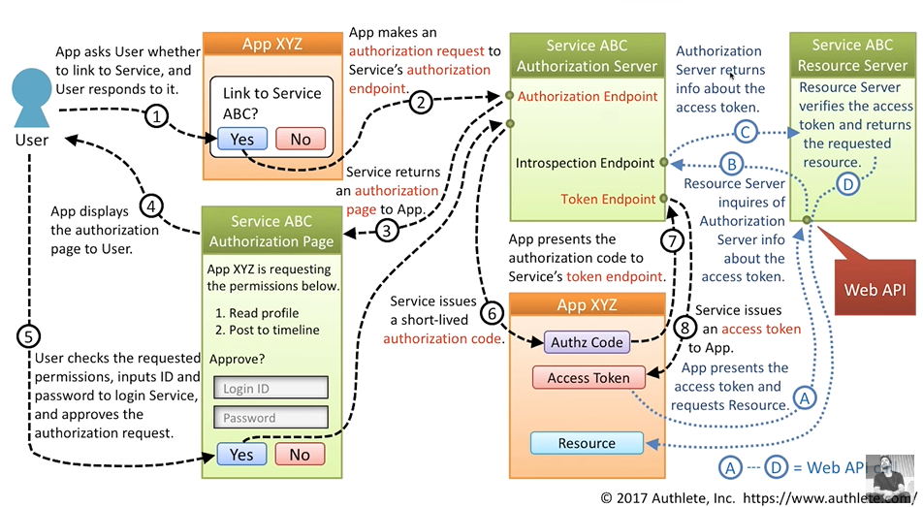

# OAuth 2 Grant Types:

In total, there are five different grant type flows defined and described to perform authorizations tasks. Those are …

* **Authorization Code Grant Type**
* **Implicit Grant Type**
* Resource Owner Credentials Grant Type
* Client Credentials Grant Type
* Refresh Token Grant

Here We will discuss only **Authorization Code Grant Type, Implicit Grant Type**

**Authorization Code Grant Type:** After successfully verify user then authorization code generated that authorization code we pass to the authorization server which send access token after verifying code, then that token we send to resource server which will call authorization server to verify token, once its done resource server will send back the data which clients wants.

Client website share the required data in scope with clientId, redirect_uri, state,..etc

GET (Authorization Endpoint) ?response_type=code  
 &client_id={CLIENT ID}  
 &redirect_uri={REDIRECT URI}  
 &scope={SCOPES}  
 &state={STATE}

As a response, the Authorization Server sent a temporaryAuthorization Code back to the Redirect URI which was defined in the GET request.

LOCATION : {REDIRECT URI}  
 ?code={AUTHORIZATION CODE}  
 &state={STATE}

**State:** An OAuth 2.0 state parameter is a unique, randomly generated, opaque, and non-guessable string that is sent when starting an authentication request and validated when processing the response. OAuth 2.0 state parameters are used primarily for mitigating CSRF attacks by confirming if the value of the state parameter coming from the response is the same as the one sent in the request.

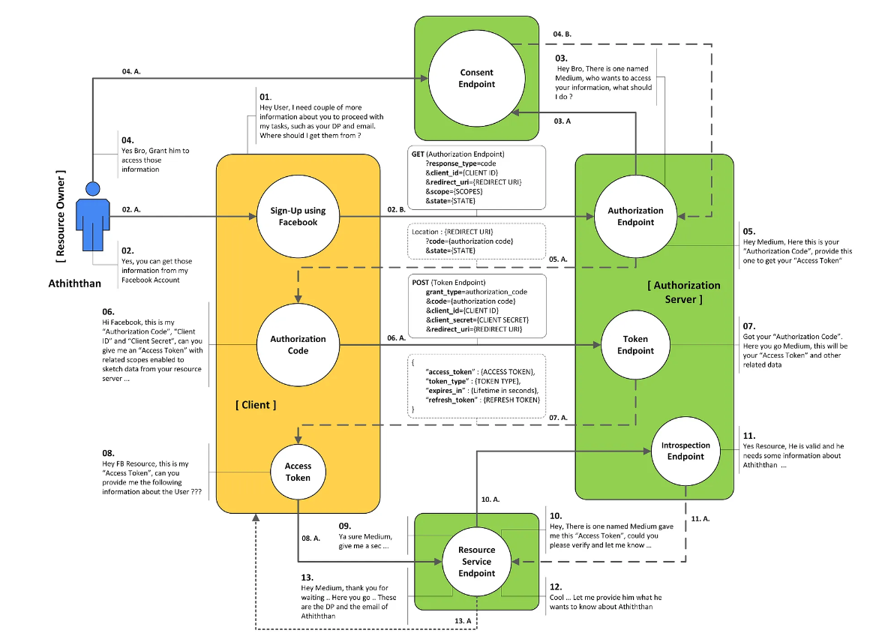

**Implicit Grant Type:** Here it is not generating authroization code, it will generated only access token after user verified or allow client app to get data from requested server and all process process are same as authorization Code Grant Type**.**

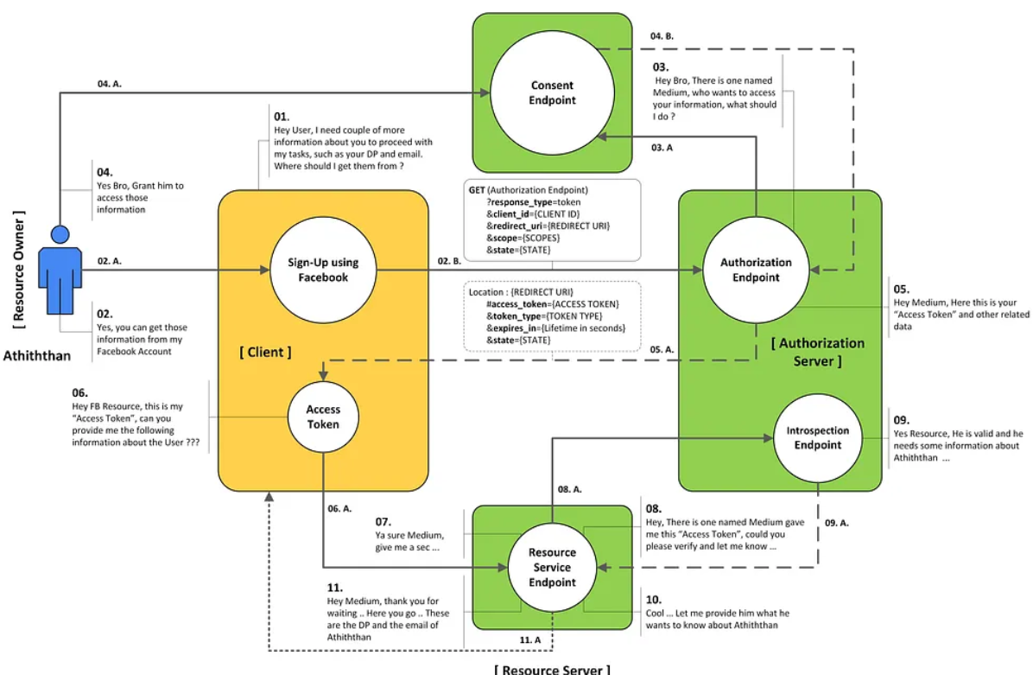

GET (Authorization Endpoint)  
 ?response_type=token  
 &redirect_uri={REDIRECT URI}  
 &scope={SCOPES}  
 &state={STATE}

As a response, the Authorization Server shipped back the actualAccess Token back to the Redirect URI which was defined in the GET request as **Query Parameter**

LOCATION : {REDIRECT URI}  
 #access_token={ACCESS TOKEN}  
 &token_type={TOKEN TYPE >> Bearer}  
 &expires_in={EXPIRES IN}  
 &state={STATE}

**Comparator and Comparable**

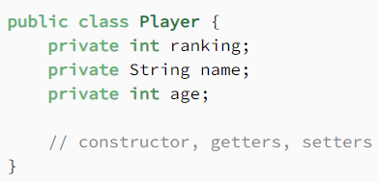 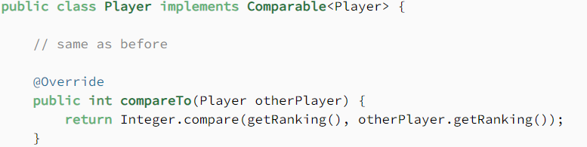

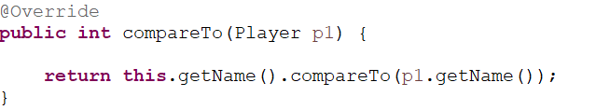

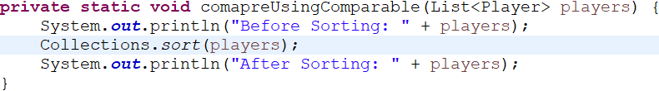

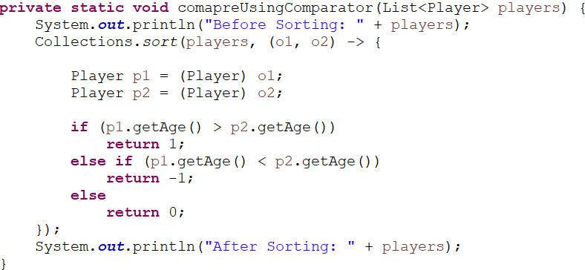

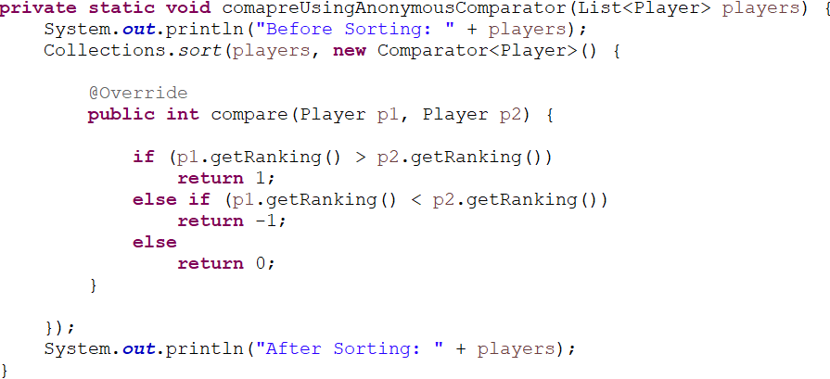

## Comparator vs Comparable

**The Comparable interface is a good choice to use for defining the default ordering,**or in other words, if it’s the main way of comparing objects. So why use a Comparator if we already have Comparable?

There are several reasons why:

* Sometimes we can’t modify the source code of the class whose objects we want to sort, thus making the use of Comparable impossible
* Using Comparators allows us to avoid adding additional code to our domain classes
* We can define multiple different comparison strategies, which isn’t possible when using Comparable

**Note:   
Collections.sort(players): This will only work when you implement comparable interface else throw Compilation error.**

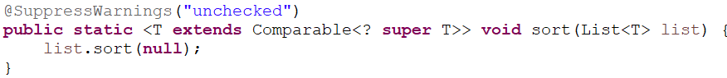

T **extends** Comparable: It means that T should be the child of comparable(means T should inherit comparable interface whether it extend or implement).

Spring:

**Bean life cycle:**

Bean life cycle is managed by the spring container. When we run the program then, first of all, the spring container gets started. After that, the container creates the instance of a bean as per the request, and then dependencies are injected. And finally, the bean is destroyed when the spring container is closed. Therefore, if we want to execute some code on the bean instantiation and just after closing the spring container, then we can write that code inside the custom **init()** method and the **destroy()** method.

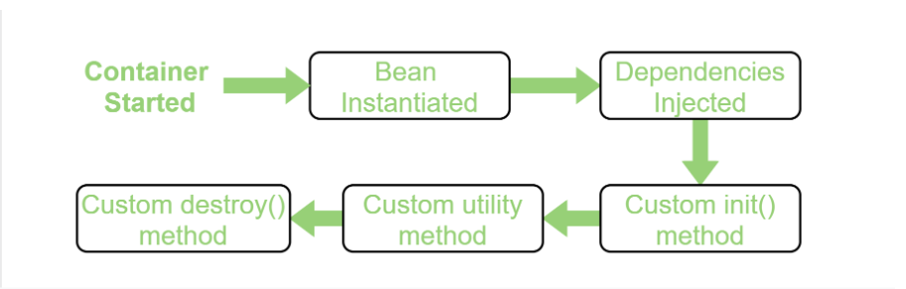

**Spring IoC container is responsible for instantiating, wiring, configuring, and managing the entire life cycle of objects. BeanFactory and**

**ApplicationContext represent the Spring IoC Containers.**

**@SpringBootApplication**

**=>@EnableAutoConfiguration(It enables AutoConfiguration)**

**=>@ComponentScan(Scan for the stereo type annotations in the given package and subpackage)**

**=>@Configuration(Marking the class as Configuration class)**

**=>@PropertySource(location="application.properties")**

groupId -> name of company or organization  
artifactId ->project name

**JWT authorization is a stateless mechanism for authentication and authorization**

**MySql**





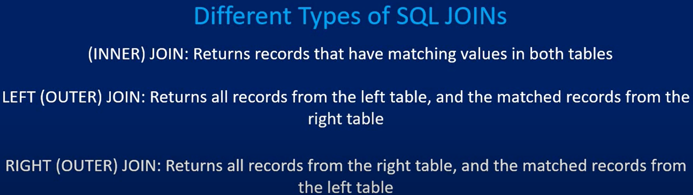

**Inner Join:**

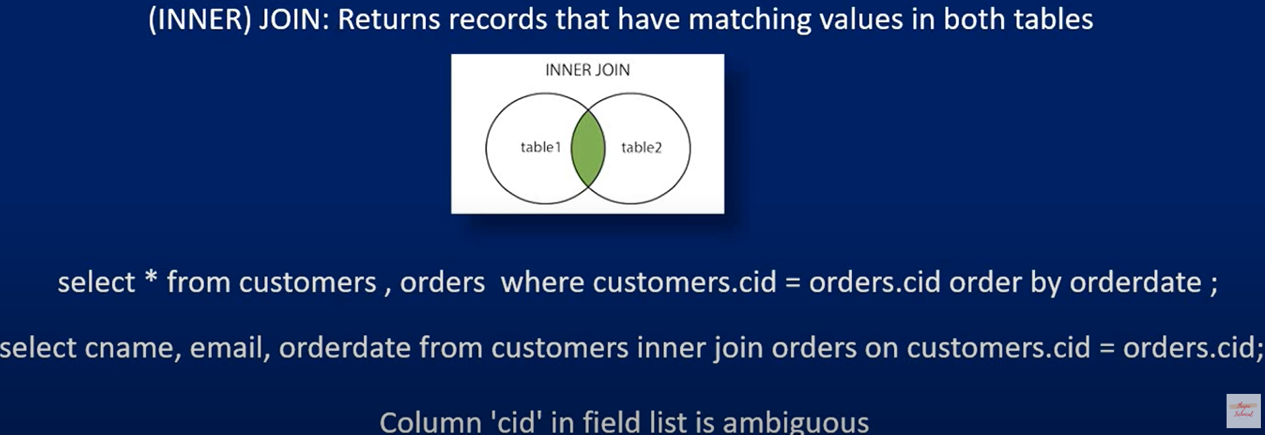

select * from customers, orders where customers.cid = orders.cid; **-> Normal query**

selct * from customers inner join orders on customers.cid = orders.cid; **-> Join query**

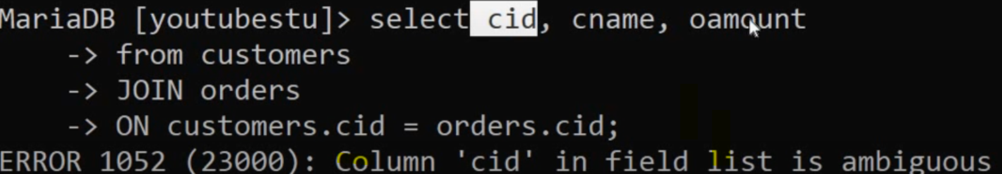

column ‘cid’ in field list is ambigous because ‘cid’ fields is present in both table with same name i.e., throwing error. If fields are different then it will execute query.

**Solution:**

select customers.cid, customers.cname, orders.oamount from customers inner join orders on customers.cid = orders.cid;

select c.cid, c.cname, o.oamount where cutsomers as c join orders as o where c.cid = o.cid;

Join Three table

SELECT

teams.team_name AS team_name,

projects.project_name AS project_name

FROM TABLE teams

INNER JOIN matches

ON teams.id = matches.team_id

INNER JOIN matches

ON matches.project_id = projects.id

ORDER BY teams.id;

**Left Join:**  
  
 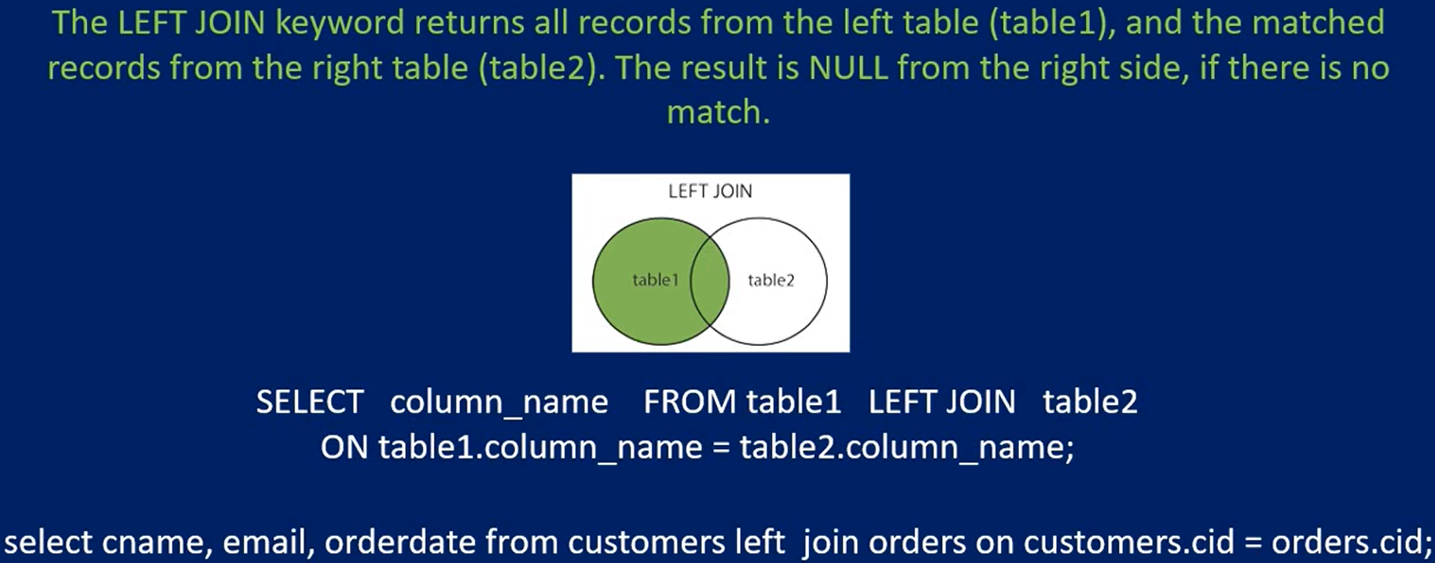

**Right Join:**

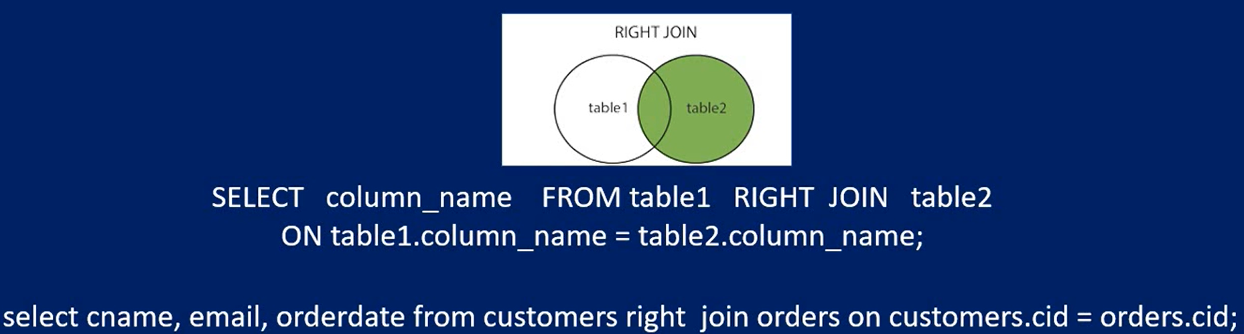

**Cross Join:**

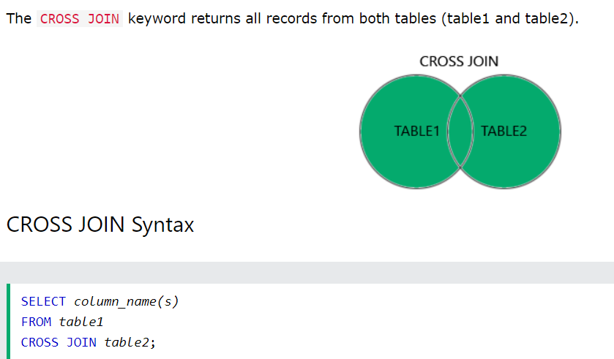

**If we use ‘where’ clause or ‘on’ then it will work as inner join.**

**MySqlCommands:**

**SELECT *column1*,*column2, ...* FROM *table_name*;**

(SELECT CustomerName, City, Country FROM Customers;)

**SELECT *column1*,*column2, ...* FROM *table_name* ORDER BY *column1, column2, ...*ASC|DESC;**

“Order By is used to get data in sorting order based on column name”

SELECT * FROM Customers ORDER BY Country;

SELECT * FROM Customers ORDER BY Country DESC;

**INSERT INTO *table_name* (*column1*,*column2*,*column3*, ...) VALUES (*value1*,*value2*,*value3*, ...);**

INSERT INTO Customers (CustomerName, ContactName, Address, City, PostalCode, Country) VALUES ('Cardinal', 'Tom B. Erichsen', 'Skagen 21', 'Stavanger', '4006', 'Norway');

**UPDATE *table_name* SET *column1*=*value1*,*column2*=*value2*, ... WHERE *condition*;**

UPDATE Customers SET ContactName = 'Alfred Schmidt', City = 'Frankfurt' WHERE CustomerID = 1;

**DROP TABLE *table_name*;**

**ALTER TABLE *table_name* ADD *column_name datatype*;**

**ALTER TABLE *table_name* DROP COLUMN *column_name*;**

**ThreadLocal:**

ThreadLocal is a class in Java that allows you to create variables that can only be read and written by the same thread. This can be useful in situations where you have multiple threads accessing the same variable, but you want to ensure that each thread has its own isolated copy of the variable.

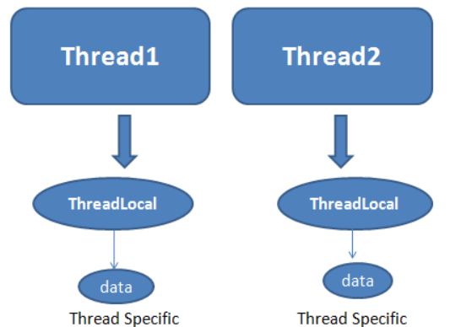

Why ThreadLocal if we can use synchronize to not allow that variable access by thread at once?

Yes, We can use synchronize but its performance is slow.

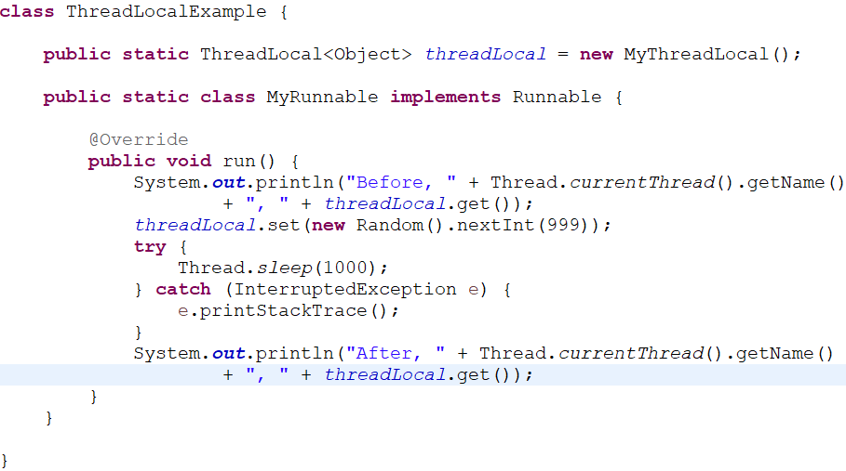

**Note:** When we call *threadLocal*.get() before setting its value then internally jvm will call initialValue() method to set initial value only once.

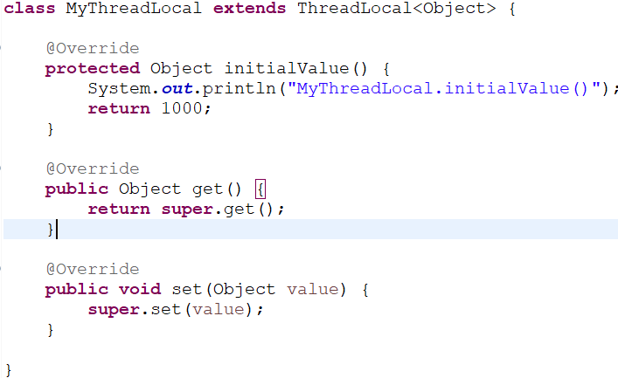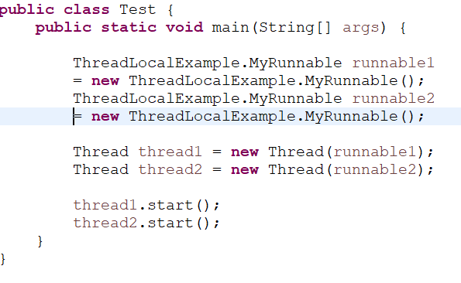

**Output:**

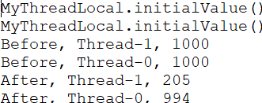

# 

**ExecutorService:**

The **ExecutorService** interface extends Executor by adding methods that **help manage and control the execution of threads. It is defined in**[**java.util.concurrent package**](https://www.geeksforgeeks.org/tag/java-concurrent-package/)**.** It defines methods that execute the threads that return results, a set of threads that determine the shutdown status. The **ExecutorService interface** is implemented in a utility class called **Executors**. It defines methods that provide an implementation of the ExecutorService interface and many other interfaces, with some default settings.

1. **submit()**: this method accepts a **runnable** or **callable** task and returns a **Future** ***that can be used to wait for completion and/or to cancel execution.***

2. **invokeAny()**: this method accepts a collection of callable tasks and returns a result if any tasks are successful.

3. **invokeAll()**: this method accepts a collection of callable tasks and returns a List of Future, which will hold the result returned by each task when the asynchronous tasks are completed.

4. **shutdown() and shutdownNow()**:

The shutdown() method of ExecutorService will allow previously submitted tasks to execute before terminating the ExecutorService and performing memory clean-up, whereas the shutdownNow() method prevents waiting for tasks from starting and attempts to stop currently executing tasks.

This shutdownNow() returns a list of tasks that are waiting to be processed. It is up to the developer to decide what to do with these tasks.

SingleThreadPool:

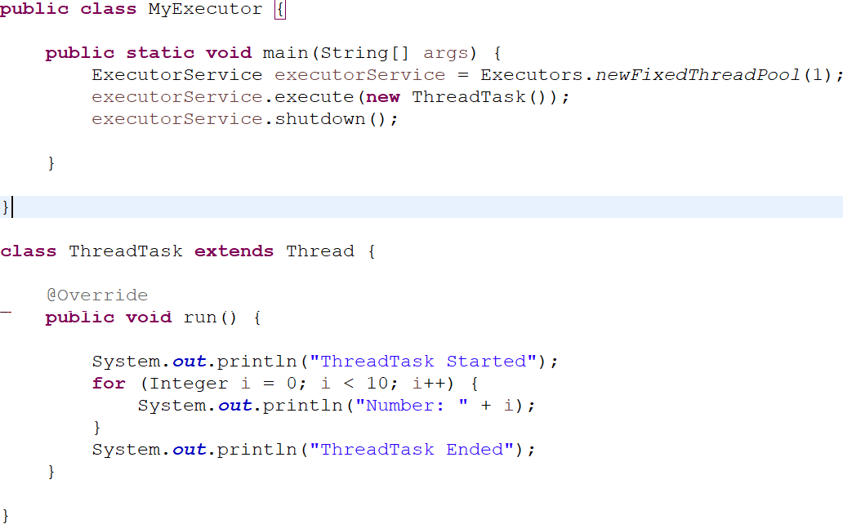

**Multiple:**

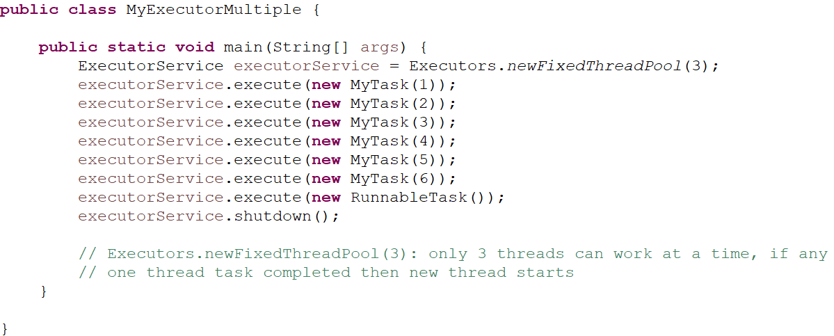

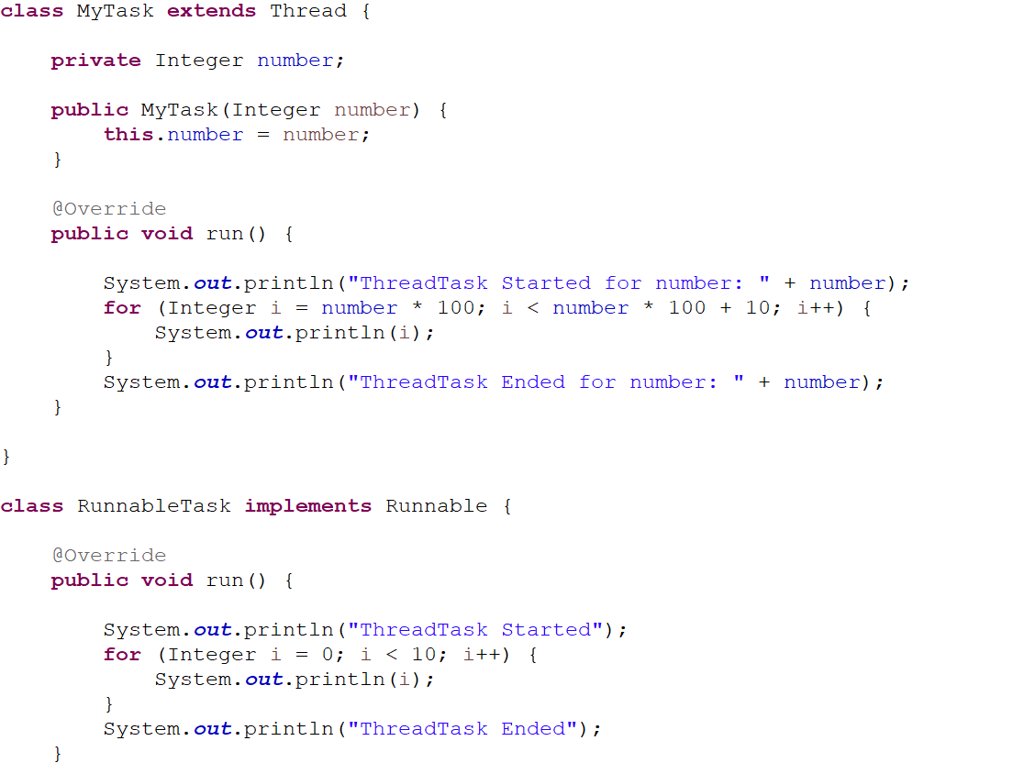

Here we created threadPool of 3 threads, so 3 threads can work simultanouesly and remaining thread will wait in task queue to get chances.

If suppose one thread completed and 2 are stillll wokring then 1 thread from task queue will do task if present.

**Callable VS Runnable:**

Callable has **call** method which **returns value** but Runnable has **run** method which **doesn't return any value**. call method can throw **checked exception** but run method **can't throw** checked exception. Callable use submit() method to put in task queue but Runnable use execute() method to put in the task queue.

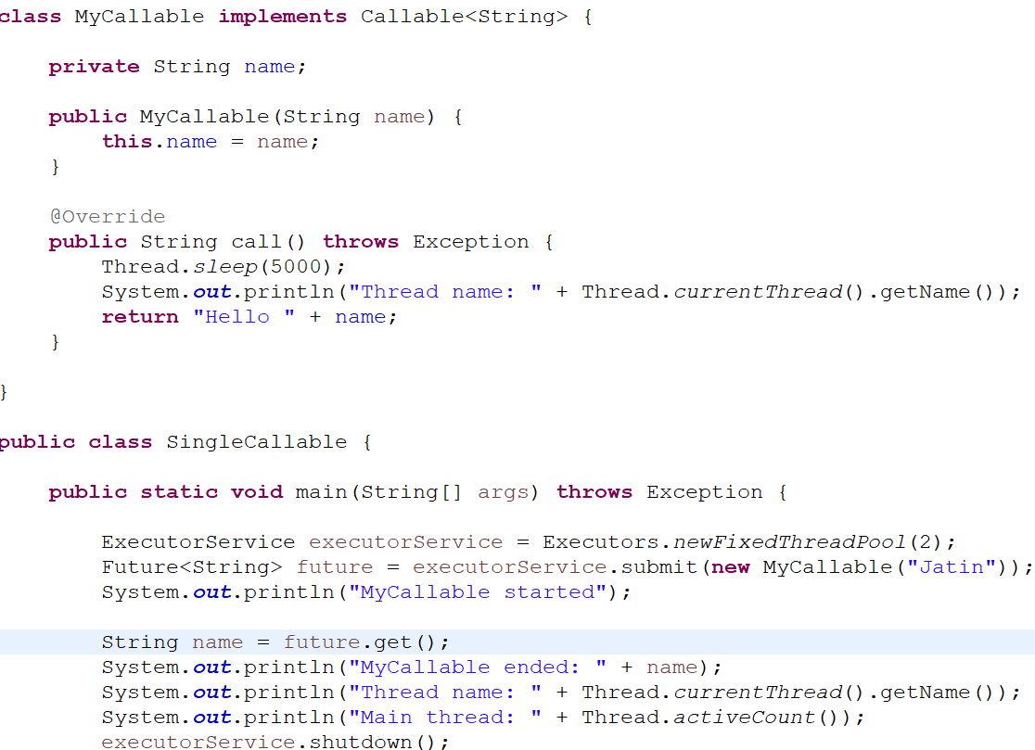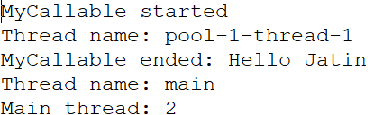

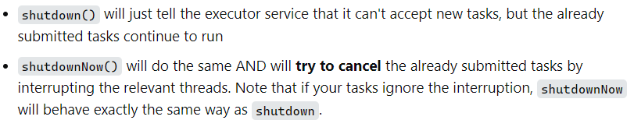

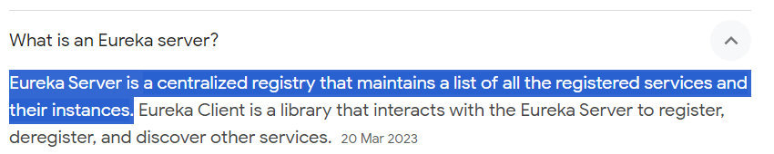

**Internal Working of Spring Security:**

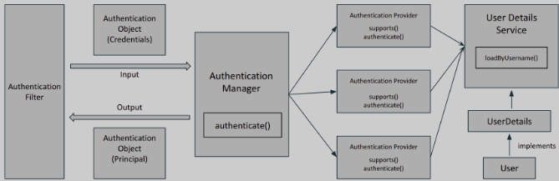

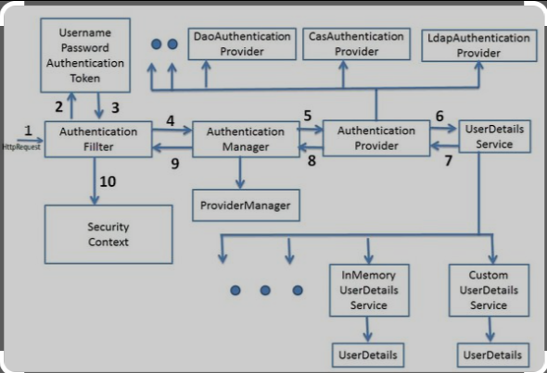

* **Authentication**: Confirming truth of credentials.
* **Authorisation**: Defines access policy for the Principal.
* **GrantedAuthority**: Permission granted to the principal.
* **AuthenticationManager**: Controller in the authentication process. Authenticates user saved in memory via authenticate().
* **AuthenticationProvider**: Interface that maps to a data store that stores your data.
* **Authentication Object**: Object that is created upon authentication. It holds the login credentials. It is an internal spring security interface.
* **UserDetails**: Data object that contains the user credentials but also the role of that user.
* **UserDetailsService**: Collects the user credentials, authorities (roles) and build an UserDetails object.

When we add the spring security starter jar, it internally adds **Filter** to the application. A Filter is an object that is invoked at pre-processing and post-processing of a request. It can manipulate a request or even can stop it from reaching a servlet. There are multiple filters in spring security out of which one is the **Authentication Filter**, which initiates the process of authentication.

Once the request passes through the authentication filter, the credentials of the user are stored in the **Authentication** object. Now, what actually is responsible for authentication is **AuthenticationProvider** (Interface that has method **authenticate()**). A spring app can have multiple authentication providers, one may be using OAuth, others may be using LDAP. To manage all of them, there is an **AuthenticationManager**.

The authentication manager finds the appropriate authentication provider by calling the supports() method of each authentication provider. The supports() method returns a boolean value. If true is returned, then the authentication manager calls its authenticate() method.

After the credentials are passed to the authentication provider, it looks for the existing user in the system by **UserDetailsService**. It returns a **UserDetails** instance which the authentication provider verifies and authenticates. If success, authentication Object containing the user Authorities (which will be used to manage the user access to the system’s resources) is returned and set into the SecurityContext.

**@RequestPart:**

This annotation is used to take input from form-data:

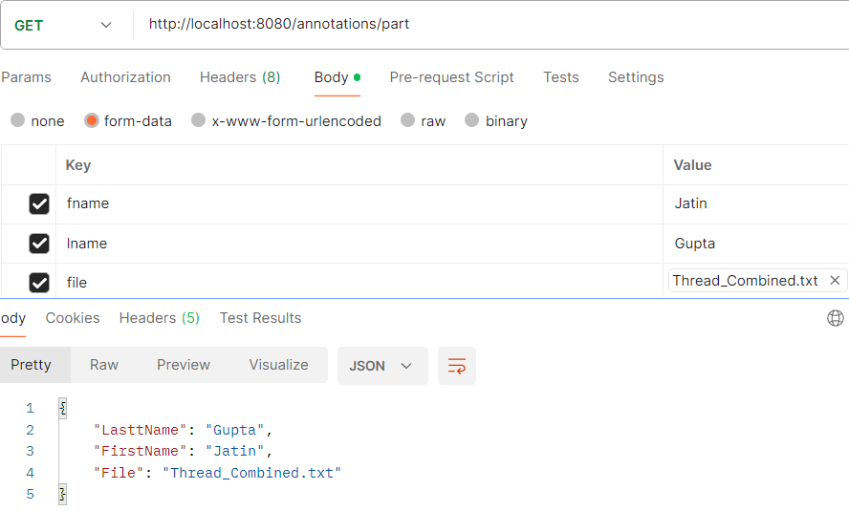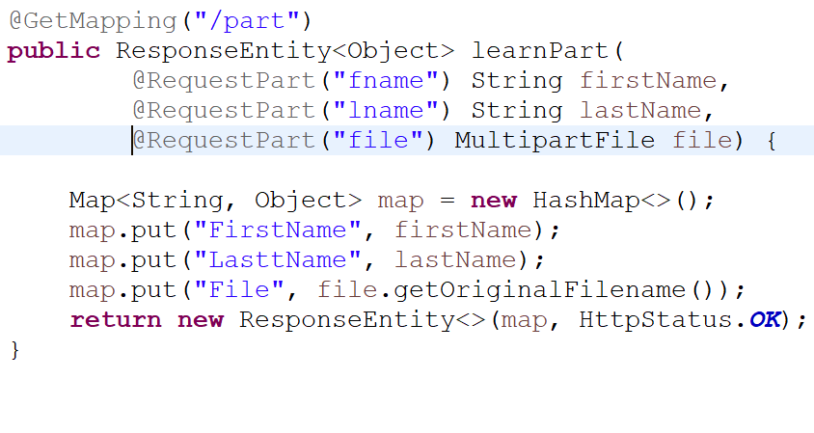

**@Param:**

In Spring Framework, @Param (org.springframework.data.repository.query.Param) is used to bind the method parameter to Query parameter.



Here, Employee is JPA Entity, and @Param is used to bind the method parameter departmentId to Query parameter deptId.

**finalize():**

It will be call by Garbage collector when any object is not used in code after assigning data or make as null.

**Exception hierarchy:**

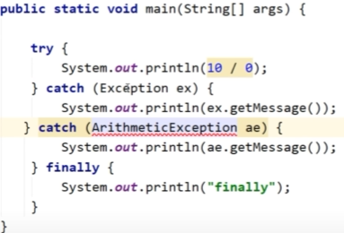

Here child exception should come before parent exception because parent can handle child exception too. So, child exception handling code is useless(**unreachable**).

**SCP**

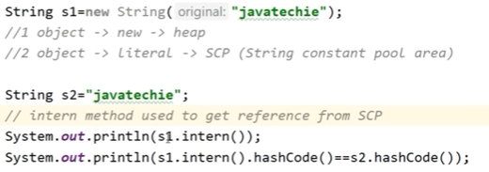

Here s1.intern() is used to get the object present in SCP.

Ouput: javatechie

true

**Which to use String or char[]?**

Use of char[]

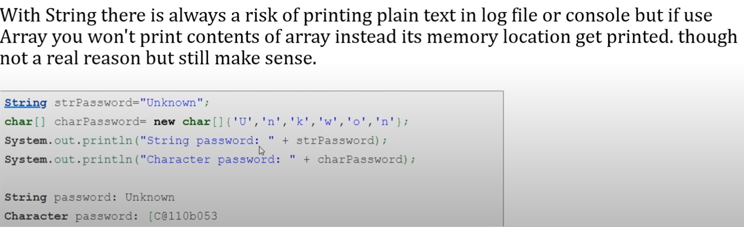

There are many points but it is major one. and string is also immutable any changes to password will create new object. We can set the size of password in char[].

**How to prevent duplicate value in an arrayList?**

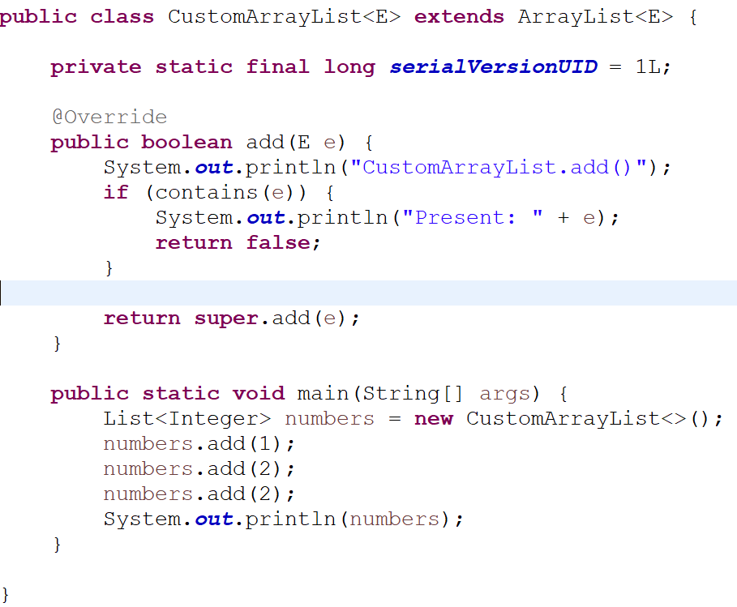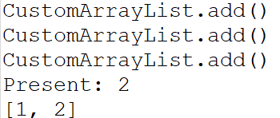

**Why Set doesn’t store duplicates?**

Because internally is use map where key is the object and value is Object class object. It compare hashcode of the object. If hashcode is same then it will compare the content of data using equals() method. Same functionality as map.

HashSet implemetations eg:

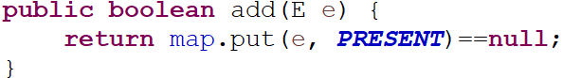



## Unit Tests

* Unit test — in which the smallest testable parts of an application, called units, are individually and independently tested for proper operation.
* We need to **perform mocking operations**. Not real ones! Reason for that is our unit tests should not affect the other parts of the application. Ex: if we only test the controller layer, it should not affect service layer.

## Integration Tests

* Integration test — in which the different units, modules or components of a software application are tested as a combined entity.
* We need to **perform real operations** to check all the layers are working well in the flow. Here, the layers are controller, service, repository…

Controller: @WebMvcTest

Service: @Mock, @InjectMock

Repository/Dao: @DataJpaTest

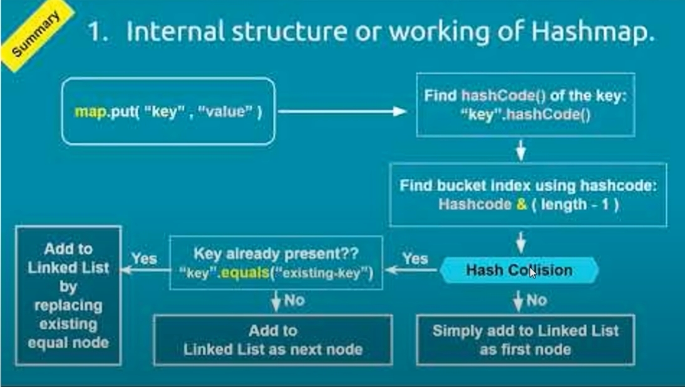

Internal working of TreeMap?

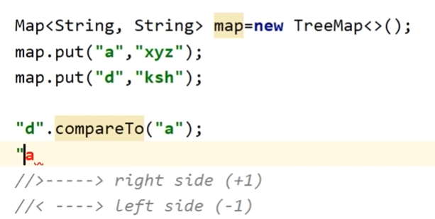

TreeMap can’t store null as it internally use compareTo() to compare. For null will get NullPointerException.

**Generics In Java:**

Diamond operator: <>

**Need:**

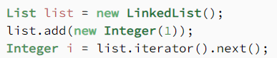



No contract could guarantee that the return type of the list is an *Integer*. The defined list could hold any object. We only know that we are retrieving a list by inspecting the context. When looking at types, it can only guarantee that it is an *Object* and therefore requires an explicit cast to ensure that the type is safe.

This cast can be annoying — we know that the data type in this list is an *Integer*. The cast is also cluttering our code. It can cause type-related runtime errors if a programmer makes a mistake with the explicit casting.

It would be much easier if programmers could express their intention to use specific types and the compiler ensured the correctness of such types. This is the core idea behind generics.



By adding the diamond operator <> containing the type, we narrow the specialization of this list to only *Integer* type. In other words, we specify the type held inside the list. The compiler can enforce the type at compile time.

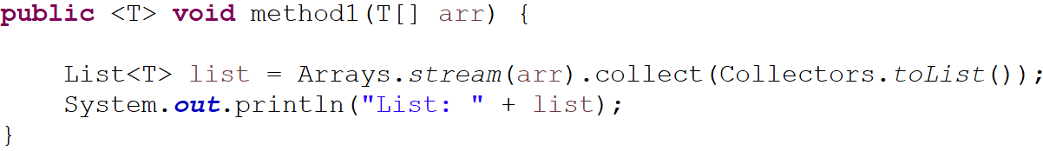

Here <T> simplify that this method is a generic method, you need to mention it with no return type and return type.

### The type parameters naming conventions are important to learn generics thoroughly. The common type parameters are as follows:

* T – Type
* E – Element
* K – Key
* N – Number
* V – Value

### Bounded Generics

Bounded means “restricted,” and we can restrict the types that a method accepts. For example, we can specify that a method accepts a type and all its subclasses (upper bound) or a type and all its superclasses (lower bound).

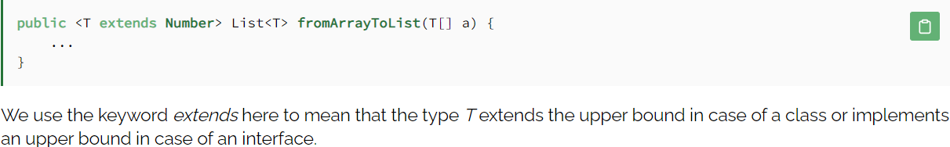

## Using Wildcards With Generics

Wildcards are represented by the question mark *?* in Java, and we use them to refer to an unknown type. Wildcards are particularly useful with generics and can be used as a parameter type. But first, there is an important note to consider. **We know that *Object* is the supertype of all Java classes.** However, a collection of *Object* is not the supertype of any collection.

For example, a *List<Object>* is not the supertype of *List<String>*, and assigning a variable of type *List<Object>* to a variable of type *List<String>* will cause a compiler error. This is to prevent possible conflicts that can happen if we add heterogeneous types to the same collection. The same rule applies to any collection of a type and its subtypes.

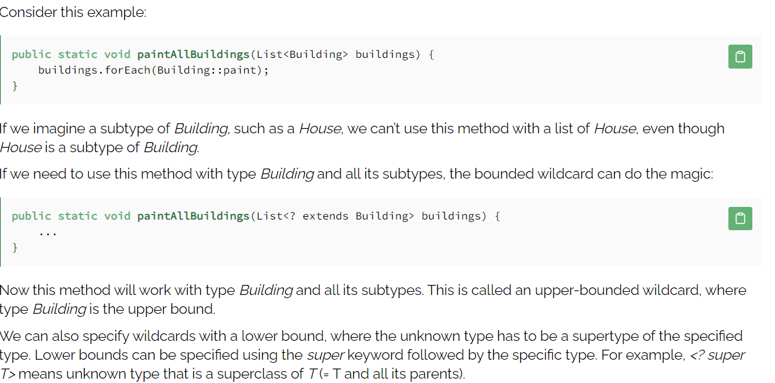

**@Async**

The **@Async** annotation in Spring Boot is used to mark a method as asynchronous. This means that the method will be executed in a separate thread, and the calling thread will not be blocked waiting for the method to complete. **This can be useful for long-running tasks, as it allows the calling thread to continue processing other requests while the asynchronous task is running.**

Few things to keep in mind when using the **@Async** annotation:

* The method must be **public**.
* The method must not throw checked exceptions. If the method throws a checked exception, the exception will be wrapped in a runtime exception and thrown to the calling thread.
* The method must return a value that implements the **Future** interface (basically **CompletableFuture**). ***This allows the calling thread to get the result of the asynchronous task once it has been completed.*** Or the method must have no return type that is **void**.
* Calling the async method from within the same class. It won’t work (Method calling like this will bypass proxy).

# NOTE: *The*[*@EnableAsync*](https://docs.spring.io/spring/docs/current/spring-framework-reference/html/scheduling.html#scheduling-annotation-support) annotation switches on Spring’s ability to run @Async methods in a background thread pool.

With CompletableFuture returnType on controller it will wait for execution and send response data after completion because it internally call join() method to fetch the result.

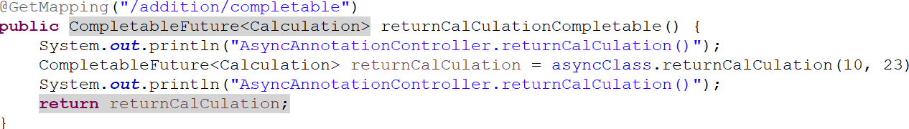

Output:

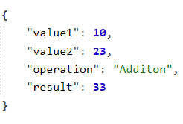

**Note:** If we use return type other then void and completable then it will throw runtime exception when we call async method.

[https://medium.com/@dvikash1001/springboot-async-the-magic-and-the-gotchas-17f9471c6fe4](https://medium.com/javarevisited/java-completablefuture-c47ca8c885af)

**Why CompletableFuture?:**

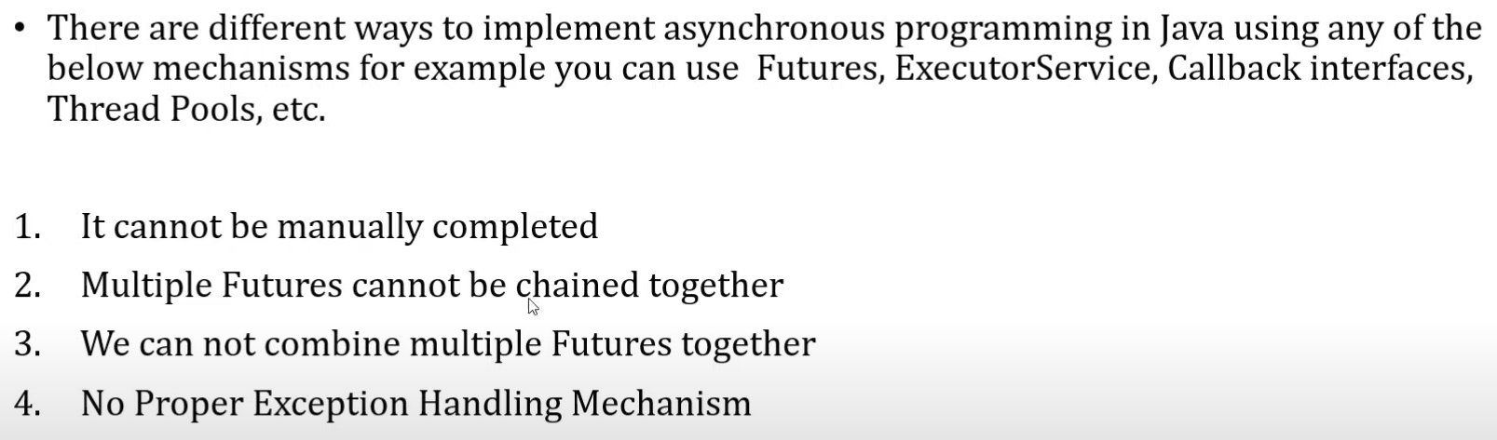

<https://medium.com/javarevisited/java-completablefuture-c47ca8c885af>

complete() -> If you want to forcefully complete any completableFuture thread then use this method.

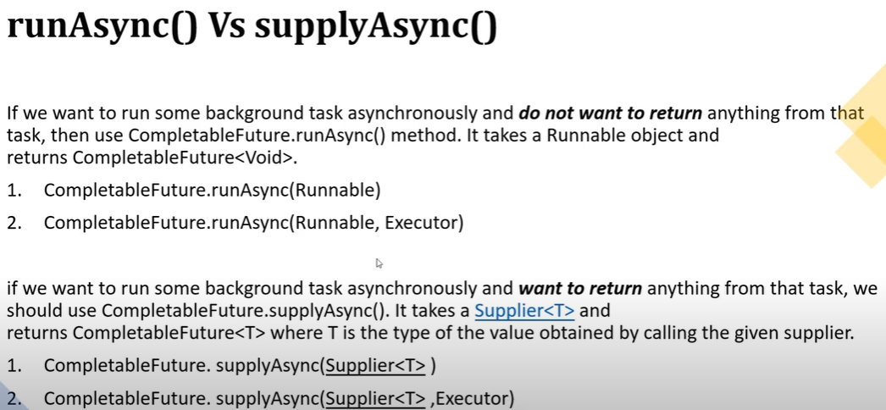

**CompletableFuture.supplyAsync(Supplier<T>):** Here it will take thread from ForkJoin pool for execution.

**CompletableFuture.supplyAsync(Supplier<T>, Executor):** It will take from the Executor pool which we configured.

thenApply(Function): will take input and return result.  **R apply(T t);**

thenAccept(Consumer): will take parameter and don’t return anything. **void accept(T t);**

thenRun(Runnable): not take any parameter and not return also. **void run();**

Function, Consumer, Runnable : All are functional interface.

Every Eureka server is also an eureka client and it register to other server because there can be multiple instance of eureka server to prevent this we have to write below properties and eureka server is run on default port 8761

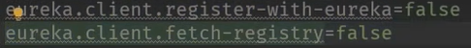

To run any springboot service on different port we can use below   
java -jar -Dserver.port=8083 spring-5.jar

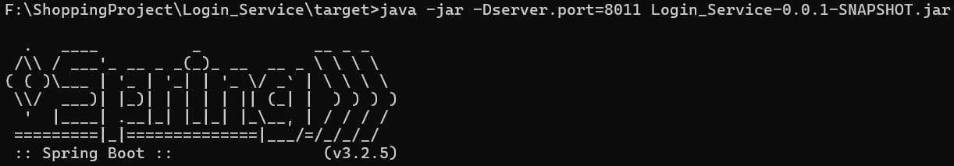



**HttpBasic()** is used to test your secure api through postman.

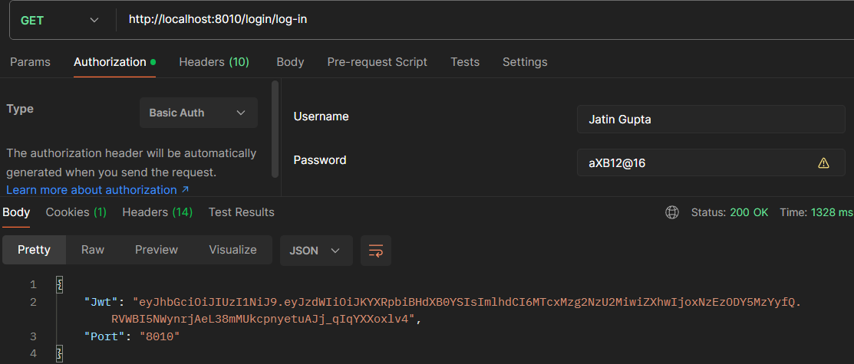

FormLogin(): It is used to get the form login page where you write your credentials and internally is worked as httpBasic() to validate user.

List → ArrayList  
 → LinkedList  
 → Vector

→ Stack

Queue → PriorityQueue

→ ArrayQueue

→ Deque

Set → HashSet

→ TreeSet

→ LinkedHashSet

Map → HashMap

→ LinkedHashMap

→ TreeMap

**Callback Function:**

A callback function is a function passed as an argument to another function and executed when that function completes or some event happens. In most programming languages, callback functions are especially useful when we’re working with asynchronous code.

**what is the callback function — basically if we pass some function as an argument to another function and then call that argument function back from executing function, then it is callback. … what?**

[Java](https://www.javatpoint.com/java-tutorial) doesn't have the concept of the callback function. Java doesn't use the concept of the pointer, due to which callback functions are not supported. However, we can create a callback function by passing an interface that refers to the location of the function instead of passing the function's memory address.

### How does the Java callback function work?

The callback function in Java works in the following manner:

Create an interface X having a single method A().

Create a method method1() with A as a method parameter.

Call the A() method inside of the method1().

For calling method1(), we pass the instance of X and override the A().

Use arrow notation as an alternative to keyword news so that the code is clear.

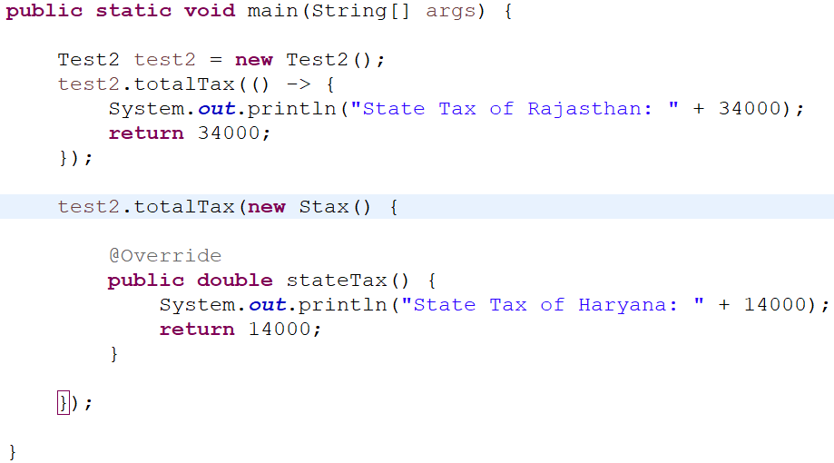

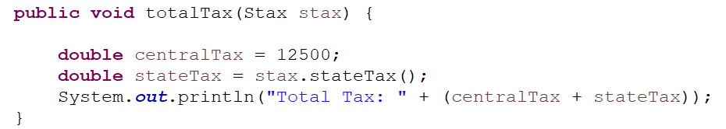

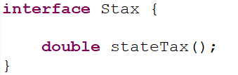

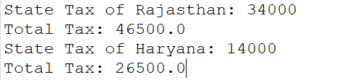

**How to Fix circular dependency:**

In Spring Boot, circular dependency occurs when two or more beans depend on each other. This can happen when a bean requires another bean to perform some operation, but that other bean also requires the first bean to perform its own operation. When this happens, the application fails to start because Spring Boot is unable to resolve the dependencies between the beans.

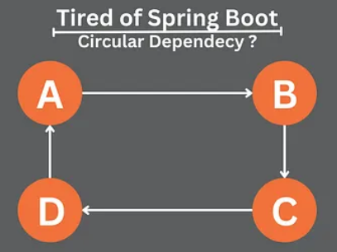

**Setter Injection:**

Another way to fix circular dependency is to use setter injection instead of constructor injection. With setter injection, Spring Boot will first create the object and then set the required dependencies using the setter method.

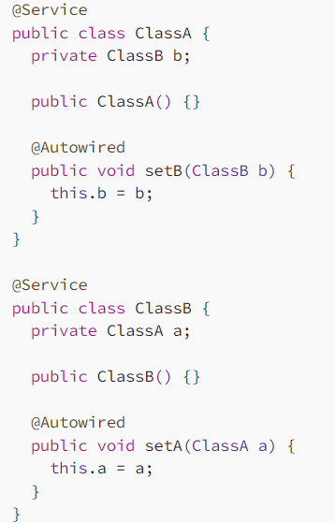

**Lazy Initialization:**

Another way to fix circular dependency is to use lazy initialization. With lazy initialization, Spring Boot will create the object only when it is first used, instead of creating it immediately at application startup. This can help break the circular reference by delaying the creation of one or more of the objects until they are actually needed.

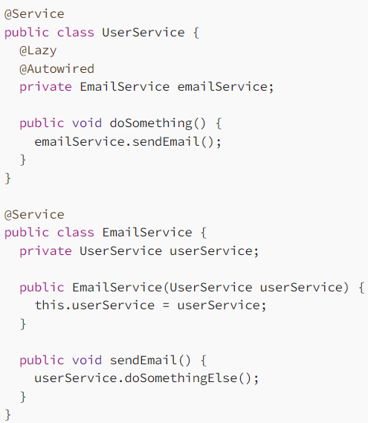

Now, when the UserService is constructed, the EmailService field will not be immediately instantiate. Instead, it will be instantiate when first time it is used, which in this case is when the doSomething() method is called. This breaks the circular dependency and allows for proper dependency injection.

**Hashing Algorithm:**

Internally is uses hashing algorithms to generate the hashcode. An algorithm that does the mapping of data to a hash of fixed size is called the hashing algorithm. **Hashing algorithm in Java** is a cryptographic hash function. A hash algorithm or hash function is designed in such a way that **it behaves like a one-way function**. One way means it is not possible to do the inversion, i.e., retrieving the original value from the hash is not possible.

**Type of Hashing algorthms:**

**MD5 Algorithm**

**SHA Algorithms**

**PBKDF2WithHmacSHA1 Algorithm**

**Garbage Collection algorithm:**

# Mark-and-Sweep(Internally used Graph data structure)

Any garbage collection algorithm must perform 2 basic operations. One, it should be able to detect all the unreachable objects and secondly, it must reclaim the heap space used by the garbage objects and make the space available again to the program. The above operations are performed by Mark and Sweep Algorithm in two phases as listed and described further as follows:

* Mark phase
* Sweep phase

### Mark Phase

When an object is created, its mark bit is set to 0(false). In the Mark phase, we set the marked bit for all the reachable objects (or the objects which a user can refer to) to 1(true). Now to perform this operation we simply need to do a graph traversal, a [depth-first search approach](https://www.geeksforgeeks.org/depth-first-traversal-for-a-graph/) would work for us. Here we can consider every object as a node and then all the nodes (objects) that are reachable from this node (object) are visited and it goes on till we have visited all the reachable nodes.

### Sweep Phase

As the name suggests it “sweeps” the unreachable objects i.e. it clears the heap memory for all the unreachable objects. All those objects whose marked value is set to false(0) are cleared from the heap memory, for all other objects (reachable objects) the marked bit is set to true(1).   
Now the mark value for all the reachable objects is set to false since we will run the algorithm (if required) and again we will go through the mark phase to mark all the reachable objects.

The mark-and-sweep algorithm is called a tracing garbage collector because it traces out the entire collection of objects that are directly or indirectly accessible by the program.

**A.** All the objects have their marked bits set to false.

**B.** Reachable objects are marked true

**C.**Nonreachable objects are cleared from the heap.

**Java 8's — Consumer, Predicate, Supplier, and Function**

**Consumer:**

A[**Consumer**](https://www.java67.com/2022/12/top-5-functional-interface-every-java.html)is an in-build functional interface in the java.util.function package. we use consumers when we need to consume objects, the consumer takes an input value and returns nothing. The consumer interface has two methods.



**Eg:**

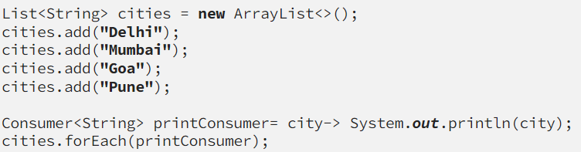

# Predicate:

A [P**redicate**](https://javarevisited.blogspot.com/2022/12/java-8-predicate-interface-example.html) is a [functional interface](https://www.java67.com/2022/12/top-5-functional-interface-every-java.html), which accepts an argument and returns a boolean. Usually, it is used to apply in a filter for a collection of objects.

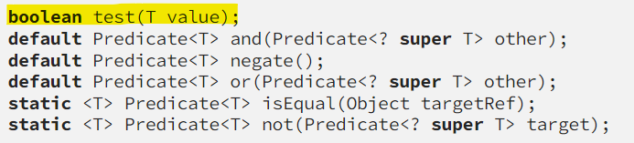

**Eg:**

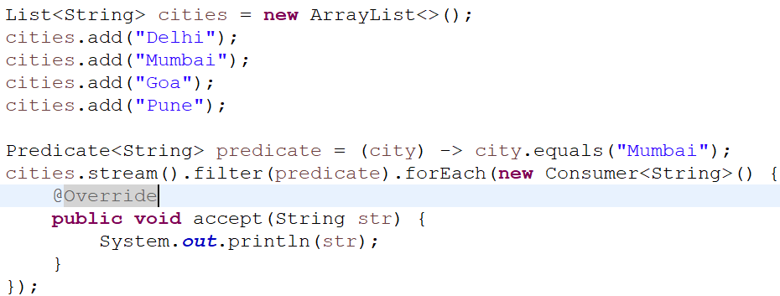

# Function:

A**Function**is another in-build functional interface in java.util.function package, the function takes an input value and returns a value. The function interface has four methods, mostly function used in map feature of stream APIs.

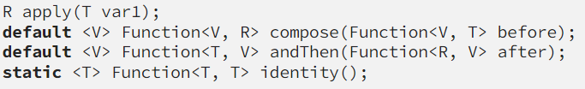

**Eg:**

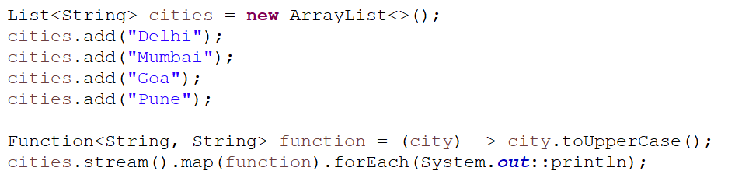

# Supplier:

The **Supplier Interface** is a part of the java.util.function package. It represents a function that does not take in any argument but produces a value of type T. It contains only one method.



**Eg:**

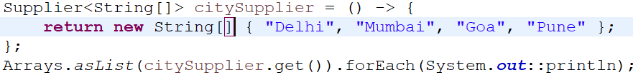

**Summary:**

Consumer: input parameter with no return type void accept(T value)

Supplier: no input parameter with return type T get()

Predicate: input paramter with boolean return type boolean test(T value)

Function: input paramter with return type R apply(T value)

**Fuctional Interface**

**Consumer**

**Supplier**

**Function**

**Predicate**

**Runnable**

**Callable**

**Comparator**

**Comparable**

**Events:**

Spring Boot Events are a part of the Spring Framework’s context module. These events are meant to provide a means of application-wide broadcasting of information, allowing beans to interact without being tightly coupled.

Consider a common scenario where a new user registers on a website. Multiple actions should take place: sending a welcome email, logging the registration event, updating the user count, etc. Rather than having the user registration service directly call these services, we can publish an event that these services listen for. This method maintains a level of separation and modularity.

It prevents below points:

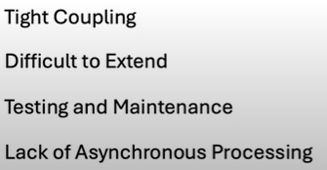

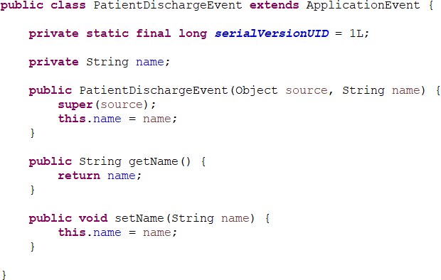

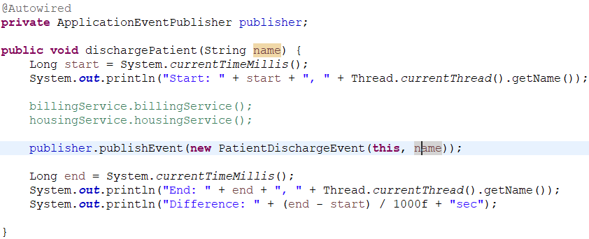

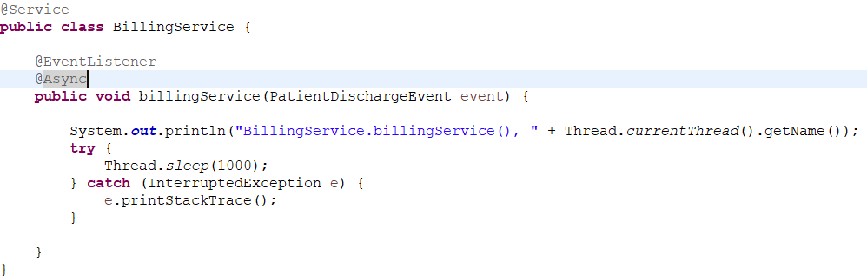

**SLF4j VS Log4j**

**SLF4J** is a simple logging façade for java. It is not a logging component, and even it does not do the actual logging. It is only an abstraction layer to an underlying logging component.

Logging fascade: It means that it is an abstraction of logging framework.

**Log4j**, it is a logging component, and it does the logging instructed to do.

Logging Component: It is the implemenation.

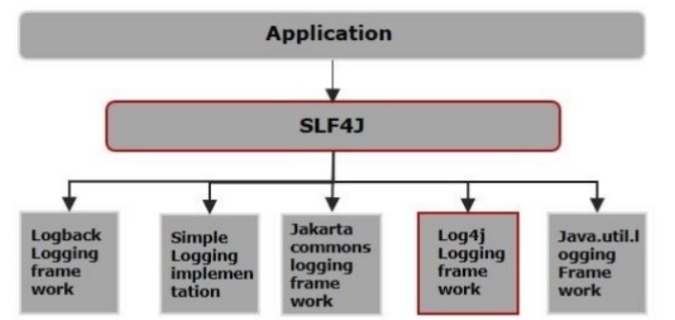

By default springboot use Logback as logging component.

For that, you will need to include two jar files:

* SLF4J binding jar file
* Desired logging framework jar files

For example, to use log4j in your project, you will need to include given below jar files:

* slf4j-log4j12-1.7.12.jar
* log4j-1.2.17.jar

Once you have placed both jar files in your application classpath, SLF4J will automatically detect it and start using log4j for processing the log statements based on the configuration you provided in log4j configuration file.

**SSLContext:**

**TrustStore**: It is used to store public certificate.

**Key**: It is used to store private certificate.

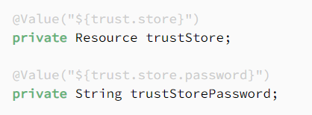

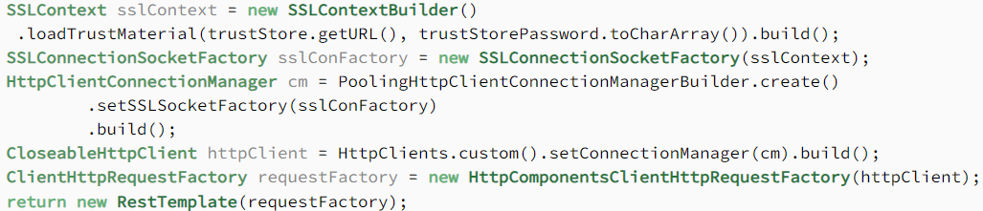

SSLContext: It is used to create implementation of secure socket protocol.

First, we create an **SSLContext** object that represents a secure socket protocol implementation. We use the  **SSLContextBuilder**  class’s  build() method to create it.

We use the SSLContextBuilder‘s **loadTrustMaterial**() method to load the keystore file and credentials into the SSLContext object.

Then, we create SSLConnectionSocketFactory, a layered socket factory for TSL and SSL connections, by loading SSLContext.

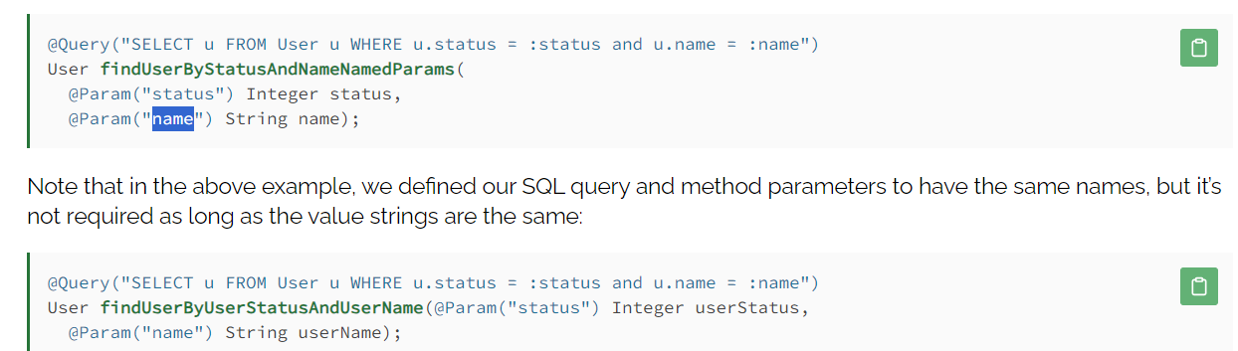

**How to create Custom mongo query?**

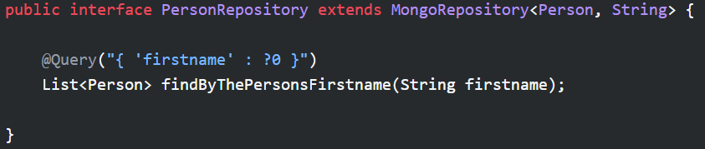

**Dependency:**

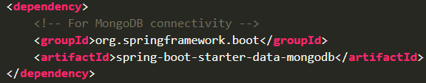

**MySQL Dependency:**

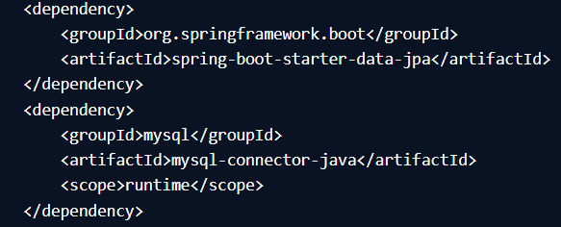

**map() and flatMap() difference in streamApi:**

**map Function:**

The map operation is used to apply a transformation to each element in a stream, resulting in a one-to-one mapping. It produces a new stream where each input element is transformed into a corresponding output element.

**flatMap Function:**

The flatMap operation is used to transform each element in a stream into a stream of multiple elements. The resulting streams are then flattened into a single stream, effectively merging all the streams into one.

Here’s a real-life analogy to help understand the difference between map and flatMap:

Imagine you have a list of people, and each person has a list of their favorite colors. You want to extract all the favorite colors from the list of people. Using the Stream API, you would use map to extract each person's list of favorite colors, and flatMap to extract all the colors from all the lists.

**using map(): Using flatMap():**

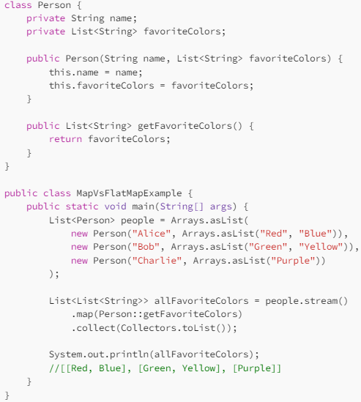 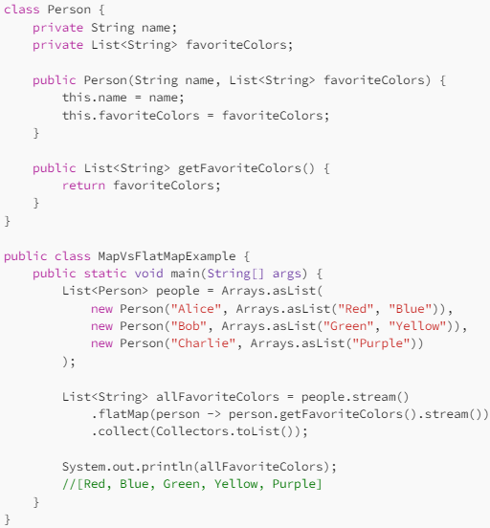

**reduce()**

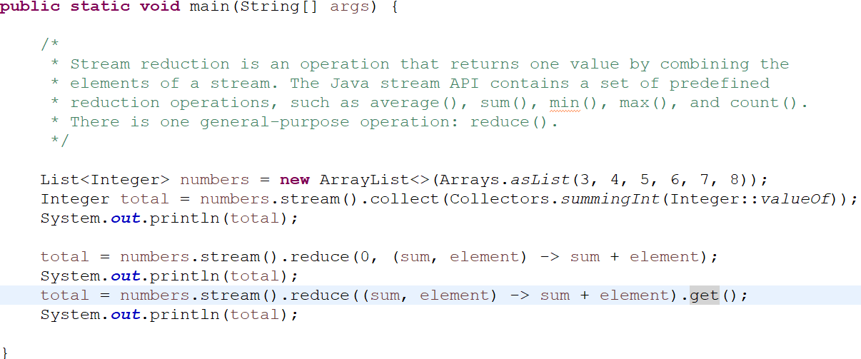

Output:

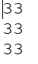

In above image if we not give initial value then it will return optional object.

## Parameters of Java Stream reduce()

In general, Java Stream reduce() comprises two parameters: the **identity** and the **accumulator**.

The **identity** element is either the initial value of the stream reduction or it can also be the default value if there are no elements present in the stream.

The **accumulator** is a function that takes up two parameters as well:

* A partial result of the reduction that has been produced by processing the elements of the list so far.
* The next element that has to be processed in the list.

**Print even and odd using two threads:**

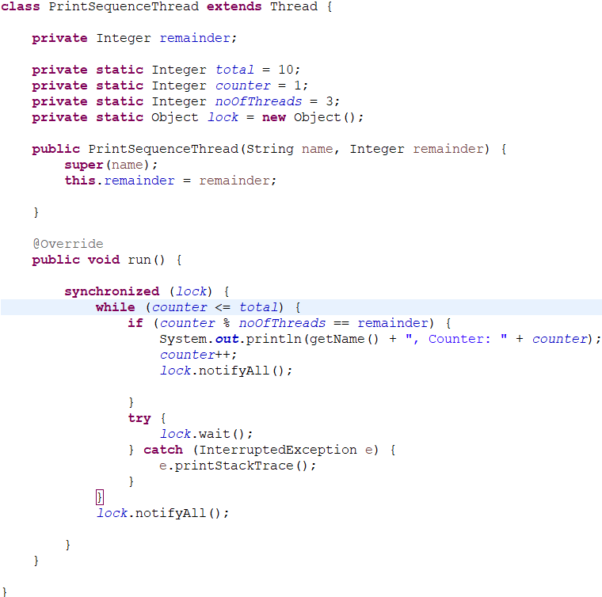

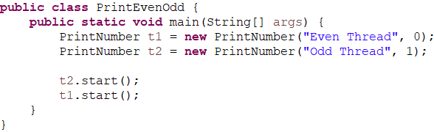

Here we are setting the remainder in print thread constructor and check it in the condition if its ture then it will print and notifyAll() so other waiting thread will get chance to execute. If it is false the it will wait() so other thread execute.

Output:

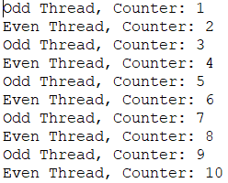

**Print number in sequence using thread:**

Eg:

Thread1 1

Thread2 2

Thread3 3

Thread1 4

Thread2 5

Thread3 6

Thread1 7

Thread2 8

Thread3 9

**Thread1** -: It will print 1,4,7,10,.... Remainder: 1

**Thread2** -: It will print 2,5,8,11,... Remainder: 2

**Thread3** -: It will print 3,6,9,12,... Remainder: 3

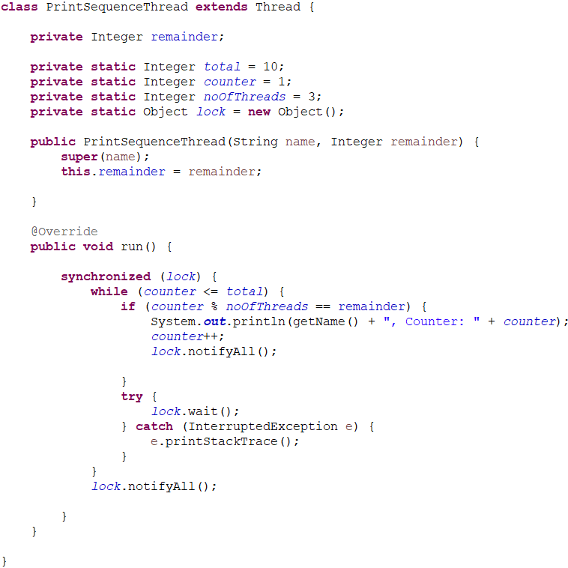

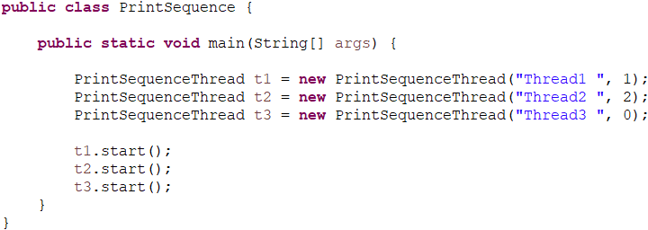

Output:

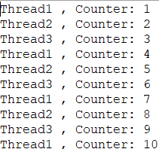

It is same as even odd but here we are setting remainder value in such a way that it will only print those value which matches condition.

**EqualsHashCodeContract:**

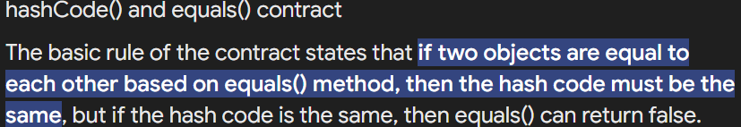

true euqals() then true hashcode()

true hashcode() then equals() map be true or false

**Circuit Breaker pattern:**

The Circuit Breaker pattern in [microservices](https://www.geeksforgeeks.org/microservices/) is a fault-tolerance mechanism that monitors and controls interactions between services. It dynamically manages service availability by temporarily interrupting requests to failing services, preventing system overload, and ensuring graceful degradation in distributed environments.

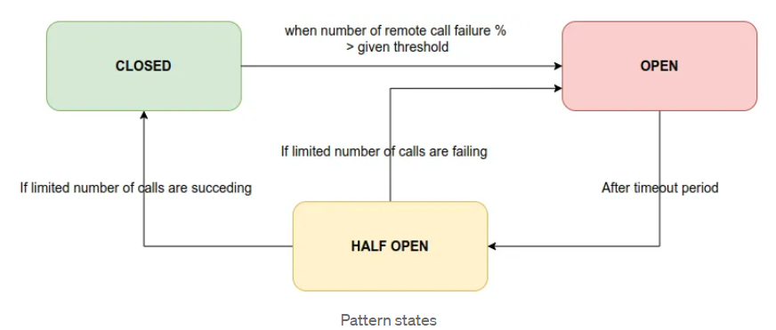

**Resilience4j** library is used to implement the circuit breaker.

# What is Resilience4j?

**Resilience4j** is a lightweight, easy-to-use **fault tolerance library** inspired by [Netflix Hystrix](https://github.com/Netflix/Hystrix). It provides various features.

* **Circuit Breaker — fault tolerance**
* Rate Limiter — block too many requests
* Time Limiter — limit time while calling remote operations
* Retry Mechanism — automatic retry for failed operations
* Bulkhead — limit number of concurrent requests
* Cache — store results of costly remote operations

Here I Have created two service Loan Service(LS) and Interest Service(IS). LS is internally calling IS to get the interest rate for a particular loan type.

Loan Service: 8080 port

Interest Service: 8081 port

Loan Service

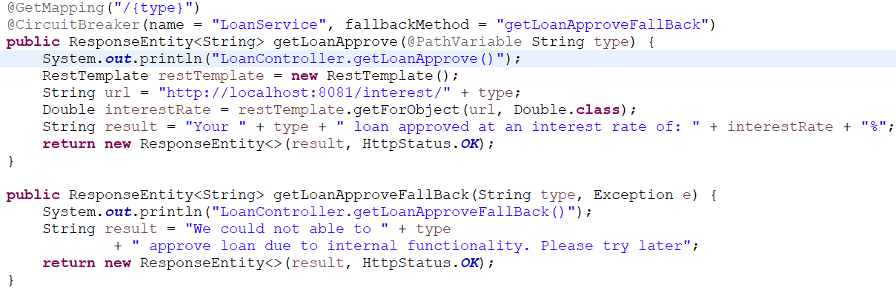

application.properties:

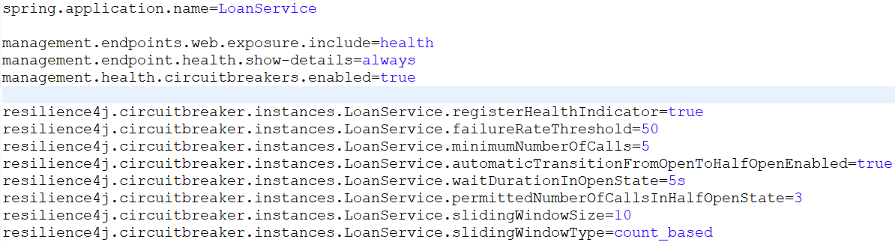

pom.xml:

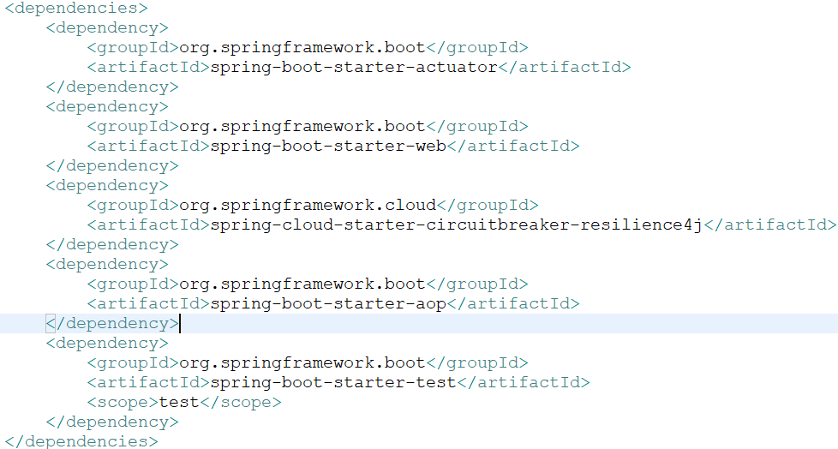

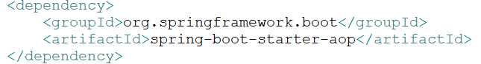  
Above dependency is required to work with circuit breaker fallback method else it will not work.

Note:

CircuitBreaker name should not contains any space or hypen(-).

Here circuitBreaker is “LoanService” 

Actuator url: [localhost:8080/actuator/health](http://localhost:8080/actuator/health)

## Life Cycle of Pattern States 

There are 3 main states discussed in Circuit Breaker pattern. They are:

CLOSED

OPEN

HALF OPEN

Let’s understand the states briefly….

## CLOSED State

When both services which are interacting are up and running, circuit breaker is CLOSED. Circuit breaker is counting the number of remote API calls continuously.

## OPEN State

As soon as the percentage of failing remote API calls is exceeding the given threshold, circuit breaker changes its state to OPEN state. Calling micro service will fail immediately, and an exception will be returned. That means, the flow is interrupted. When cycle is in open state then will call fallback method directly not the actual method as connection is open.

## HALF OPEN State

After staying at OPEN state for a given timeout period, breaker automatically turns its state into HALF OPEN state. In this state, only a LIMITED number of remote API calls are allowed to pass through. If the failing calls count is greater than this limited number, breaker turns again into OPEN state. Otherwise it is CLOSED.

Now lets understand cmds in application.properties file.

spring.application.name=LoanService

management.endpoints.web.exposure.include=health

management.endpoint.health.show-details=always

management.health.circuitbreakers.enabled=true

resilience4j.circuitbreaker.instances.LoanService.registerHealthIndicator=true

resilience4j.circuitbreaker.instances.LoanService.failureRateThreshold=50

resilience4j.circuitbreaker.instances.LoanService.minimumNumberOfCalls=5

resilience4j.circuitbreaker.instances.LoanService.automaticTransitionFromOpenToHalfOpenEnabled=true

resilience4j.circuitbreaker.instances.LoanService.waitDurationInOpenState=5s

resilience4j.circuitbreaker.instances.LoanService.permittedNumberOfCallsInHalfOpenState=3

resilience4j.circuitbreaker.instances.LoanService.slidingWindowSize=10

resilience4j.circuitbreaker.instances.LoanService.slidingWindowType=count_based

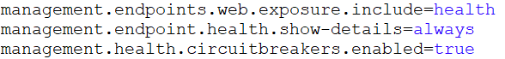

Above cmds are used to enable circuitBreaker and health status using actuator.

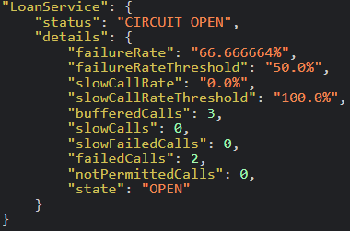

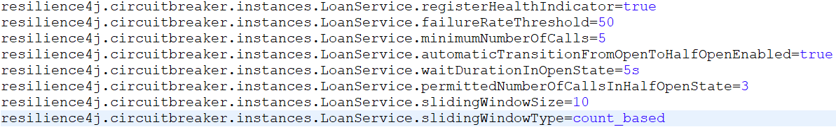

**registerHealthIndicator**: This is used to enable LoanService circuitBreaker in actuator.

**failureRateThreshold**: Expected percentage of the failure threshold.  
I have set it as 50%. It means, when total failed remote calls % is equal or greater than 50%, breaker will be active to stop furthermore requests.

**minimumNumberOfCalls**: This shows minimum no of calls required to enable circuitBreaker. Suppose total request is 4 then at this time it will not be enable, once we hit one more time then it will enable and then check how many request are failed and passed, then calcuate failure rate(%). If it is greater than 50% then it will move to open state else closed state.

I have set it as 5. Let’s say 3 API calls are failing from the the first 5 API calls. It means failureRateThreshold = (3/5) * 100 = 60%.

**automaticTransitionFromOpenToHalfOpenEnabled**: I have set this as true. It will automatically transfer OPEN state to HALF OPEN state when it comes the right time for that transition. In Open state it will call fallback method.\

**waitDurationInOpenState**:  Timeout period before going to HALF OPEN state from OPEN state. After 5 seconds, breaker will change the state, here.

**permittedNumberOfCallsInHalfOpenState**: Number of LIMITED API calls that should be sent while in HALF OPEN state. I have set it as 3. So, after 3 API calls, if they are failed, then breaker will again go to OPEN state. Otherwise breaker will be CLOSED since rate-service is UP.

How can we know to move to open state or closed state?

As we set failureRateThreshold: 50% and permittedNumberOfCallsInHalfOpenState: 3. It will call the service 3 times and from that is will find fail call and success call. Then it calculate the failure rate. If if is higher or equal than failureRateThreshold then state change to OPEN. Else for lower it will set to CLOSED.

**slidingWindowSize**: It is same as minimumNumberOfCalls. It will find the minimum from minimumNumberOfCalls and slidingWindowSize if both are present. If minimumNumberOfCalls is not present then it will considered slidingWindowSize as minimumNumberOfCalls.

**slidingWindowType**: Here I have set the type to keep the circuit breaker behavior based on the requests counts.

